Kennesaw State University
HPC & Parallel Computing
Project – GPU programming

Instructor: Kun Suo
Points Possible: 100
Difficulty: 

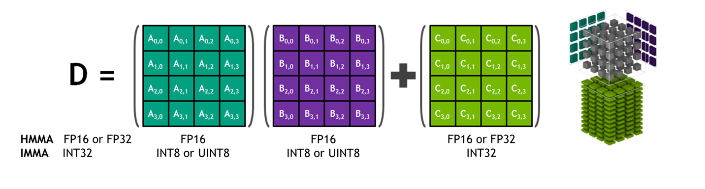

General Matrix Multiplication (GEMM) is typically defined as:

$$C=AB$$

$$C_{m,n}=\sum_{n=1}^{N}{A_{m,n}B_{n,k}}$$

where A is an m*n matrix and B is an n*k matrix.

Task 1 (20 points):

Write a program running on CPU that the user inputs 3 integers M, N, K (512 ~ 8192) and it randomly generates two matrices A (M*N) and B (N*K), and performs matrix multiplication to obtain matrix C. The output is the time taken for the matrix calculation.

Task 2 (40 points):

First, configure CUDA C/C++ and the environment yourself in Google Colab with GPU runtime.
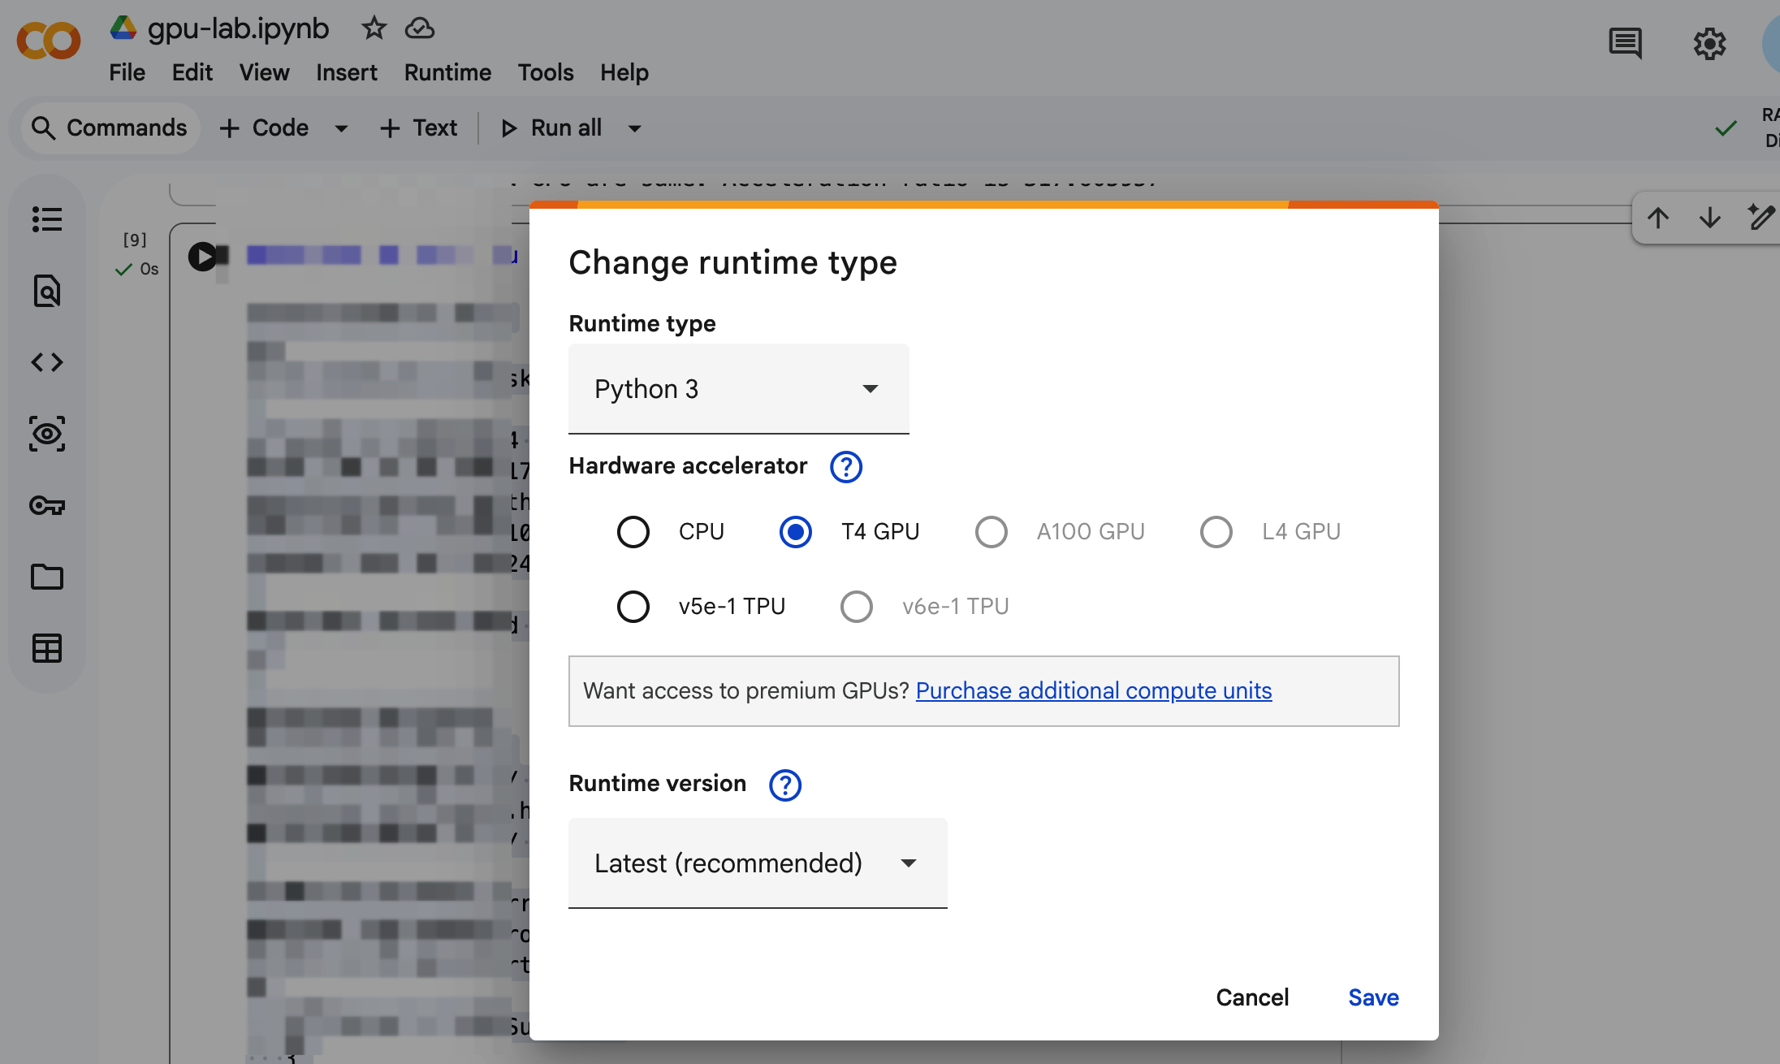

Test the CUDA environment as follows:

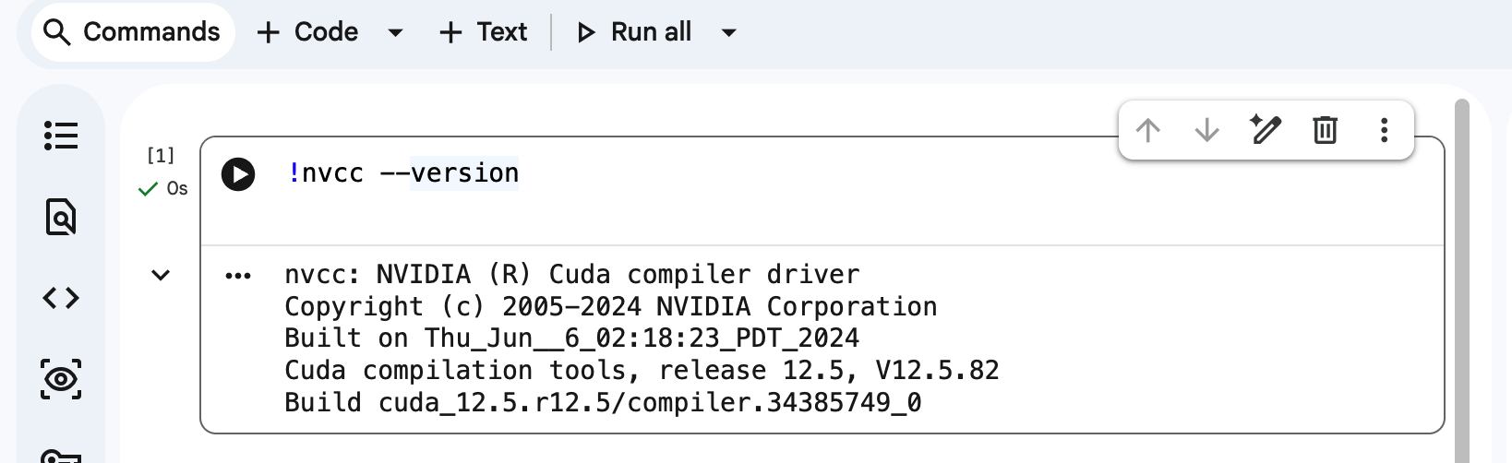

Modify the code in Task 1 and implementing a parallel version of general matrix multiplication using CUDA. Inputs of the program are matrix dimensions m, n, k, and CUDA block_size. In the code, make sure it has 2 functions: One function uses the CPU for GEMM (General Matrix Multiplication), and the other uses CUDA. After both functions finish running, the output matrices C from both functions are compared to see if they are identical. If they are the same, the speedup ratio of CPU vs. GPU is printed on the screen; otherwise, an error message indicating inconsistent results is printed. (Note that if your matrix elements are floating-point numbers, elements within a certain tolerance can be considered the same. You can set a very small threshold (Epsilon), such as 10⁻⁹. The equality check formula is: |a - b| < ε. If the difference between a and b is less than this small value, we consider them "equal".)

For GPU programs, measure and plot the execution time for different block sizes and matrix sizes:

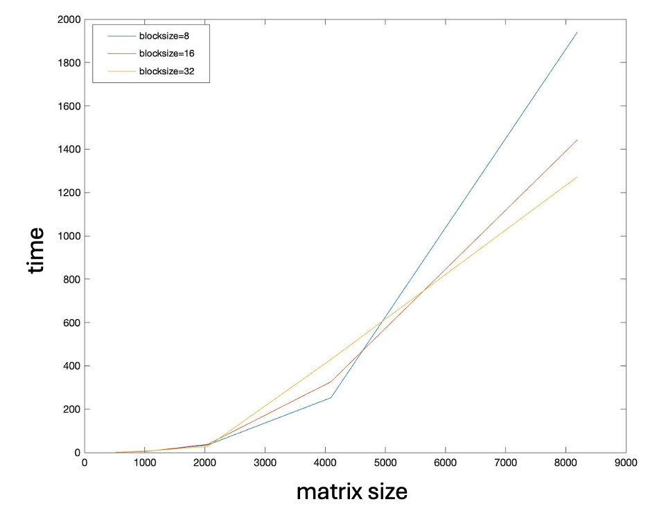

For a given block size (e.g., block size = 8), compare the speedup ratio of the CPU version and the GPU version.

Order of Matrix | 1024 | 2048 | 4096
CPU Time
GPU Time
Speedup

Expected Output
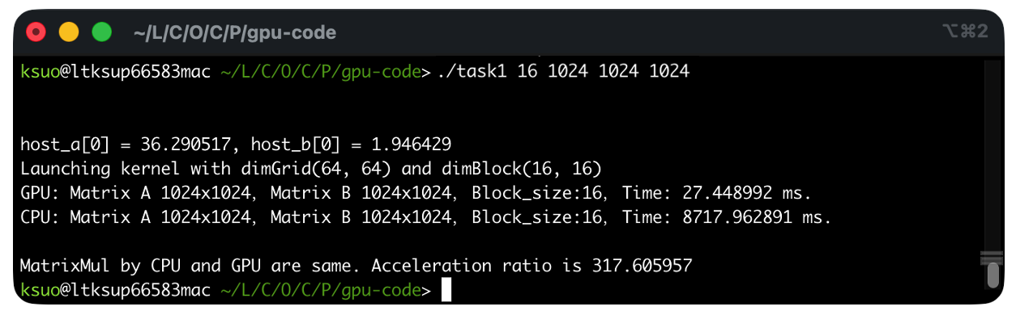

Task 3 (40 points):

cuBLAS is a CUDA-X math library containing highly optimized basic linear algebra subroutines for matrix and vector operations, specifically tuned for superior performance on NVIDIA hardware.
Using NVIDIA's matrix computation library cuBLAS, we will perform matrix multiplication with matrix sizes increasing from 512 in increments of 2 up to 8192, and compare and analyze its performance against the matrix multiplication performed in Task 2.

CUBLAS Reference Documentation:
https://docs.nvidia.com/cuda/pdf/CUBLAS_Library.pdf

CUBLAS matrix multiplication example:
https://github.com/kevinsuo/CS4522/blob/main/matrixMulCUBLAS.pdf

For GPU vs. cuBLAS results, measure and plot the execution time for different matrix sizes:

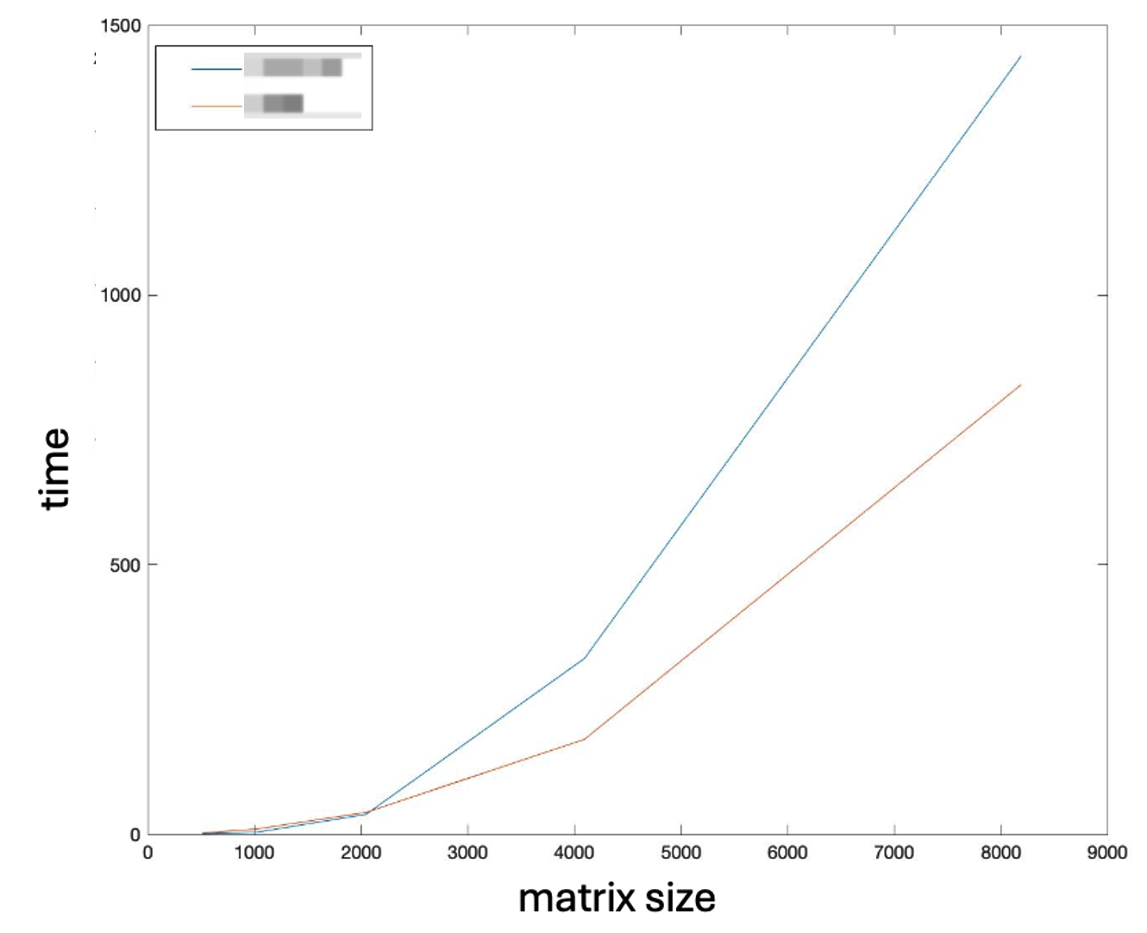

For a given block size (e.g., block size = 32), compare the speedup ratio of the GPU version and the cuBLAS version.

Order of Matrix | 512 | 1024 | 2048 | 4096 | 8192
GPU Time
cuBLAS Time
Speedup

Expected Output

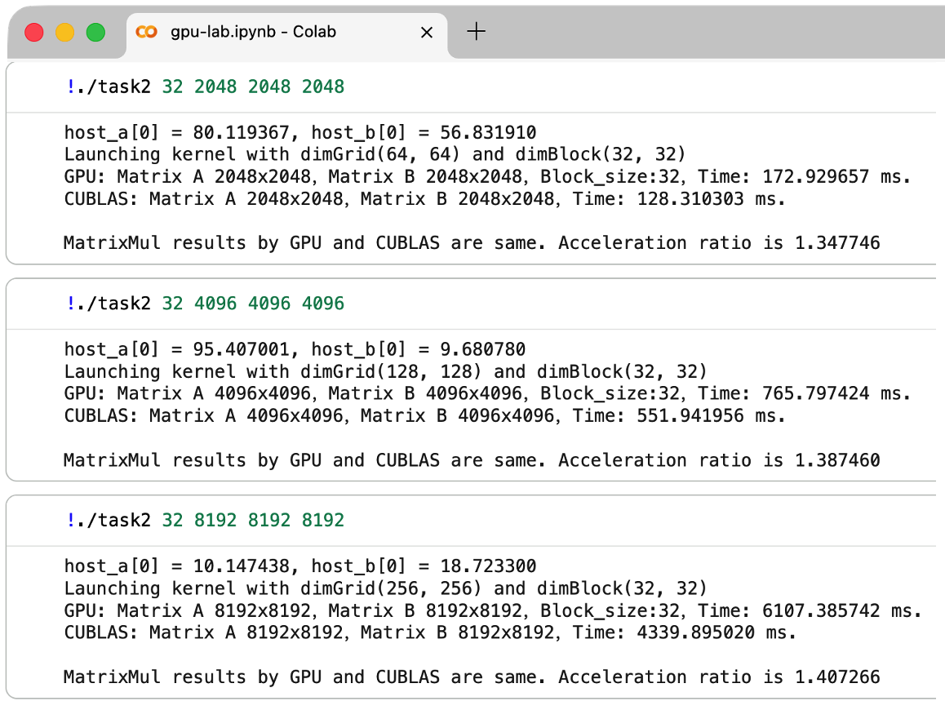

Submitting Assignment

Submit your assignment file through D2L using the appropriate link.
The submission must include the source code, and a report describe your code logic. Output screenshot of your code and dot-line-chart (e.g., Chart 1) & Tables should be included in the report.

