Kennesaw State University
CSE 3502 Operating Systems
Project 3 - The /Proc File Systems and mmap
Instructor: Kun Suo
Points Possible: 100
Difficulty: 

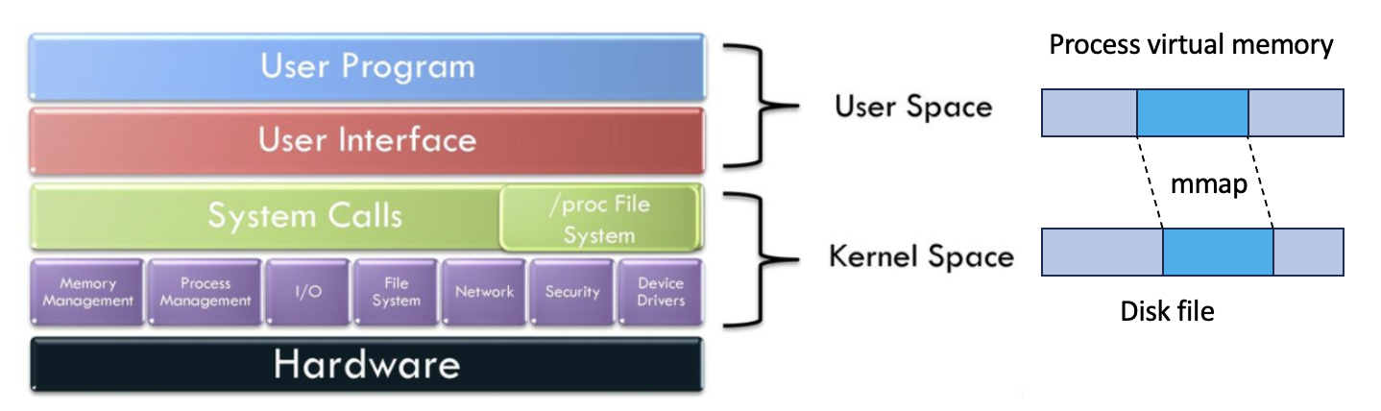

Part 1: Create a helloworld kernel module (20 pts)

The following code is a complete helloworld module. Name it as new_module.c
https://github.com/kevinsuo/CS3502/blob/master/project-4-1.c

--------------------------------------------------------------------------------------------------------------------------
#include <linux/module.h>
#include <linux/kernel.h>

int init_new_module(void)
{
printk(KERN_INFO "Hello, world!\n");
return 0;

}

void exit_new_module(void) {
printk(KERN_INFO "Goodbye, world!\n");
}

module_init(init_new_module);
module_exit(exit_new_module);
--------------------------------------------------------------------------------------------------------------------------

The module defines two functions. init_module is invoked when the module is loaded into the kernel and exit_module is called when the module is removed from the kernel. module_init and module_exit are special kernel macros to indicate the role of these two functions.

Use the following makefile to compile the module. Name it as Makefile
https://github.com/kevinsuo/CS3502/blob/master/project-4-1-Makefile

Note that here new_module.o is the output after compiling.
--------------------------------------------------------------------------------------------------------------------------
obj-m += new_module.o
all:
sudo make -C /lib/modules/$(shell uname -r)/build M=$(PWD) modules
clean:
sudo make -C /lib/modules/$(shell uname -r)/build M=$(PWD) clean
--------------------------------------------------------------------------------------------------------------------------

Compile the new_module.c file using make command.
$ make

To insert the module into the Linux kernel:
$ sudo insmod new_module.ko

Use the following command to verify the module has been loaded:
$ lsmod
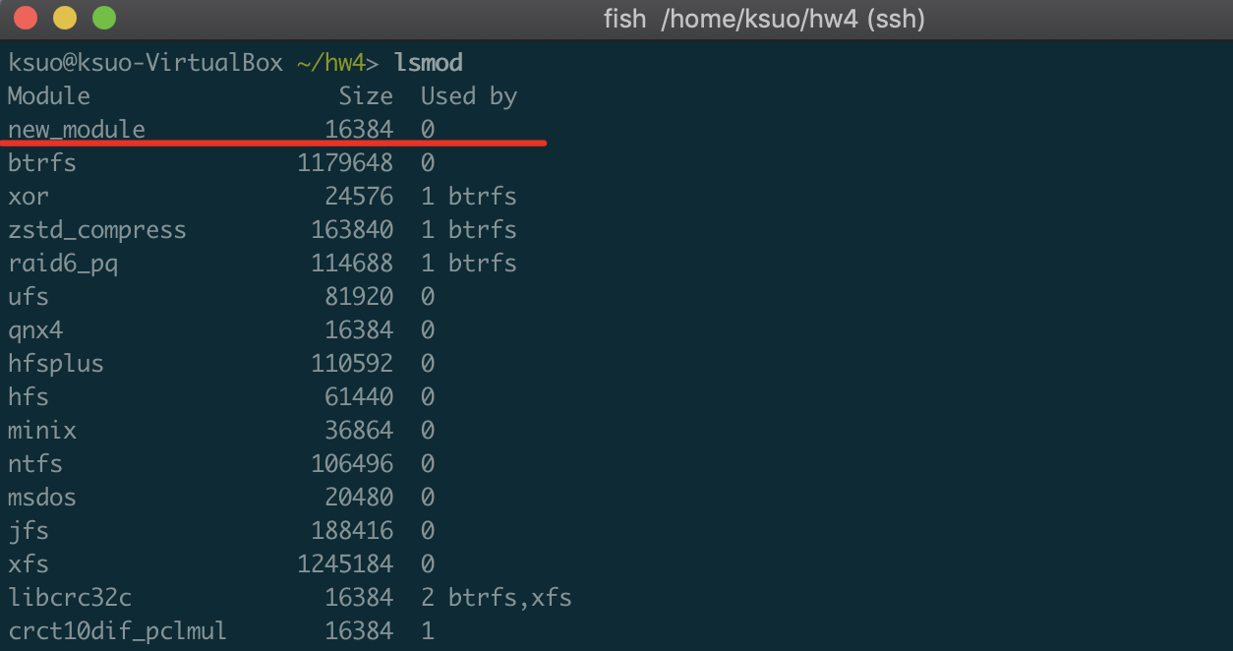

To remove the module from the kernel:
$ sudo rmmod new_module

When you insert or remove the module, corresponding information will be printed out under the dmesg.

Part 2: Create an entry in the /proc file system for user level read and write (30 pts)

Write a new kernel module following steps in Part 1. This module creates an entry in the /proc file system. Use the following code skeleton to write the module:

https://github.com/kevinsuo/CS3502/blob/master/project-4-2.c

--------------------------------------------------------------------------------------------------------------------------
#include <linux/module.h>
#include <linux/kernel.h>
#include <linux/proc_fs.h>
#include <linux/string.h>
#include <linux/vmalloc.h>
#include <linux/slab.h>
#include <linux/uaccess.h>

#define MAX_LEN 4096
static struct proc_dir_entry *proc_entry;

ssize_t read_proc(struct file *f, char *user_buf, size_t count, loff_t *off )
{
//output the content of info to user's buffer pointed by page
return count;
}

ssize_t write_proc(struct file *f, const char *user_buf, size_t count, loff_t *off)
{
//copy the written data from user space and save it in info
return count;
}

struct file_operations proc_fops = {
read: read_proc,
write: write_proc
};

int init_module( void )
{
int ret = 0;
//create the entry named myproc and allocated memory space for the proc entry

printk(KERN_INFO "test_proc created.\n");

return ret;
}

void cleanup_module( void )
{
//remove the entry named myproc and free info space
}
--------------------------------------------------------------------------------------------------------------------------

Step 1: create an entry in proc file system named myproc when the kernel module is loaded; this entry myproc will be deleted when the kernel mode is deleted. You can use $ ls /proc/ to check whether it is existed. (Hint: proc_create() and remove_proc_entry() are needed.)

Step 2: implement read_proc and write_proc function to read/write the proc file entry in Step 1. You need to add codes for allocating memory in init_module and releasing the memory in cleanup_module for the proc file entry. (Hint: copy_to_user() is needed for the read and copy_from_user() is needed for write.)

To test your results, load the kernel module and there should be a new entry created under /proc. Use cat and echo to verify and change the content of the new entry.

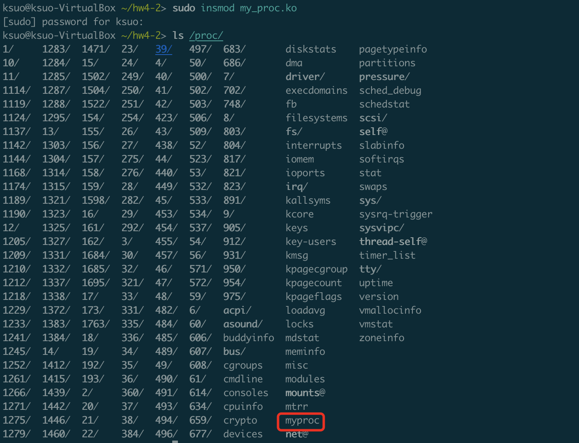

You can use the following to test the read or write on the entry of proc file system. Here the root user is needed.

Expected output:

Write “your name” into /proc/myproc. For instance, a student named “Sisi”


Read /proc/myproc and printout its content:

Part 3: Exchange data between the user and kernel space via mmap (50 pts)

Write a kernel module that create an entry in the /proc file system. The new entry cannot be directly read or written using cat and echo commands. Instead, map the new entry to a user space memory area so that user-level processes can read from and write to the kernel space via mmap. The skeleton of the kernel module is given below:

https://github.com/kevinsuo/CS3502/blob/master/project-4-3-1.c

--------------------------------------------------------------------------------------------------------------------------
#include <linux/module.h>
#include <linux/list.h>
#include <linux/init.h>
#include <linux/kernel.h>
#include <linux/types.h>
#include <linux/kthread.h>
#include <linux/proc_fs.h>
#include <linux/sched.h>
#include <linux/mm.h>
#include <linux/fs.h>
#include <linux/slab.h>

static struct proc_dir_entry *tempdir, *tempinfo;
static unsigned char *buffer;
static unsigned char array[12]={0,1,2,3,4,5,6,7,8,9,10,11};

static void allocate_memory(void);
static void clear_memory(void);
static int my_map(struct file *filp, struct vm_area_struct *vma);

static const struct file_operations myproc_fops = {
.mmap = my_map,
};

static int my_map(struct file *filp, struct vm_area_struct *vma)
{
// map vma of user space to a continuous physical space
return 0;
}

static int init_myproc_module(void)
{
tempdir=proc_mkdir("mydir", NULL);
if(tempdir == NULL) {
printk("mydir is NULL\n");
return -ENOMEM;
}

tempinfo = proc_create("myinfo", 0, tempdir, &myproc_fops);
if(tempinfo == NULL) {
printk("myinfo is NULL\n");
remove_proc_entry("mydir",NULL);
return -ENOMEM;
}
printk("init myproc module successfully\n");

allocate_memory();

return 0;
}

static void allocate_memory(void)
{
/* allocation memory */
buffer = (unsigned char *)kmalloc(PAGE_SIZE,GFP_KERNEL);
/* set the memory as reserved */
SetPageReserved(virt_to_page(buffer));
}

static void clear_memory(void)
{
/* clear reserved memory */
ClearPageReserved(virt_to_page(buffer));
/* free memory */
kfree(buffer);
}

static void exit_myproc_module(void)
{
clear_memory();
remove_proc_entry("myinfo", tempdir);
remove_proc_entry("mydir", NULL);
printk("remove myproc module successfully\n");
}

module_init(init_myproc_module);
module_exit(exit_myproc_module);
MODULE_LICENSE("GPL");
--------------------------------------------------------------------------------------------------------------------------

The above code will create an entry /proc/mydir/myinfo under the proc file system. You are required to implement the my_map function to map one piece of memory (char array[12]) into user space. Then write a user space program using mmap to visit the memory space of the proc file and print the data in that memory area. You can use the following skeleton:
https://github.com/kevinsuo/CS3502/blob/master/project-4-3-2.c

--------------------------------------------------------------------------------------------------------------------------
#include <unistd.h>
#include <stdio.h>
#include <stdlib.h>
#include <string.h>
#include <fcntl.h>
#include <linux/fb.h>
#include <sys/mman.h>
#include <sys/ioctl.h>

#define PAGE_SIZE 4096

int main(int argc , char *argv[])
{
int fd;
int i;
unsigned char *p_map;

/* open proc file */
fd = open("/proc/mydir/myinfo", O_RDWR);
if(fd < 0) {
printf("open fail\n");
exit(1);
}else {
printf("open successfully\n");
}

// map p_map to the proc file and grant read & write privilege
// read data from p_map
// unmap p_map from the proc file

return 0;
}
--------------------------------------------------------------------------------------------------------------------------

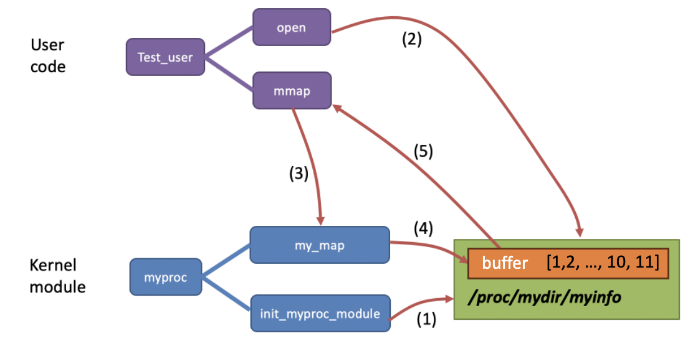

The above figure shows the entire workflow:
- Kernel module create a proc file: /proc/mydir/myinfo
- User process open the created proc file
- User process calls mmap function, which further executed my_map defined in the kernel
- my_map() then maps one piece of memory into user space (e.g., buffer) and puts some data inside
- User process visits this piece of memory and prints the data out.

Expected output:
For instance, a student named Sisi should upload a screenshot like:

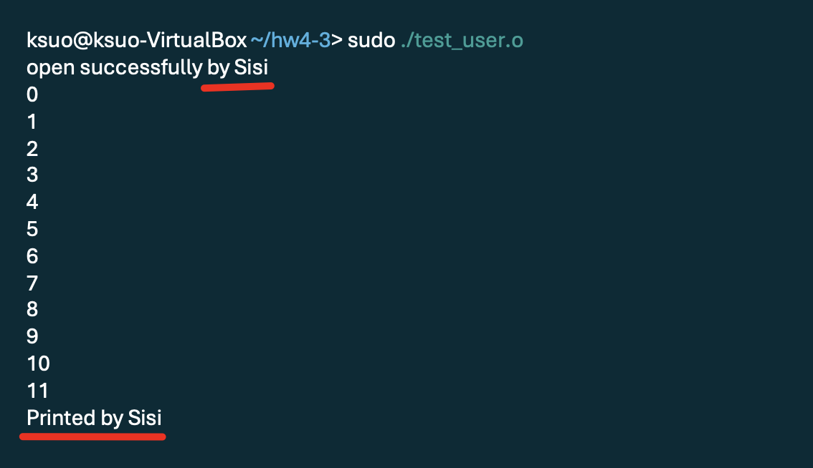

Submission requirements:
Submit your assignment file through D2L using the appropriate link.
The submission must include the source code, and a report describe your code logic （including part 1/2/3）. Output screenshot（including part 1/2/3） of your code should be included in the report.

