Kennesaw State University
CS 7172 Parallel and Distributed Computing - Spring 2020
Project 3 – MPI

Instructor: Kun Suo
Points Possible: 100
Due date: check on the D2L

Task 1: calculate PI with MPI (50 points):

Mathematically, we know the following equation:

$$\int_{0}^{1}{\frac{4}{(1+x^{2})}dx= π}$$

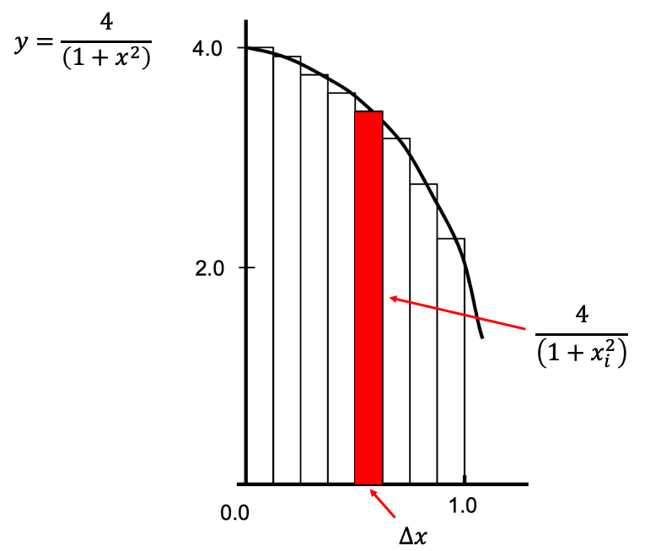

We can approximate the value of $π$ as a sum of rectangles:

$$\sum_{i=0}^{N}{f\left(x_{i}\right)Δx≈π}$$

Where each rectangle has width ∆x and height F(x_{i}) at the middle of interval i.

The following code implements the above calculation of PI. We divide the area between 0 and 1 into 100000 small rectangles and the value of PI is approximately equal to the sum of all rectangles’ size. However, the program executes in the sequential implementation.

https://github.com/kevinsuo/CS7172/blob/master/pi.c

----------------------------------------------------------------------------------------------------------------
#include <stdio.h>
#include <stdlib.h>
#include <time.h>
#define NUMSTEPS 1000000

int main() {
int i;
double x, pi, sum = 0.0;
struct timespec start, end;

clock_gettime(CLOCK_MONOTONIC, &start);
double step = 1.0/(double) NUMSTEPS;
x = 0.5 * step;

for (i=0;i<= NUMSTEPS; i++){
x+=step;
sum += 4.0/(1.0+x*x);
}
pi = step * sum;
clock_gettime(CLOCK_MONOTONIC, &end);
u_int64_t diff = 1000000000L * (end.tv_sec - start.tv_sec) + end.tv_nsec - start.tv_nsec;

printf("PI is %.20f\n",pi);
printf("elapsed time = %llu nanoseconds\n", (long long unsigned int) diff);

return 0;
}
----------------------------------------------------------------------------------------------------------------

Write a parallel program to calculate PI using MPI based on this sequential solution.

To compile the program with OpenMP, use:
$ mpicc -g program.c -o program.o

Please write a brief report introducing your implementation.
(Hint: MPI_Bcast and MPI_Reduce are required.)

Task 2 Soring in MPI (50 points):

https://github.com/kevinsuo/CS7172/blob/master/data.txt

The above link is a file which contains 1 million unsorted numbers.

----------------------------------------------------------------------------------------------------------------
#include <stdio.h>
#include <stdlib.h>
#include <string.h>
#include <time.h>

int data[1000000];

void swap(int* a, int* b)
{
int t = *a; *a = *b; *b = t;
}

int partition (int arr[], int low, int high)
{
int pivot = arr[high]; // pivot
int i = (low - 1); // Index of smaller element

for (int j = low; j <= high- 1; j++)
{
if (arr[j] < pivot)
{
i++; // increment index of smaller element
swap(&arr[i], &arr[j]);
}
}
swap(&arr[i + 1], &arr[high]);
return (i + 1);
}

void quickSort(int arr[], int low, int high)
{
if (low < high)
{
int pi = partition(arr, low, high);
quickSort(arr, low, pi - 1);
quickSort(arr, pi + 1, high);
}
}

void printArray(int arr[], int size)
{
int i;
for (i=0; i < size; i++)
printf("%d\n", arr[i]);
}

int main()
{
//read the unsorted array
char str[100];
int count = 0;
struct timespec start, end;
FILE* fp = fopen("data.txt", "r");
while (fscanf(fp, "%s", str) != EOF) {
data[count] = atoi(str);
count++;
}

//quick sort the array
clock_gettime(CLOCK_MONOTONIC, &start);
quickSort(data, 0, count - 1);
clock_gettime(CLOCK_MONOTONIC, &end);

u_int64_t diff = 1000000000L * (end.tv_sec - start.tv_sec) + end.tv_nsec - start.tv_nsec;
printf("elapsed time = %llu nanoseconds\n", (long long unsigned int) diff);

// printArray(data, count);

fclose(fp);

return 0;
}
----------------------------------------------------------------------------------------------------------------

https://github.com/kevinsuo/CS7172/blob/master/quicksort.c

The above source code file quicksort.c is a Divide and Conquer algorithm which sorts the above 1 million unsorted numbers. However, the program executes in the sequential implementation. Please write a parallel program quick sort using MPI based on this sequential solution. Compare the parallel program execution time with the sequential version and write a report with data and figures introducing your implementation.

(Hint: MPI_Send and MPI_Recv are required.)

Submitting Assignment

Submit your assignment zip file through D2L using the appropriate assignment link. For task 1 and 2, please submit the source code , screenshot of output and report.

