Kennesaw State University
Parallel and Distributed Computing
Project – Get to know your machine
Instructor: Kun Suo
Points Possible: 100
Difficulty: 

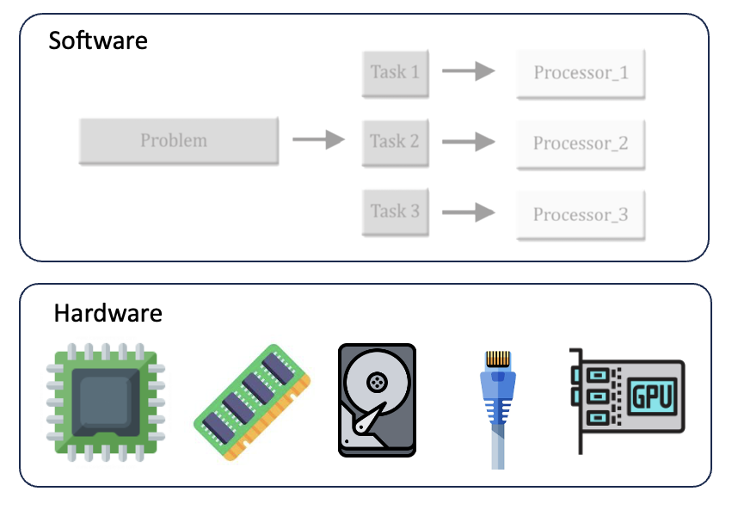

Please write a report of hardware specification for your Linux VM (at local or KSU cloud). The hardware information should include:

- CPU clock rate
- Number of CPU cores
- Number of Sockets
- Number of NUMA nodes
- CPU model name
- CPU topology ¹ (please draw a figure in your report)
- L1, L2, L3 cache size
- Memory size
- Current free memory
- Disk size
- Current utilization of the hard disk
- Network IP address
- Current Operating System name and version (open question)
- Current OS kernel version (open question)
- Machine hostname (open question)

1: Topology here means how many NUMA nodes the CPU has; on each NUMA node, how many sockets it has; on each socket, how many cores it has. For instance, if the processor has 2 NUMA nodes, and each NUMA node has 2 Sockets, and each Socket has two CPU cores, then its processor topology is as the following figure illustrates:

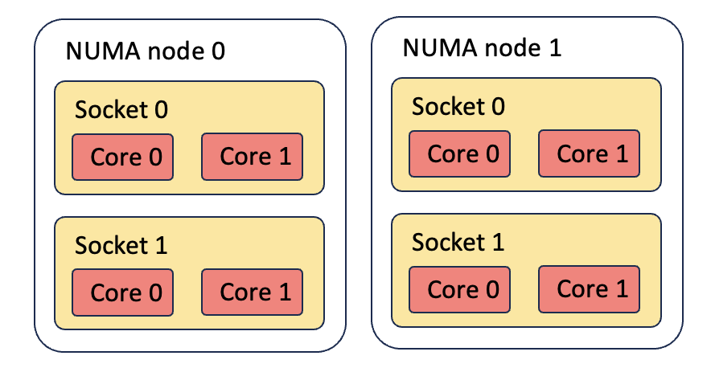

In your report, please also select the benchmarks to measure hardware specification for your VM. You can use any benchmarks you can find on the internet. The hardware information should include:

- CPU compressing or decompressing speed (using 7-Zip, you can compare it with Apple A12Z chip: https://www.7-cpu.com/)
- Memory bandwidth or speed
- Disk read speed
- Disk write speed
- Network latency to the Google server (www.google.com or 8.8.8.8)
- Network throughput

Submission

Submit your assignment pdf file named “Firstname_Lastname_Hardware.pdf” through D2L using the appropriate link. Please submit a report describe the details of your machine and the benchmarks and commands you are using.

