Kennesaw State University
CS 3502 Operating Systems
Project 1 - System call
Instructor: Kun Suo
Points Possible: 100
Difficulty: 

Part A: Build the Linux kernel (50 points)
--- Please work this part on the VMs you built on your own laptop

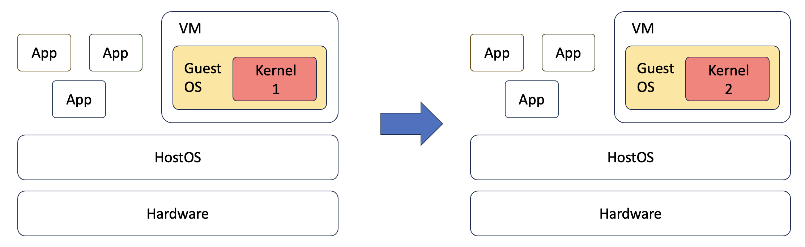

Create a virtual machine using VirtualBox or UTM (for Apple Silicon) on your laptop. As the kernel compiling is pretty large, please make sure your VM has at least 4GB memory and 80GB storage (if your disk is small, create a 60GB disk for the VM). For the Operating System, use Ubuntu 22.04 iso: https://releases.ubuntu.com/jammy/. There exist images for two architectures: x86 (e.g., Intel, AMD) and arm (e.g., Apple silicon). Please select the one that fits your machine.

How to build one Ubuntu VM?
Windows 10 (x86):
https://www.youtube.com/watch?v=QbmRXJJKsvs
MacOS (x86):
https://www.youtube.com/watch?v=GDoCrfPma2k&t=321s
MacOS (arm):
https://youtu.be/O19mv1pe76M?si=4cYayFiqPNoHoY1w

Step 1: Get the Linux kernel code
Before you download and compile the Linux kernel source, make sure you have development tools installed on your system. We recommend you work this project on your virtual machine.

In Ubuntu, install this software using apt:
$ sudo apt-get install -y gcc libncurses5-dev make wget flex bison vim libssl-dev libelf-dev

To obtain the version of your current kernel, type:
$ uname -r
5.15

For newer distributions of Ubuntu, you can see 5.x or 6.x. Please screenshot it and save it as the original kernel version.

Here is the screenshot of my current kernel:
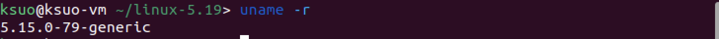

Then, download kernel 5.19 and extract the source:
$ wget https://cdn.kernel.org/pub/linux/kernel/v5.x/linux-5.19.tar.gz
$ tar xvzf linux-5.19.tar.gz

We will refer LINUX_SOURCE to the top directory of the kernel source. Go to the linux source code folder:
$ cd linux-5.19

Step 2: Configure your new kernel
Before compiling the new kernel, a .config file needs to be generated in the top directory of the kernel source. To generate the config file and make possible changes to the default kernel configurations, type:
$ make localmodconfig

For Y/N, select all “N” if any questions on the terminal to minimize the configuration file. All other selection, just select the default one. (There could be tens or even hundreds Y/N to choose, just be patient, here is sample on my side: https://youtu.be/hnROoXlTvcc?si=br2g1xb8iGESvx-S)

Here, we avoid using $ make menuconfig to save the kernel compiling time. You can check .config using the following command under kernel folder. (https://youtu.be/UyOGF4UOoR0)
$ ls -al

Here is a screenshot of my VM:
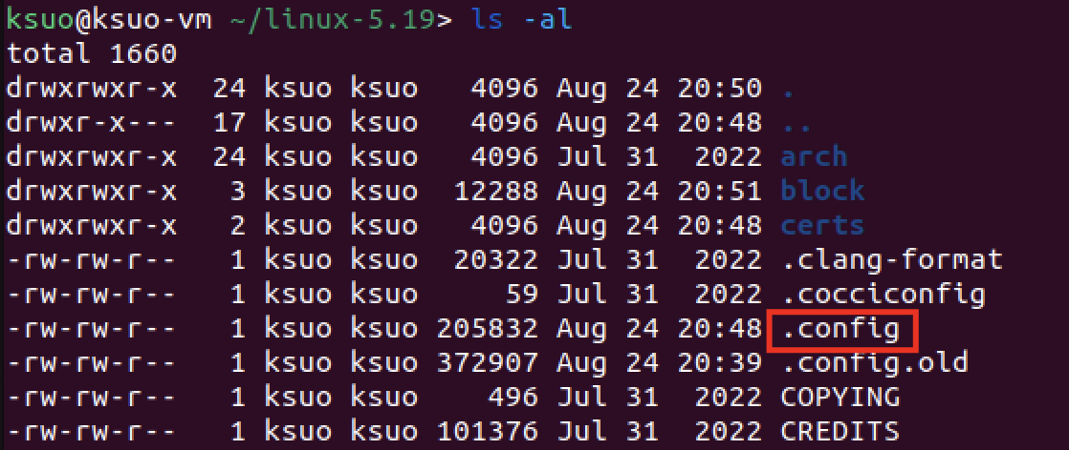

-------------------------------------------------[Possible Error] -------------------------------------------------
For some distributions of Ubuntu, you may see errors like this when compiling:
No rule to make target 'debian/canonical-certs.pem', needed by 'certs/x509_certificate_list'.

[Solution]
Edit the .config file and change the value of CONFIG_SYSTEM_TRUSTED_KEYS to null
$ vim .config

Before:
CONFIG_SYSTEM_TRUSTED_KEYRING=y
CONFIG_SYSTEM_TRUSTED_KEYS="debian/canonical-certs.pem"

After:
CONFIG_SYSTEM_TRUSTED_KEYRING=y
CONFIG_SYSTEM_TRUSTED_KEYS=""

If the CONFIG_SYSTEM_REVOCATION_KEYS="debian/canonical-revoked-certs.pem“ is not null, please also set it as null as:
CONFIG_SYSTEM_REVOCATION_KEYS=""

Then recompile the kernel using the make command.
-----------------------------------------------------------------------------------------------------------------------

Step 3: Compile the kernel
Please keep in mind that the compiling might take 0.5-1 hour, depending on your machine hardware specs and speed. For instance, in my 2021 Macbook, it takes about 20 mins.

In LINUX_SOURCE, compile to create a compressed kernel image:
$ make
If your VM has more than 1 core, we suggest you use "make -j N" to accelerate the compiling. Here, N denotes the number of CPUs on your VM.

To compile kernel modules:
$ make modules
You can use "make modules -j N" to accelerate the compiling. Here N denotes the number of CPUs on your VM.

Step 4: Install the kernel
Install kernel modules (become a root user, use the su command):
$ sudo make modules_install

Install the kernel:
$ sudo make install

If you are using Ubuntu, you need to create an init ramdisk manually:
$ sudo mkinitramfs -o /boot/initrd.img-5.19.0
$ sudo update-initramfs -c -k 5.19.0

The kernel image and other related files have been installed into the /boot directory. You can check it from /boot/grub/grub.cfg. Linux will boot by default using the 1st menu item.

Step 5: Modify grub configuration file
If you are using Ubuntu: change the grub configuration file:
$ sudo vim /etc/default/grub

Make the following changes:
GRUB_DEFAULT=0
GRUB_TIMEOUT=10

If your GRUB_HIDDEN_TIMEOUT_QUIET=true, change it to GRUB_HIDDEN_TIMEOUT_QUIET =false. If there is no GRUB_HIDDEN_TIMEOUT_QUIET, just ignore it.

If your GRUB_TIMEOUT_STYLE=hidden, change it to GRUB_TIMEOUT_STYLE=menu. If there is no GRUB_TIMEOUT_STYLE, just ignore it.

Then, update the grub entry:
$ sudo update-grub2

Step 6: Reboot your VM
Reboot to the new kernel:
$ sudo reboot

(If you are using university VM, ignore the following steps. It only works for local VM)
Immediately after the BIOS/UEFI splash screen during boot, with BIOS, quickly press and hold the Shift key, which will bring up the GNU GRUB menu. (If you see the Ubuntu logo, you've missed the point where you can enter the GRUB menu.)

Select the following option:
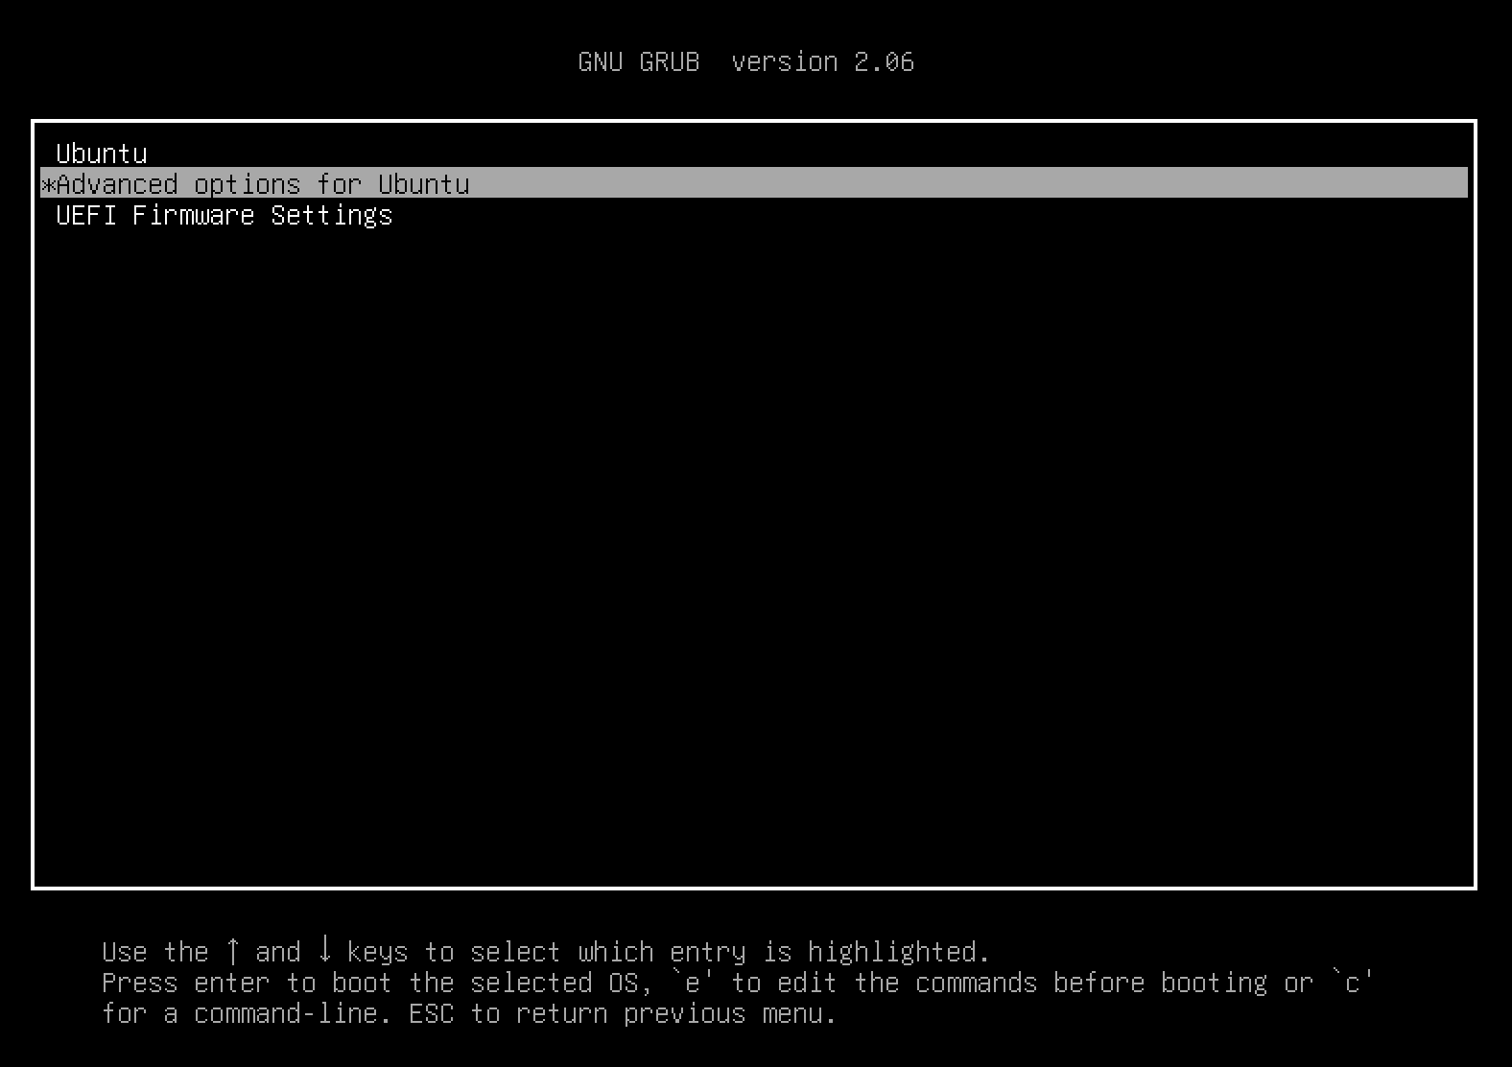

Under the Advanced options, you will see the old kernel and the new kernel:
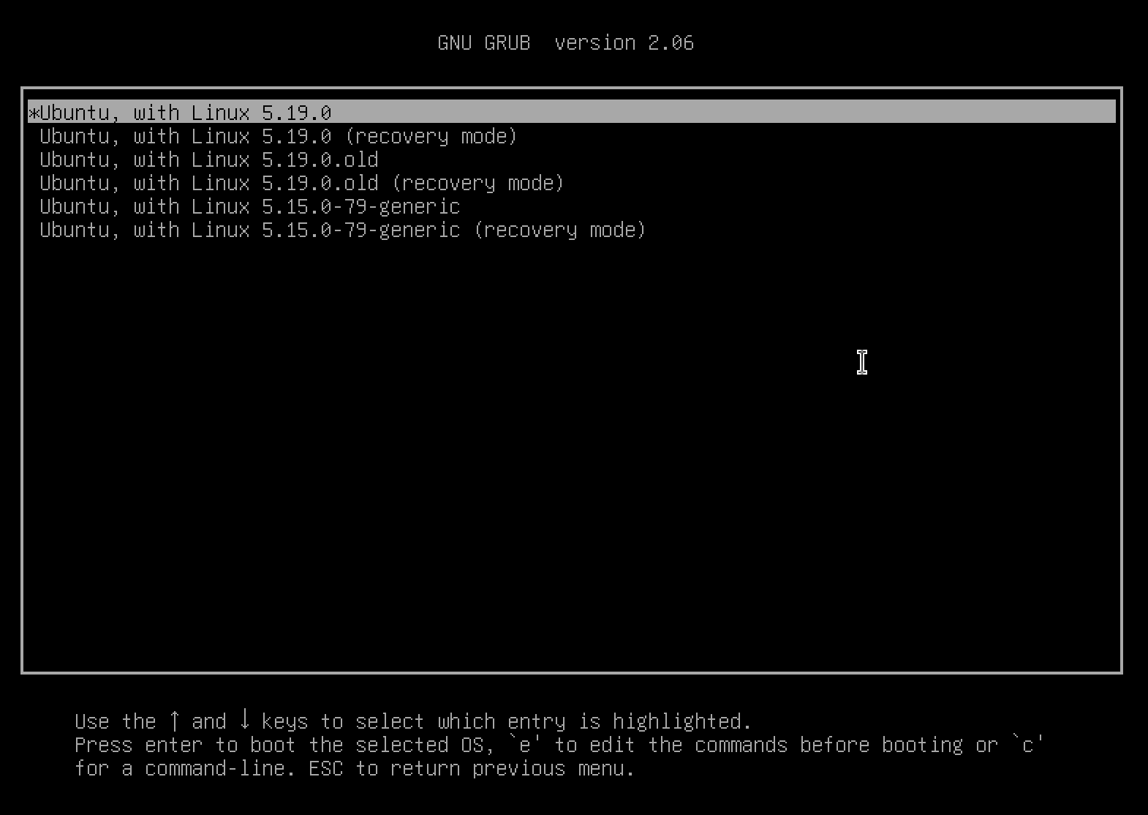

Select the new kernel and wait for a few seconds, you will enter the VM with new kernel:
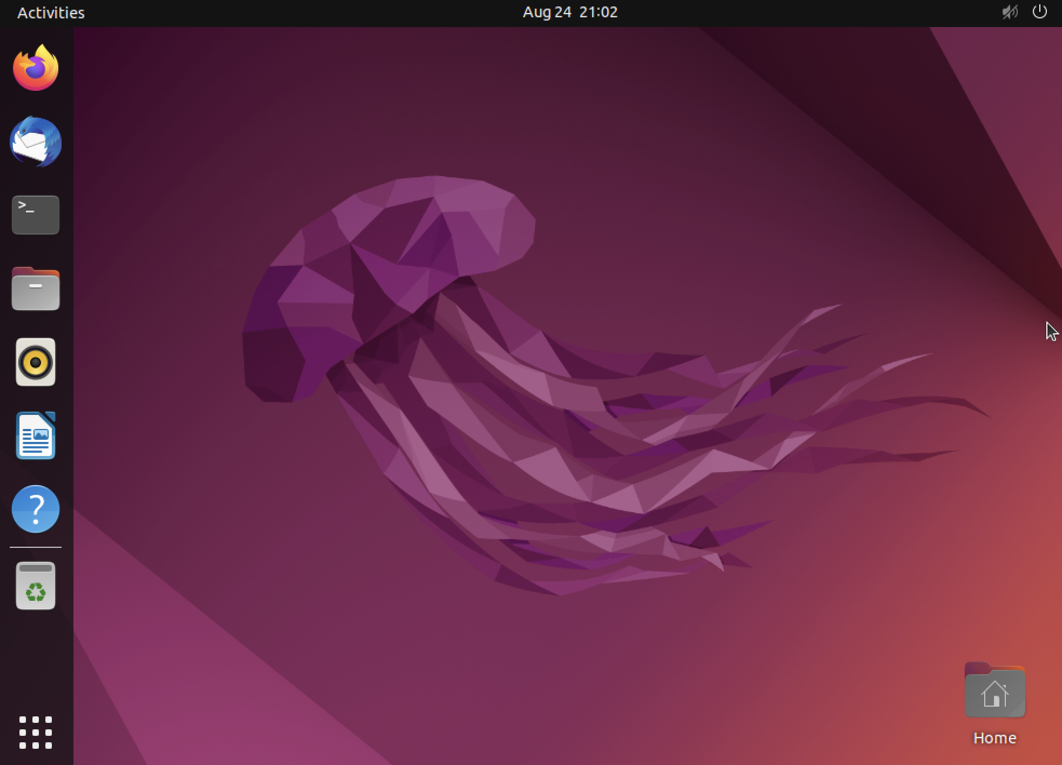

After boot, check if you have the new kernel:
$ uname -r
5.19.0
Here is the screenshot of my new kernel:

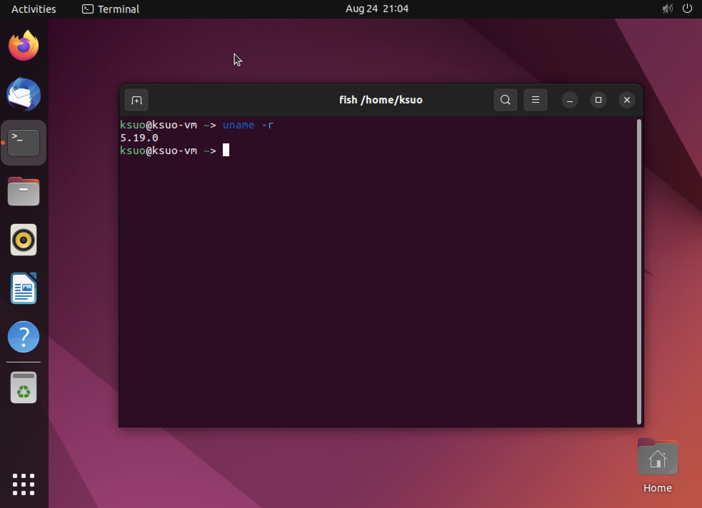

Submission of Part A:
Please submit a report with the screenshot of $uname -r in your old and new kernel.

Part B: Add a new system call into the Linux kernel (50 points)
--- Please work this part on VM in Part A (kernel version = 5.19)

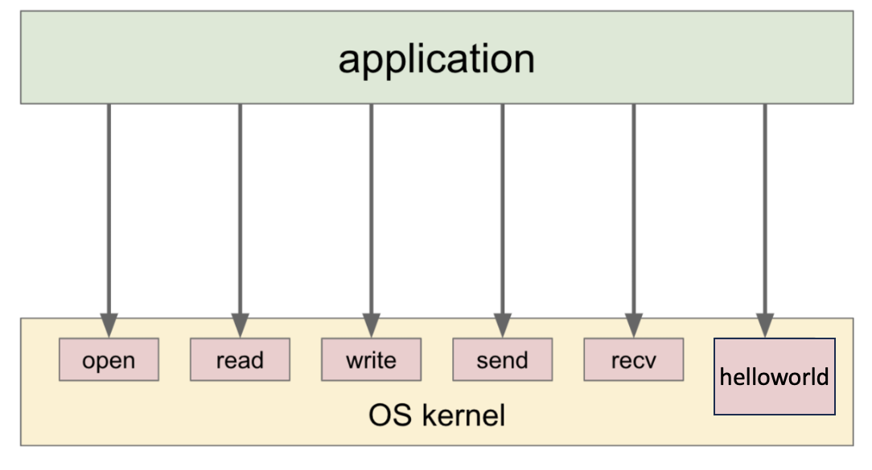

In this assignment, we add a simple system call helloworld to the Linux kernel. The system call prints out a hello world message to the syslog. You need to implement the system call in the kernel and write a user-level program to test your new system call.

If your system is x86 architecture, the following files are needed to modify:
File | Change
kernel/helloworld/helloworld.c | New — syscall implementation
kernel/helloworld/Makefile | New — build file
arch/x86/entry/syscalls/syscall_64.tbl | Added syscall entry
include/linux/syscalls.h | Added declaration
kernel/Makefile | Added helloworld/ to obj-y

Step 1: Add the System Call Implementation
Under Linux source code folder, create a new file for your syscall:
$ mkdir -p kernel/helloworld
$ cat > kernel/helloworld/helloworld.c << 'EOF'
#include <linux/kernel.h>
#include <linux/syscalls.h>

SYSCALL_DEFINE0(helloworld)
{
printk(KERN_INFO "Hello, World! from syscall\n");
return 0;
}
EOF

Create a Makefile for it:
$ cat > kernel/helloworld/Makefile << 'EOF'
obj-y := helloworld.o
EOF

Step 2: Register the Syscall in the Syscall Table
Edit the x86 syscall table:
$ nano arch/x86/entry/syscalls/syscall_64.tbl

Add your entry at the end of the common section. Find the last entry (around 450+) and add the following:
451 common helloworld sys_helloworld

Step 3: Declare the Syscall in the Header
$ nano include/linux/syscalls.h

Find the end of the file (before the last #endif) and add:
asmlinkage long sys_helloworld(void);

Step 4: Hook Into the Build System
Edit kernel/Makefile to include your new directory:
$ nano kernel/Makefile

Find the line starting with obj-y = (it's a long multi-line list). Add your directory at the end of that block:
obj-y += helloworld/

Repeat step 3 and 4 in PART A to re-compile, install the kernel and reboot to the new kernel.

Step 5: write a user-level program to test your system call
Go to your home directory and create a test program. Compile it and test the new system call by running.
$ cat > test_hello.c << 'EOF'
#include <stdio.h>
#include <unistd.h>
#include <sys/syscall.h>

#define SYS_helloworld 451 /* use the number you assigned */

int main() {
long ret = syscall(SYS_helloworld);
printf("syscall returned: %ld\n", ret);
return 0;
}
EOF

$ gcc -o test_hello test_hello.c
$ ./test_hello

Then check the kernel log:
$ sudo dmesg | grep "Hello, World"
# Expected: [ ... ] Hello, World! from syscall

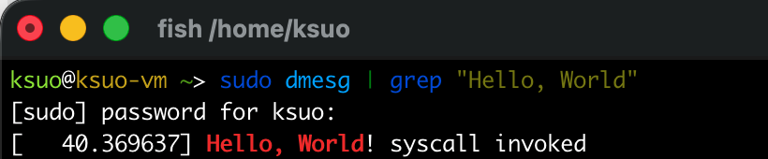

If your system is arm64 architecture (like Macbook Apple silicon), the following files are needed to modify:
File | Change
include/uapi/asm-generic/unistd.h | Add syscall number 451
include/linux/syscalls.h | Add prototype
kernel/helloworld.c | Implement the syscall
kernel/Makefile | Add helloworld.o to build

Step 1: Define the System Call Number
Edit the ARM64 syscall table:
$ vim arch/arm64/include/asm/unistd32.h
# for 32-bit compat (optional)

For 64-bit, open:
$ vim include/uapi/asm-generic/unistd.h

Find the last syscall entry (around __NR_syscalls) and add:
#define __NR_helloworld 451
__SYSCALL(__NR_helloworld, sys_helloworld)

Then update the count:
#undef __NR_syscalls
#define __NR_syscalls 452
Step 2: Add the ARM64-Specific Syscall Table Entry
$ vim arch/arm64/include/asm/unistd.h

Make sure this line exists (it usually does):
#define __NR_compat_syscalls 452

Step 3: Declare the System Call Prototype
$ vim include/linux/syscalls.h

Add near the end (before #endif):
asmlinkage long sys_helloworld(void);

Step 4: Implement the System Call
Create a new file or add to an existing one. The cleanest approach is a new file:
$ vim kernel/helloworld.c

#include <linux/kernel.h>
#include <linux/syscalls.h>

SYSCALL_DEFINE0(helloworld)
{
printk(KERN_INFO "Hello, World! syscall invoked\n");
return 0;
}

Step 5: Register the File in the Build System
$ vim kernel/Makefile

Find the obj-y line and add your file:
obj-y += helloworld.o

Repeat step 3 and 4 in PART A to re-compile, install the kernel and reboot to the new kernel.

Step 6: Test the System Call
Write a small C test program:

#include <stdio.h>
#include <unistd.h>
#include <sys/syscall.h>

#define __NR_helloworld 451

int main() {
long ret = syscall(__NR_helloworld);
printf("syscall returned: %ld\n", ret);
return 0;
}

Compile and run:
$ gcc -o test_hello test_hello.c
./test_hello

Check the kernel log:
$ sudo dmesg | grep "Hello, World"

Submission of Part B:

Please update the system call above so that your system call message will print out “Here is my syscall in the OS kernel by [Your Name]!”. Then, submit a report with the screenshot of $ dmesg | grep “by Your name”.

For instance, a student named Sisi should upload a screenshot like:

Please submit your report with all screenshots required in part A & B.

