Kennesaw State University

College of Computing and Software Engineering Department of Computer Science Mathematical Structures for Computer Science
CS5070 Assignment 2
- Find the truth value of the logical expression:
P(A ∪ B) = P(A) ∪ P(B)
- With sets A = {3,4}, B = {x,y,z}, C = {a,b}, write the Cartesian product A × B × C.
- With set B = {1,2,2,4,5,6,7}, write the power set of B.
- (a) Write the set expression for all even integer numbers greater than 26 and less than 50.
(b) Determine the cardinality of the set
- With set A = {1,2,3,4,5,6,7}, Find all sets B ∈ P(A) that have the property {2,3,5} ⊆ B.
- Given A₂ the set of all multiples of 2 except for 2 and A₃ the set of all multiples of 3 except for 3, and so on, so that A_{n} is the set of all multiples of n except for n, for any n ≥ 2. Describe (in words) the set
$$\overline{A_{2}∪A_{3}∪A_{4}∪…}$$

Hint: It might help to think about what the union A₂ ∪ A₃ is first. Then think about what numbers are not in that union. What will happen when you also include A₅ ?
- The following functions all have domain {1,2,3,4,5} and codomain {1,2,3}. For each, determine whether it is (only) injective, (only) surjective, bijective, or neither injective or surjective.
(a)
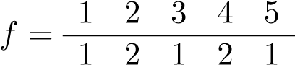
(b)
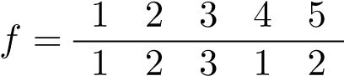
(c)
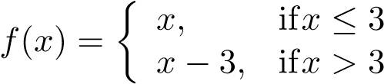
- Suppose f: N → N satisfies the recurrence f(n + 1) = f(n) + 3. For each of the initial conditions below, find the value of f(5).
  - f(0) = 0
  - f(0) = 1
  - f(0) = 2
  - f(0) = 100
2

