1. Download and install Launch4j from <http://launch4j.sourceforge.net/>.
2. Create the jar files using ant build *(build.xml in the DiffusedCloudStorage project)*.
   1. Use the entry “**dist.client.pvfs.eldosx86**” and/or “**dist.client.pvfs.eldosx64**”

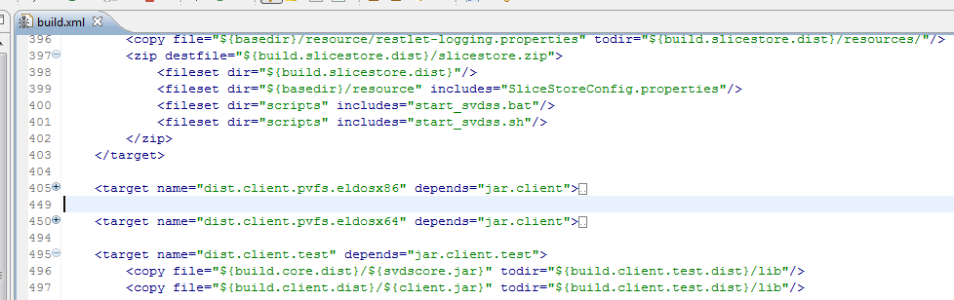

Fig 1 Ant build confirguration XML

1. Start the Launch4j application.
2. Open the “**launch4j_pvfs_eldos.xml**” configuration file *(located in the scripts folder of the DiffusedCloudStorage project)*.
3. Under the “Basic” tab *(See Fig 2)*:
   1. Change the path of the output file entry to the folder where the jar files are created using the ant build (E.g … DiffusedCloudStorage\build\client\dist).
   2. The name of the output file (*.exe) can be changed if needed.
   3. Ensure the checkbox “Don’t wrap the jar, launch only” is checked.

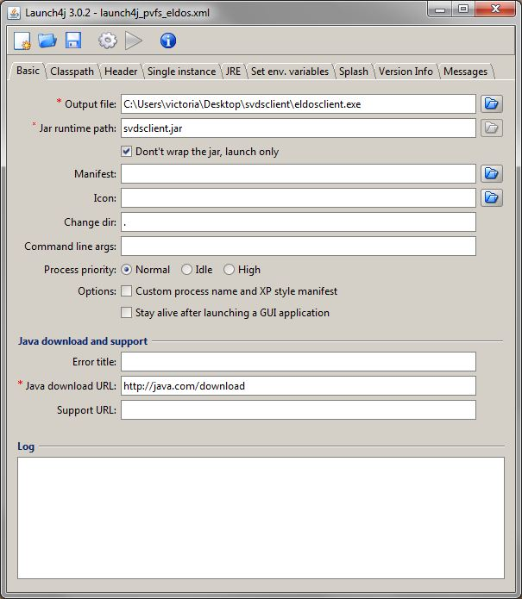

Fig 2 Launch4j basic settings

1. Under the “Classpath” tab *(See Fig 3)*:
   1. Ensure the checkbox “Custom classpath” is checked.
   2. Add/remove required libraries (relative path) in the classpath listbox.

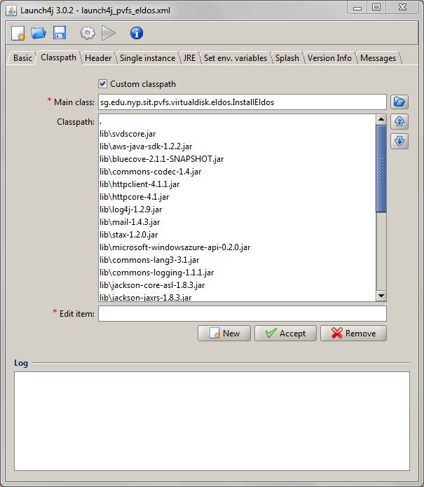

Fig 3 Launch4j classpath settings

1. Under the “JRE” tab *(See Fig 4)*:
   1. The min JRE version has to be set.
   2. The “-Djava.library.path” has to be set in the JVM options due to eldos library “jnicbfs.dll”.

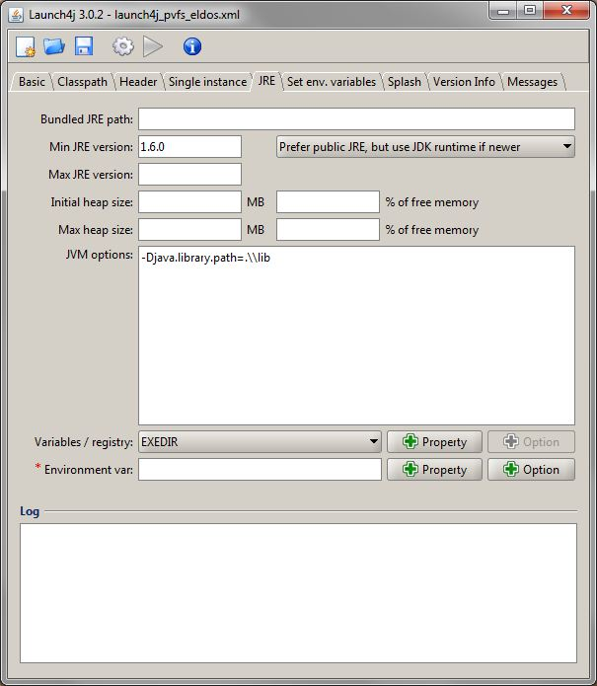

Fig 4 Launch4j JRE settings

1. Click on the build wrapper icon . The installer will be created in the path specified in the output file entry under basic settings tab.