1.4

1. event: change in voltage such as 1 to 0 or 0 to 1

2. pulse: signal portion from rising to falling

3. arrow indicate input event triggered causing output change

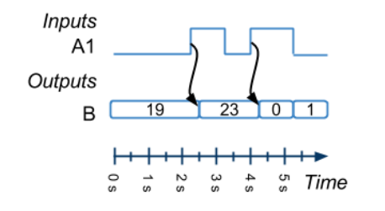

B is a integer output not a Boolean so

If no arrow saying triggered, the change is coincident. At 5s 0 to 1

4. trace statement: printf in RIMS to see the output value

5. since there are too many combination, should test the extreme case

**RIMS**

unsigned char: 8 bits (decimal range: 0 to 255)

unsigned short: 16 bits (decimal range: 0 to 65,535)

unsigned long: 32 bits (decimal range: 0 to 4,294,967,295)

Break: pause the program

Step: watch the next pulse

Test vectors: more like psudo code for programmer

Generate time graph: the process during the run

signed char: 8 bits (decimal range: -128 to 127)

signed short: 16 bits (decimal range: -32,768 to 32,767)

signed long: 32 bits (decimal range: -2,147,483,648 to 2,147,483,647)

if input is overflow, the output can be wrong

float: 32 bits (typical) (range: 3.4x10-38 to 3.4*1038)

double: 64 bits (typical) (range: 1.7x10-308 to 1.7*10308)

ch2

1. if just checking B0 is 1, don't use B ==0x01 because it is only true if other pin are 0s

2. set B to A but with B1 and B0 force to 1s : B = A | 0x03 ( masking, aka filter)

0 & x : used to set a particular bit to 0

1 | x : used to set a particular bit to 1

0 | x : used to pass a bit through unchanged

3. (A == 0xF) check if A3 A2 A1 A0 are 1, and A7 A6 A5 A4 are 0s (not just A3 through A0)

4. (b ? x | (0x01 << k) : x & ~(0x01 << k));

if (b ==true)

{

x | (0x01 << k)

}

else

{

x & ~(0x01 << k);

}