Yun: package manager in centos

* Yum update
  + update all packages
* Yum upgrade
  + update all packages and delete obsolete packages(risky)

Shell script: <http://www.panix.com/~elflord/unix/bash-tute.html>

* # is ignore bt shell
* Variable:
  + $USER
    - Show Username
  + $PWD
    - - show directories
  + We can define variable
    - x = “hello”
    - Use it
      * $x
  + Echo
    - echo "\$USER=$USER"
      * $USER=ktsai017
        + # USER= ktsai017
        + \ is used to tell bash to cancel first $ sign
    - -n
      * Don’t go to next line
  + In If condition [ ]
    - operand1<space>operator<space>operand2
      * Need space to distinguish operator
      * Need space [] such as [spcace3space-ltspace3space]
    - -n
      * [ -n $x]
        + Check if x is non-empty
    - -lt: less than
      * [$X -lt $Y]
        + Is X less than Y
    - -e: if it exit
      * if [ -e "${HOME}/.fvwmrc" ]; then # test to see if ~/.fvwmrc exists
        + echo "you have a .fvwmrc file"
      * if [ -L "${HOME}/.fvwmrc" ]; then # is it a symlink ?
      * echo "it's a symbolic link
      * elif [ -f "${HOME}/.fvwmrc" ]; then # is it a regular file ?
      * echo "it's a regular file"
      * fi
    - 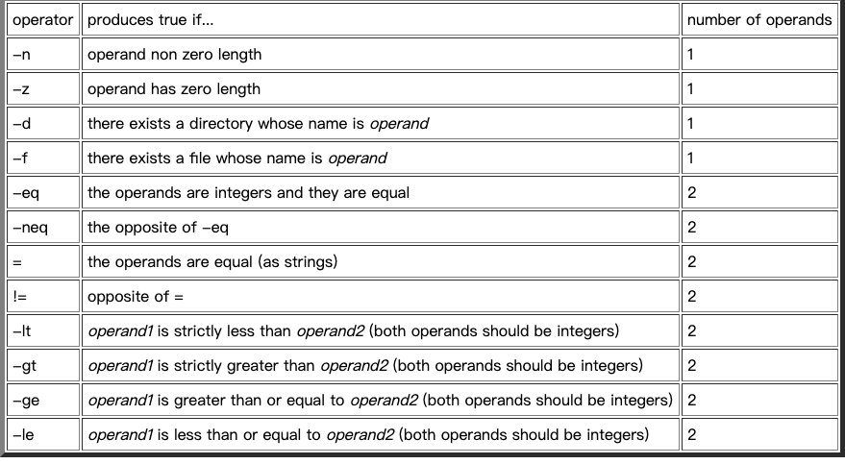
  + Expansion in action
    - LS="ls"
    - LS_FLAGS="-al"
    - $LS $LS_FLAGS $HOME
      * ls -al /home/elflord
  + Protect data with brace
    - X=ABC
    - echo "${X}abc"
      * #ABCabc
  + If else condition
    - Always end with fi
  + For loop
    - #!/bin/bash
    - colour1="red"
    - colour2="light blue"
    - colour3="dark green"
    - for X in "$colour1" $colour2" $colour3"
    - do
    - echo $X
    - Done
    - echo * #lists all the files and directories in the current directory
    - echo *.jpg #lists all the jpeg files.
    - echo ${HOME}/public_html/*.jpg #lists all jpeg files in your public_html #directory.
    - #!/bin/bash
    - X=0
    - while [ $X -le 20 ]
    - do
    - echo $X
    - X=$((X+1))
    - done

Chmod777:

User group others

* Made of binary
  + 111 111 111
  + Rwx rwx rwx
    - S: setu bit, not execute
* Chmod754 -r /dir/this/
  + Give this permission to the diectory

**Part1.**

* Yum install kernel-devel
* Go to directories /usr/src/kernels
* Man grep: check the explaination grep
* Find:
  + Find -type f
    - Find file
  + Find -type d
    - Find directories
  + Find -name *.h
    - Find any filenames that is .h at the end
* Grep
* grep -ir --include=*.h "magic" . | wc -l
  + -i
    - Ignore case sensitive
  + -r
    - Do it recursive for every file
  + --include
    - Only include filename that contain.h
  + .
    - Current directories
  + |
    - It takes the output of grep as input of wc
  + Wc
    - Word count
    - -l
      * Count by line

**Part2:**

part3:

* use -e to check if file exist
  + save log file with if else statement
    - need to replace old statement
* use some autorobot to run script periodically
* <http://linux.vbird.org/linux_basic/0430cron.php>
* 