Lab 7

This lab is to help learn about TCP congestion control and how TCP behaves under loss conditions. We shall first send traffic between two hosts with no loss while taking Wireshark traces. We shall then repeat the experiment with loss introduced between the two nodes. The graphs generated by these two files will then be used to answer the questions at the end of the lab.

- Login to mininet
- Check the version of TCP congestion control algorithm running on mininet by running the following command
cat /proc/sys/net/ipv4/tcp_congestion_control

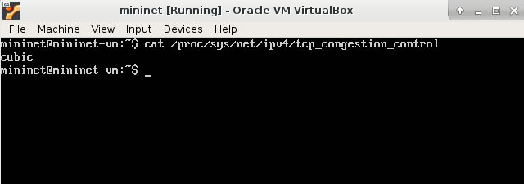

- Confirm the ip address being used by mininet using
ifconfig -a

- Open Wireshark (refer to lab 2 for details)
NOTE: If you have re-installed mininet since lab 1 you may have to run the following commands in mininet to get Wireshark working again
    - sudo dpkg-reconfigure Wireshark-common
    - sudo usermod -a -G Wireshark mininet
    - Log out of mininet and log in again

- First run the experiment with no loss. Open 2 mininet terminals using ssh -X -p 2222 mininet@localhost

- Start a Wireshark trace

- In one terminal run the following command: iperf -s

- In the second terminal run the following command and wait for 60s for the command to complete:
iperf -c localhost -t 60

- Stop the Wireshark trace and save the file

- Now run the experiment with loss. Open two more mininet terminals (so you have a total of 4 terminals including the mininet login terminal)

- Start a new Wireshark trace

- In one terminal run the command iperf -s

- In the second terminal run the following command: iperf -c localhost -t 60

- After approximately 10s run the following command in the third window to simulate loss 70% loss
sudo tc qdisc add dev eth0 root netem loss 70%

- You can check the loss has been configured by using
sudo tc qdisc show dev eth0

- In the last window (which had the mininet login) after an additional 15s, run the command below to stop the loss. Please use this specific terminal for deleting the loss setting because once you set the high loss the other terminals which are connected via ssh (through eth0) will experience loss and may appear to freeze preventing you from sending any commands on those terminals.
sudo tc qdisc del dev eth0 root

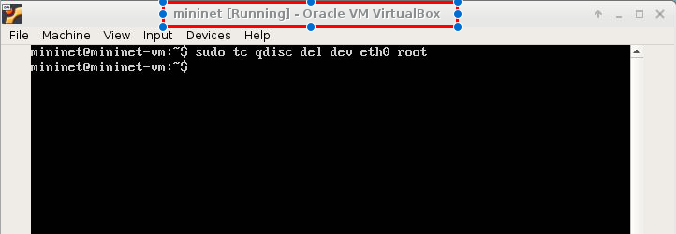

The screenshot illustrates the 4 open windows

- Wait for the iperf -c localhost -t 60 to complete

- Stop the Wireshark trace and save the file.

- Transfer both files to the local machine using scp
scp file.pcap username@wch129-04:

- On the local machine, open Wireshark and open the first file. Filter out tcp traffic using the filter tcp.

- Select the first packet where the source IP is the mininet IP address obtained in step 3.

- Select Statistics->TCP Stream Analysis and look at the different graphs available.
- Generate a Time Sequence (Stevens) and Time Sequence (tcptrace) graph and save each graph

- To save the image you will need to take a screen shot. You can maximize the image and use Cntrl+Fn+PrntScreen to copy the image, then post the image in Libre Office Draw using Cntrl+V or take a picture with your phone.

Questions
- Copy your Time Sequence Graphs into a file for both the loss and no loss cases and label them appropriately

No Loss
- On the time-sequence graph (tcp trace) with no loss, identify the regions of slow start and congestion avoidance.
- Estimate the largest observed congestion window size

Loss
- On the time-sequence graph in the loss case, identify the region where the loss started
- Identify areas where slow start and congestion avoidance was used.
- Did you see any occurrence of fast recovery? If so, did it affect the congestion window?
- Estimate the largest observed congestion window size.
- Is there a difference in throughput for the case with loss and no loss.

