after changing the default DNS

* kai.cs164 should server should be 127.0.0.1 instead of localhost

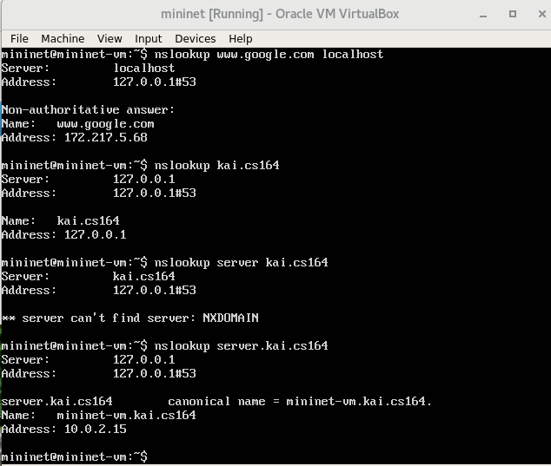

canonical name is the server name

everytime restart mininet, the default DNS change back

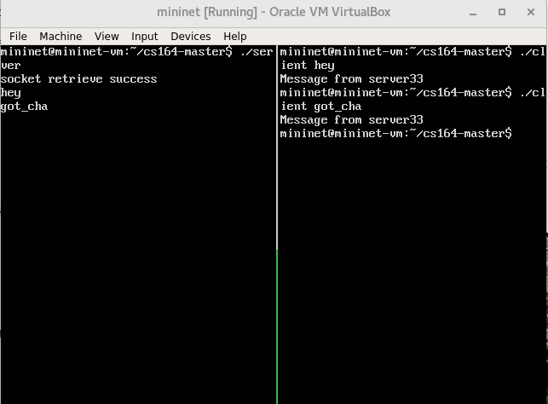

make sure to change default DNS before running client.c because it now read from DNS server server.kai.cs164