**Kai Wen Tsai**

**ktsai017**

**861261944**

**Copy file from mininet to localhost**

* **scp lab_7_wireshark1.pcapng** [**ktsai017@wch132-20.cs.ucr.edu**](mailto:ktsai017@wch132-20.cs.ucr.edu)**:/extra/ktsai017**

without loss:

slow starts from : 0-2.5s

congestion: is from: 2.5s - 58s

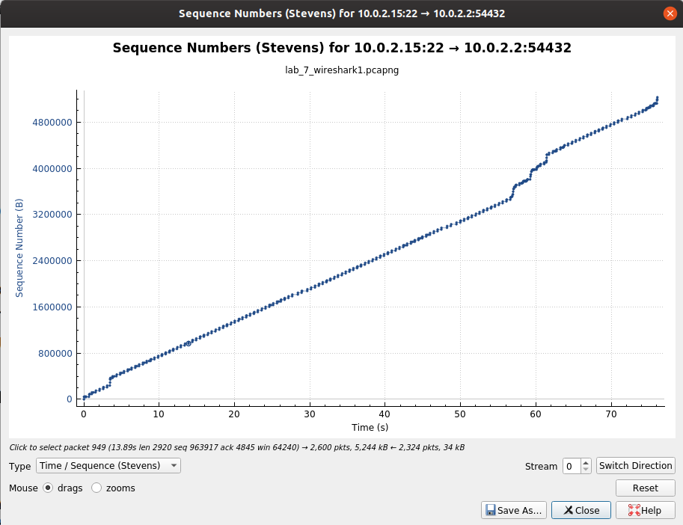

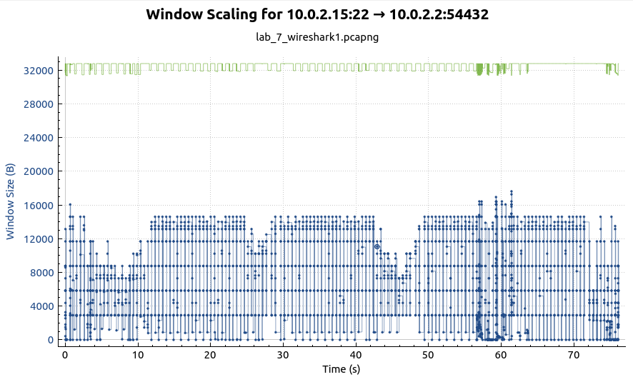

largest windows size: around 18000

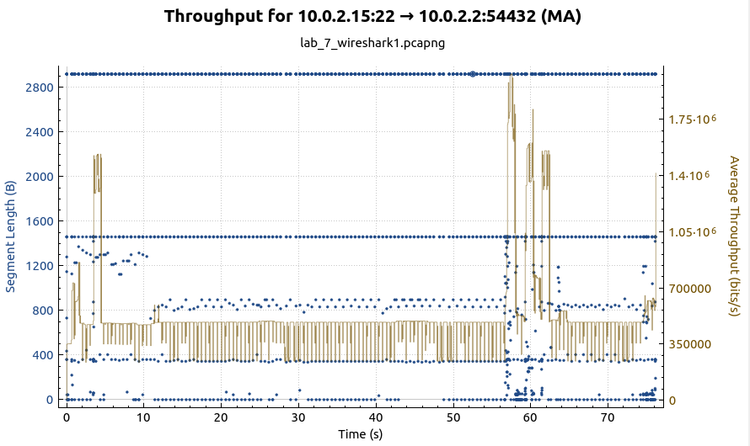

With loss:

slow start: 30-32s

avoidance: 32-66s

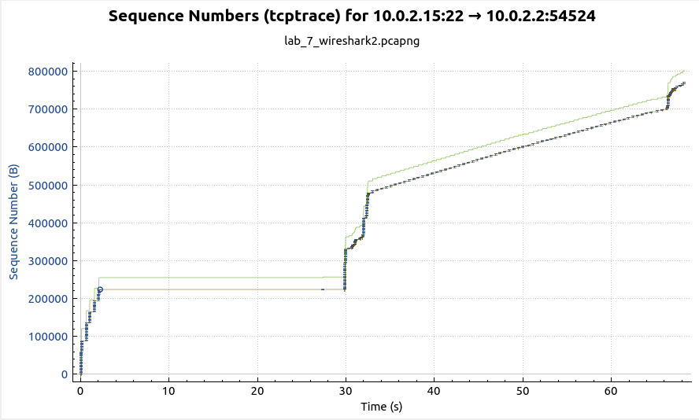

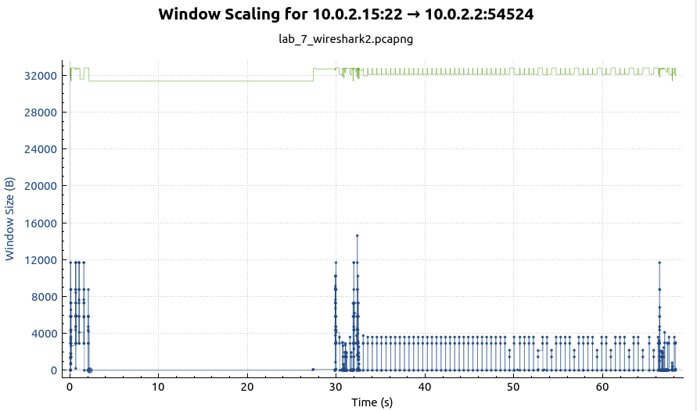

largest window size: around 15000

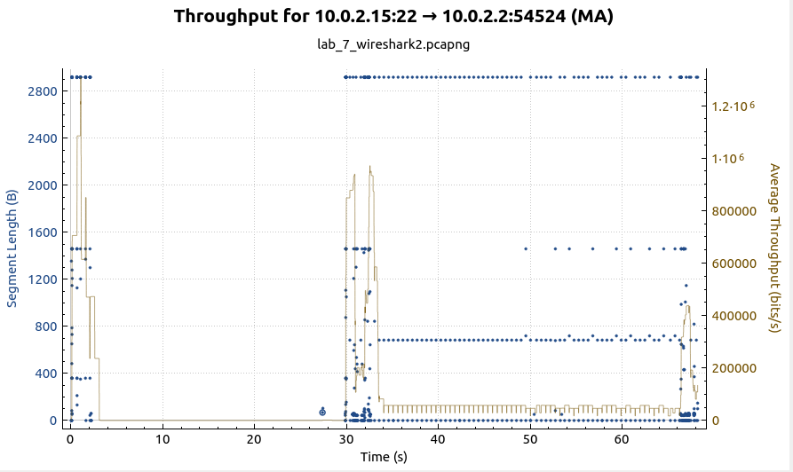

we can see that in no loss case the average throughput would be higher than loss case