Web API
Description
API stands for Application Programming Interface which is a software intermediary that allows two applications to talk to each other. Each time you use an app like Facebook, send an instant message, or check the weather on your phone, you're using an API.
- It can extend the functionality of the browser
- It can greatly simplify complex functions
- It can provide easy syntax to complex code

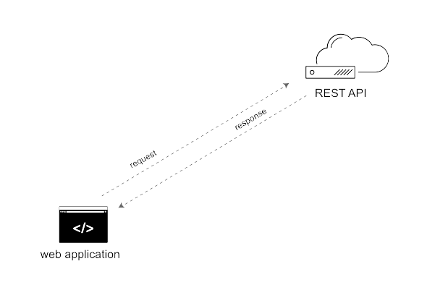

Feature highlights:
- Easy-to-use REST client
- Offer rich interface
- Provide many integrations like support for Swagger
- Run, test, document, and monitoring features

Create and Consume Simple REST API in PHP
What is REST?
REST stands for Representational State Transfer, REST is an architectural style which defines a set of constraints for developing and consuming web services through standard protocol (HTTP). REST API is a simple, easy to implement and stateless web service. There is another web service available which is SOAP which stands for Simple Object Access Protocol which is created by Microsoft.

REST API is widely used in web and mobile applications as compared to SOAP.
REST can provide output data in multiple formats such as JavaScript Object Notation (JSON), Extensible Markup Language (XML), Command Separated Value (CSV) and many others while SOAP described output in Web Services Description Language (WSDL).

How Does REST API Work
REST requests are related to CRUD operations (Create, Read, Update, Delete) in database, REST uses GET, POST, PUT and DELETE requests. Let me compare them with CRUD.

- GET is used to retrieve information which is similar to Read
- POST is used to create new record which is similar to Create
- PUT is used to update record which is similar to Update
- DELETE is used to delete record which is similar to Delete

3. Create a REST API File
Create a api.php file and paste the following script in it.
<?php
header("Content-Type:application/json");
if (isset($_GET['order_id']) && $_GET['order_id']!="") {
include('db.php');
$order_id = $_GET['order_id'];
$result = mysqli_query(
$con,
"SELECT * FROM `transactions` WHERE order_id=$order_id");
if(mysqli_num_rows($result)>0){
$row = mysqli_fetch_array($result);
$amount = $row['amount'];
$response_code = $row['response_code'];
$response_desc = $row['response_desc'];
response($order_id, $amount, $response_code,$response_desc);
mysqli_close($con);
}else{
response(NULL, NULL, 200,"No Record Found");
}
}else{
response(NULL, NULL, 400,"Invalid Request");
}

function response($order_id,$amount,$response_code,$response_desc){
$response['order_id'] = $order_id;
$response['amount'] = $amount;
$response['response_code'] = $response_code;
$response['response_desc'] = $response_desc;
$json_response = json_encode($response);
echo $json_response;
} ?>
The above script will accept the GET request and return output in the JSON format.

I have created all these files in folder name rest, now you can get the transaction information by browsing the following URL.
http://localhost/rest/api.php?order_id=15478959
You will get the following output.
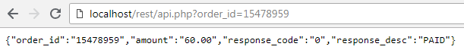

Above URL is not user friendly, therefore we will rewrite URL through the .htaccess file, copy paste the following rule in .htaccess file.

RewriteEngine On # Turn on the rewriting engine
RewriteRule ^api/([0-9a-zA-Z_-]*)$ api.php?order_id=$1 [NC,L]

Now you can get the transaction information by browsing the following URL.

http://localhost/rest/api/15478959
You will get the following output.

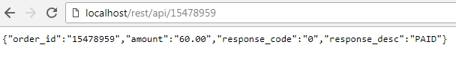

Top API Testing Tools (REST API Test Tools)
#1) ReadyAPI
#2) ACCELQ
#3) Katalon Studio
#4) Postman
#5) REST-Assured
#6) Swagger.io
#7) JMeter
#8) Karate DSL
#9) Airborne
#10) Pyresttest
#11) Apigee
More details on this link:
https://www.softwaretestinghelp.com/api-testing-tools/

Postman
Postman is an Application Programming Interface (API) testing tool. This tutorial shall provide you with a detailed understanding on Postman and its salient features. The tutorial contains a good amount of examples on all important topics in Postman

Postman – Authorization
In Postman, authorization is done to verify the eligibility of a user to access a resource in the server. There could be multiple APIs in a project, but their access can be restricted only for certain authorized users.

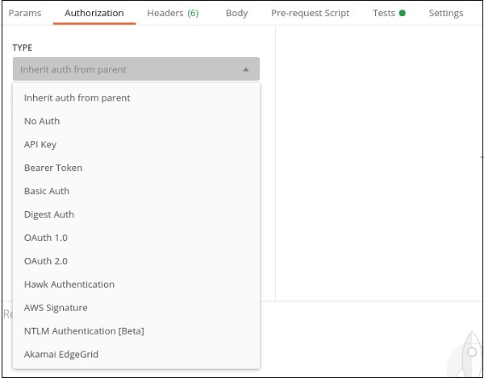

Using the pre-built requests from the collection
Edit a POST request
When editing a POST request, open the request and navigate to the Body section in the request editor. For readability, select the raw radio button to format the JSON request body.
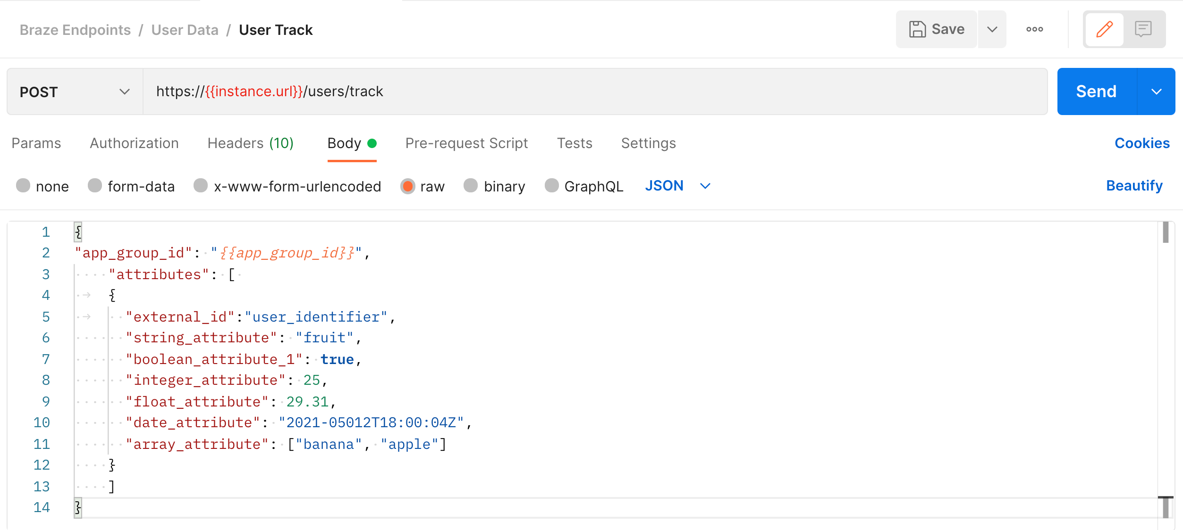

Edit a GET request
When editing a GET request, edit the parameters passed in the request URL. To do so, select the Params tab and edit the key-value pairs in the fields that appear.
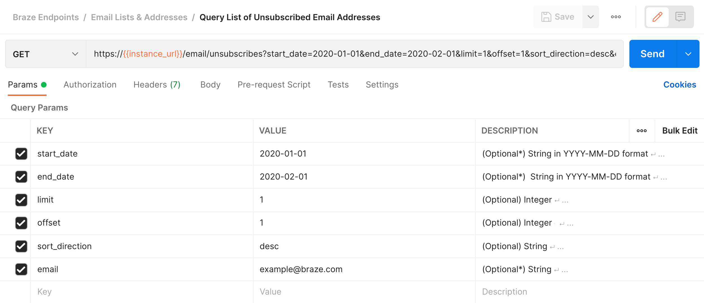
Postman - PUT Requests
A Postman PUT request is used to pass data to the server for creation or modification of a resource. The difference between POST and PUT is that POST request is not idempotent.

Send your request:
Once your API request is ready, click Send. The request sends and the response data populates in a section underneath the request editor. From here, you can view the raw data returned from Braze’s API, see the HTTP response code, see how long the request took to process, and view header information.

Reference Link: -
- https://www.tutorialspoint.com/postman/postman_environment_variables.htm
- https://code.tutsplus.com/tutorials/how-to-build-a-simple-rest-api-in-php--cms-37000
- https://www.phpzag.com/how-to-create-simple-rest-api-in-php/
- https://www.postman.com/gold-shadow-8959/workspace/demo/request/9419210-96919f48-0b00-4f84-847b-fe2a1b26bcd2

