**Nathan:**

<http://embedjournal.com/make-a-rc-robot-car/>

<http://machinedesign.com/archive/shake-hands-robot> ( 3 finger gripper design example)

<https://www.element14.com/community/community/raspberry-pi/blog/2015/04/21/raspberry-pi-2-fun-with-i2c-dacs-and-adcs> (Raspberry Pi ADC/DAC)

<http://www.geeks3d.com/20150327/meet-the-raspberry-pi-gpio-connector/#26pin> (raspberry pi 2 limits)

<https://www.raspberrypi.org/help/faqs/> ( raspberry pi 2 FAQ, can be used to look up for the power supply and current limits)

<http://www.mosaic-industries.com/embedded-systems/microcontroller-projects/raspberry-pi/gpio-pin-electrical-specifications> (GPIO electrical specification)

**Michael:**

Complete Tutorial: https://www.youtube.com/watch?v=L1Kgm4S8c90&index=3&list=LL6kNO5jEaX5chTpLS0OkYQQ

https://www.youtube.com/watch?v=LhSFHuK2EXU

Info: <https://www.youtube.com/watch?v=GPjS0SBtHwY>

Sample and Hold Circuit:<http://www.asdlib.org/onlineArticles/elabware/Scheeline_ADC/ADC_ADC_SandH.html>

<http://forum.allaboutcircuits.com/attachments/s-h-png.23465/>

Parts List

<http://engineering.tamu.edu/media/2196643/eic-electronic-inventory-2015.pdf>

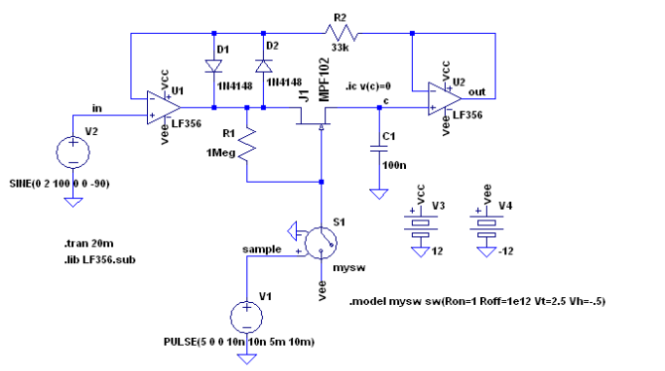

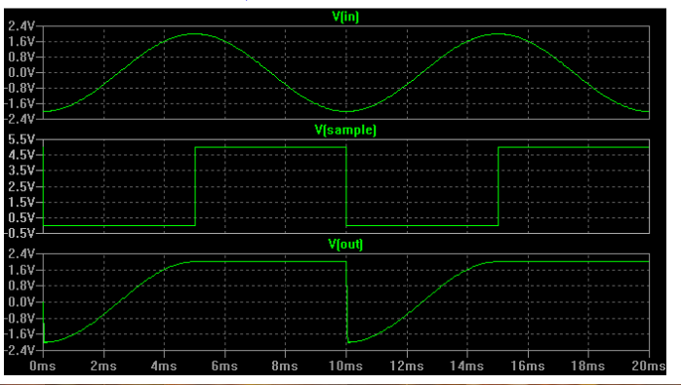

**Fuhua:**

<http://www.amazon.com/Panda-Wireless-PAU06-300Mbps-Adapter/dp/B00JDVRCI0>

youtube: <https://www.youtube.com/watch?v=7X53_QCXbjk> ADC tutorial

<http://www.circuitsgallery.com/2011/12/what-is-analog-to-digital-converter-adc_25.html>

<https://www.youtube.com/watch?v=vJ8V8ipSZ50>

ADC DAC <http://www.robotshop.com/en/raspberry-pi-high-precision-ad-da-expansion-board.html?gclid=CK_6ifD0m8sCFQqKaQod0yAD3w>

RF Module:

# **nRF24L01 Module**

<https://www.sparkfun.com/datasheets/Components/SMD/nRF24L01Pluss_Preliminary_Product_Specification_v1_0.pdf>

Analog to PWM coding

<https://github.com/CurtisIreland/electronics/tree/master/RPi-Analog>

Important link tutorial link

<http://www.waveshare.com/wiki/High-Precision_AD/DA_Board>

**Kevin:**

<http://www.seas.upenn.edu/~ese206/labs/adc206/adc206.html>

expansion board

<http://www.amazon.com/gp/product/B017GUVPAK?psc=1&redirect=true&ref_=oh_aui_detailpage_o01_s00>

<http://www.societyofrobots.com/electronics_negative_voltages.shtml>

<http://elinux.org/RPi_Low-level_peripherals#Model_A.2B.2C_B.2B_and_B2>

<https://learn.adafruit.com/introducing-the-raspberry-pi-model-b-plus-plus-differences-vs-model-b/power-supply>

<https://www.raspberrypi.org/forums/viewtopic.php?f=28&t=40150>

<http://www.utm.edu/staff/leeb/LM301.pdf>

<http://www.ti.com/lit/an/sloa097/sloa097.pdf>

PWM OUTPUT

<http://www.instructables.com/id/Arduino-RC-Circuit-PWM-to-analog-DC/?ALLSTEPS>

<http://www.instructables.com/id/Analog-Output-Convert-PWM-to-Voltage/>

<http://ww1.microchip.com/downloads/en/AppNotes/00538c.pdf>

Minilab stuff:

Voltage Regulator

<https://www.adafruit.com/products/2165>

<https://www.sparkfun.com/products/526>

2x20 Female Header

https://www.adafruit.com/products/2222

Terminals:

<http://www.digikey.com/product-detail/en/OSTTA044163/ED2582-ND/614531>

Op Amp

<http://www.analog.com/en/products/amplifiers/operational-amplifiers/general-purpose-amplifiers/ad8541.html#product-overview>