February 12, 2019

PROJECT PROPOSAL

CSIS 3300

GROUP MEMBERS

TSAN THANH TAI – 300272880

Yan Cheng Ren – 300179993

PEDRAM Milani – 300200168

SUBMIT TO

Instructor: Xiaoqiang Ma

# PROJECT PROPOSAL

Creating a Guessing game base on the drawing from other users.

## goal

Create a game application that is fun, self- explained, dynamic for multiple users to describe words through the images that other user draw by utilizing the relational database to effectively retrieving and storing data.

## requirements

External

* Application’s input:
  + User Name
  + Password
  + Game mode (Guess or Draw)
  + For each mode, there will be Difficulty level and Category that allows users to select
* Application’s output:
  + For drawing mode, users will see their drew images and the successful guesses on the total guess.
  + For Guessing mode, users will see an image to guess, and the successful guesses on the total guess of that word.

Internal

* The Database
  + User information – User name, password, current level and their EXP, their turn position, ...
  + Contains information such as words to be generated by the application
  + Save the picture that is drew by the users.
* The Client Side
  + Login as a player or sign up for those who don’t have an account.
  + Will guess the word that is described through the image – if their drawing turn not yet come.
  + Choose to draw or ignore the turn when their turn comes
* The Server Side
  + Wipe the image when the turn is over.
  + Timing period for drawing and guessing
  + Generate the words for user who has drawing turn
  + Keep track of users score and update the leaderboard accordingly
  + Give warning to users that has been reported by 2 or more users

## E-R Diagram

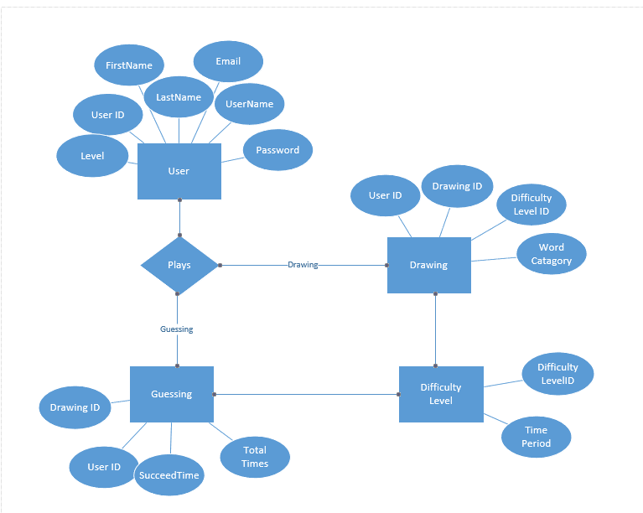

## relational model

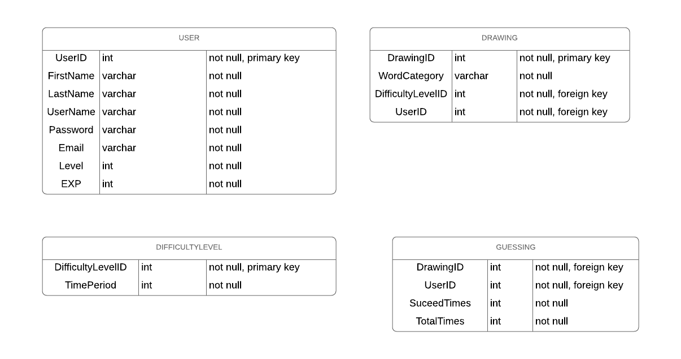

## Group member roles

Tsan Thanh Tai: Client side

Yan Cheng Ren: Database

Pedram Milani: Server side

## gantt chart

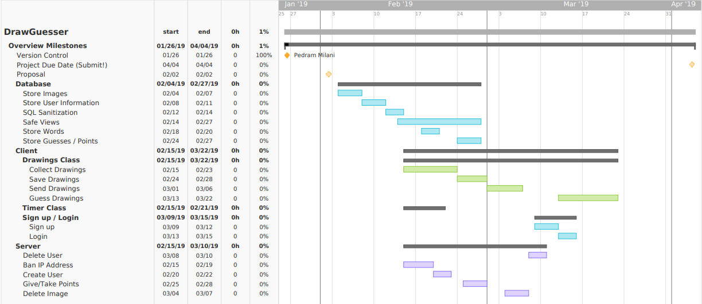

## functions to be implemented and tools

*FUNCTION*

* Login as a user to start playing the game
* Users will get the word that is generated by the game and they will draw to describe that word( When their turn comes only)
* Player will get points when their drawing is guess correctly by other users
* Otherwise, they will guess other player’s drawing to catch the right answer and points will be awarded.
* Drawing turn will be passed to every players according to the time that they join the game.
* After a specific number of rounds the game will be over, player with highest score will win.
* The leaderboard will be updated at each turn.

*TOOLS*

* Java
* SQL MANAGAEMENT STUDIO