Lab 1, Act 3: Defend
  - Does the evidence actually support our candidate?
NRES 746 – name: ____________________ group: ______

Picking up where we left off
In Act 1, your group diagnosed the tadpole data as hump-shaped and picked the Ricker function as your top candidate. In Act 2, you put specific numbers on it ($a=0.9$, $b=1/12$) and derived its peak, $x^{*}=12$ mm. Today we put that candidate on trial: does it actually predict the real data well, or does it just look plausible?
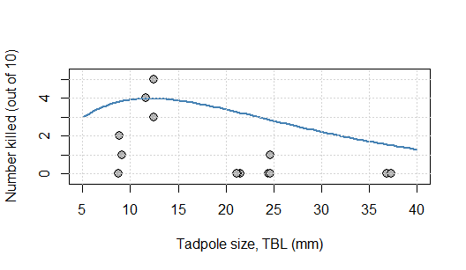

Part 1: Does the shape earn its keep? (individual, ~10 min)
A model earns its keep by predicting better than a “dumb” baseline. One simple way to score any model: for each data point, compute the residual (observed $−$ predicted), square it (so overshoots and undershoots both count against the model, and big misses count extra – this is the same squared-deviation idea from Act 1’s variance calculation), and add up the squares. Smaller total = better fit. This total is often called the sum of squared residuals (SSR).
Model 1: our Ricker candidate. Using $a=0.9$, $b=1/12$ from Act 2, fill in the missing residuals:
TBL (mm) | Observed mean | Ricker predicted | Residual | Squared residual
9 | 1.00 | 3.83 | ________ | 8.01
12 | 4.00 | 3.97 | ________ | 0.00
21 | 0.00 | 3.28 | ________ | 10.76
25 | 0.33 | 2.80 | ________ | 6.10
37 | 0.00 | 1.53 | ________ | 2.34
 |  |  | SSR: | 27.21
Model 2: the “null” model. The simplest possible model: ignore tadpole size entirely, and always predict the overall average. First, find that average (using either Act 1’s data table or the mean of the five group means):
$\overset{‾}{y}=$ ________
Now fill in the rest of the table yourself:
TBL (mm) | Observed mean | Null predicted | Residual | Squared residual
9 | 1.00 | ________ | ________ | ________
12 | 4.00 | ________ | ________ | ________
21 | 0.00 | ________ | ________ | ________
25 | 0.33 | ________ | ________ | ________
37 | 0.00 | ________ | ________ | ________
 |  |  | SSR: | ________
Compare. Which model has the smaller (better) SSR – the Ricker curve, or the null model that ignores body size entirely? Is this what you expected, given Acts 1 and 2?

Does today’s result mean the hump-shaped idea itself is wrong, or could it mean our specific numbers ($a=0.9$, $b=1/12$) were just bad guesses? How could you tell those two possibilities apart?

Group discussion (~10 min)
Compare your work with your group:
- Compare your SSR(null) calculations. Did everyone get the same total? Resolve any arithmetic disagreements.
- Debate the “wrong shape vs. bad parameters” question above. Where does your group land?
- Look back at Act 1’s variance table – most groups had only 3 replicate tanks. Given that, how much would you trust any single group’s mean? Would you be surprised if a different set of tanks gave noticeably different numbers, especially for TBL=25?
- As a group: are you ready to defend the Ricker function as the right model for this system, or do you want to reserve judgment? What (if anything) would change your mind?

Revise and reflect (individual, ~8 min)
Revise any of your answers above based on the group discussion. Then answer:
- In your own words: what’s the difference between a model having the wrong shape versus the right shape but poorly-chosen parameters? Based on today’s evidence, which one is the bigger problem for our Ricker candidate?

- If you could plug in the best possible $a$ and $b$ for the Ricker shape – not just eyeballed guesses – do you think it could beat the null model? Why or why not?

- Muddiest point: what’s the one thing from this part of the lab you’d like to see explained again?

