**Pygame project:**

**DESCRIPTION OF THE GAME**

**Title of the program:** Ninja Parkour

**Goal of the game**

Ninja Parkour is a running game set in an oriental background. The main character of the game is a ninja, who has to run and jump up the blocks to survive. If the ninja falls in the gap dies, and the game is over. The aim of the game is to do not make the ninja falls down, in order to survive as long as possible.

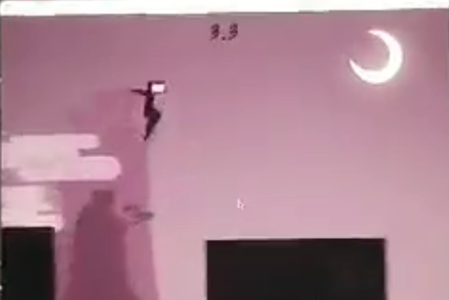

The character is timed to score how long the game lasts. The timer begins when the player starts the game and finishes when the ninja dies. At the end of each match, it is displayed the score achieved.

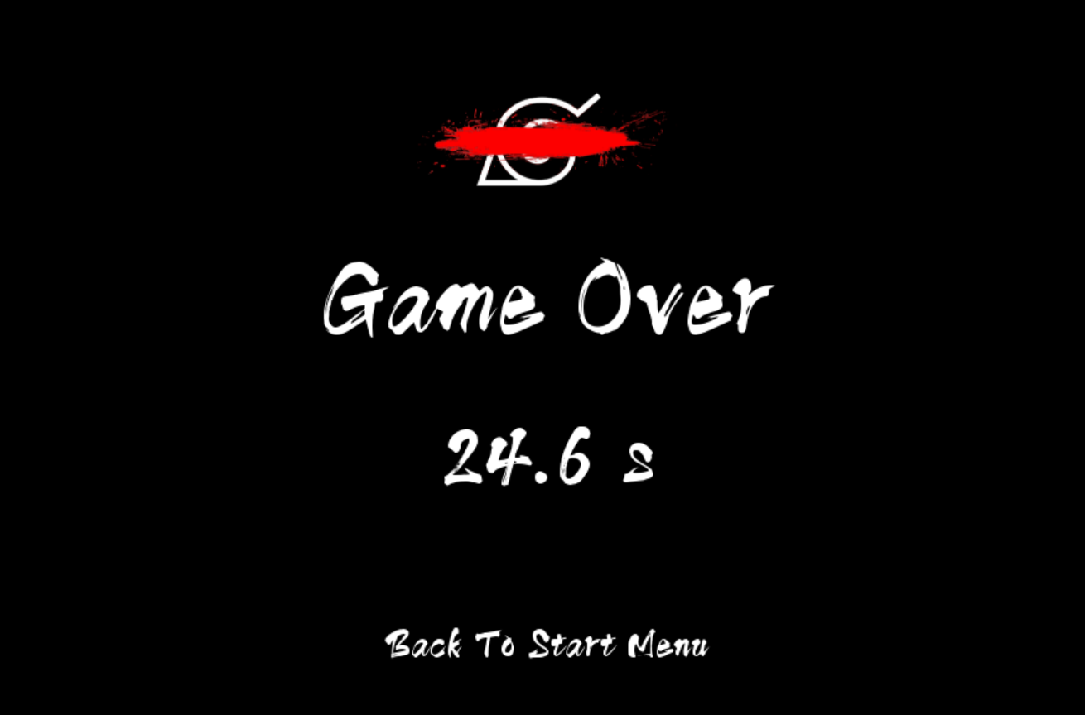

**Game inspiration idea**

This game is developed using Pygame 2.0.0; however, for the creation of this project, we were inspired by another similar game, also called "Ninja Parkour" developed with Unity 3D. It is important to state that during the development of our game, it was not used any code from the original Ninja Parkour, although we decided to keep the background image.

**How to play the game?**

When the user runs the game, it pops up a window whose displays the main menu, which shows three options to choose:

**Options:**

1) Start the game: To play the game

2) Introduction: Explanation of the commands to play the game

3) Credits: The name of the game developers

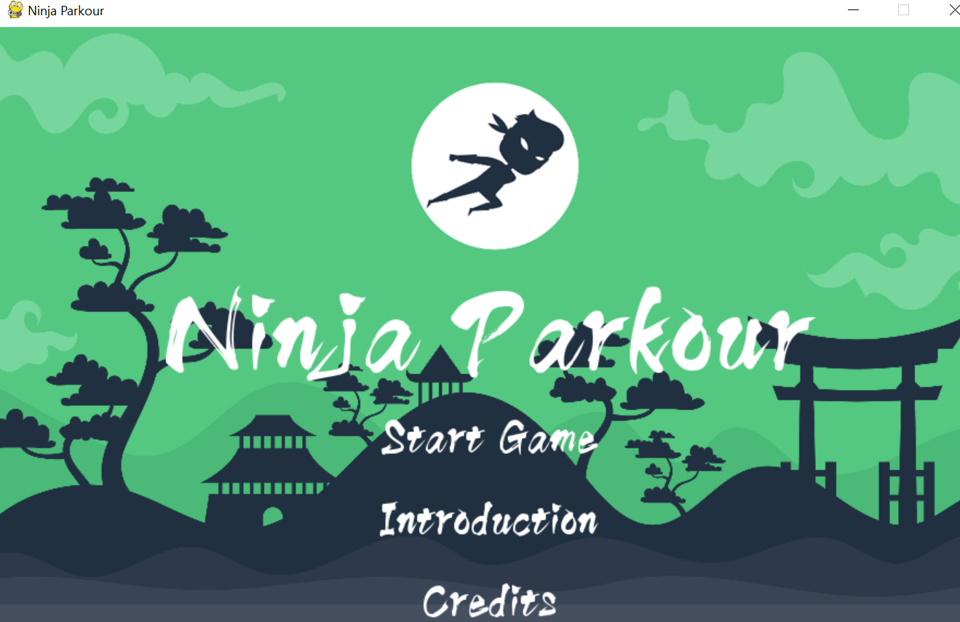

The menu is navigable through mouse control or using up and down arrow keys, ENTER key to select the option and ESC key to quit the game. It is advised to read the introduction prior to starting the game. The commands to play this game are:

* Left and right arrow keys to move (run) the ninja in left or right directions.
* The space key bar makes the Ninja jumps and pressing on it multiple time increase the highest of the jump.
* To quit the game, the user has to play ESC key.

**The essential to run the game**

We decided that each team member would work on different modules in order to develop the game. Here below, there is a list of modules implemented with a brief description of the purpose of the code.

Character.py: This module defines player class and contains the store functions to control the ninja, to make it jump, run and move left or right.

Configuration.py: This module set the width and height of the game screen, it stores variables and the location of images and sounds used in the game.

LoadResource.py: This module load relevant resources such as images, sound from the configuration module.

Map.py: This module defines floor class and store functions related to the map (blocks) used to make the ninja jump/run.

Game_control.py: This module defines control class, it stores the variables to control the game, such as initialize the game, changes scenes and detect key event.

Main.py: This module is the entrance of the program, it contains dictionaries that store the scenes related to the game.

Scene.py : This module is the hyper class for all the scenes in the game. It contains the menu/design navigation, where it is implemented the starting menu and the game over scene.

***References***

*Game inspiration:*

Unity 忍者跑酷 Ninja Parkour - 泰课在线 - 国内专业的Unity在线学习平台|Unity3d培训|Unity教程|Unity教程 Unreal 虚幻 AR|移动开发|美术CG|UI平面设计|前端开发 - Powered By EduSoho. (2020). Retrieved 10 December 2020, from <https://www.taikr.com/course/157?fbclid=IwAR0MQkyuwuW_gSQo7TlIa0efmQEH4nPIR3RzZrX48L2LjF-mRSKij4ciDDE>

*Floor, scene and control:*

用python写游戏之2D跑酷游戏（一）. (2020). Retrieved 10 December 2020, from <https://zhuanlan.zhihu.com/p/139570399?fbclid=IwAR1El9qhN1r50cCKAMHJL_RUeZ_st_btUFY4cAVG1BcgdKs5_NulhfuuAoo>

用python写游戏之2D跑酷游戏（二）. (2020). Retrieved 10 December 2020, from <https://zhuanlan.zhihu.com/p/127092232?fbclid=IwAR2pUShv6KgjK8VNcSHDULTsdSpHhQ31LQ4h-1YayXFmn-6COd8onruZmwk>

*Running scene image background:*

Unity 忍者跑酷 Ninja Parkour - 泰课在线 - 国内专业的Unity在线学习平台|Unity3d培训|Unity教程|Unity教程 Unreal 虚幻 AR|移动开发|美术CG|UI平面设计|前端开发 - Powered By EduSoho. (2020). Retrieved 10 December 2020, from <https://www.taikr.com/course/157?fbclid=IwAR0MQkyuwuW_gSQo7TlIa0efmQEH4nPIR3RzZrX48L2LjF-mRSKij4ciDDE>

*Main menu image background:*

Download Green Ninja Warrior Background for free. (2020). Retrieved 10 December 2020, from <https://www.freepik.com/free-vector/green-ninja-warrior-background_2584714.htm?fbclid=IwAR186WBB9YwWX-hGSHXtMnwgElu7kxtj9aSrq4cOwaXT11q6wSwO8t9FEbw#page=1&query=ninja&position=21>

*Sound effects:*

Freesound - Freesound. (2020). Retrieved 10 December 2020, from <https://freesound.org/?fbclid=IwAR02hjTTxGUcyKLb2amC4psnmYT5XHNC3OhzMuiUshaxeO8RjeEFvz6RUko>

*Main sound:*

Naruto Main Theme song. Retrieved 10 December 2020, from <https://www.youtube.com/watch?v=daPo6q4FXDw>