Nama : Kevin A

NIM : 24030005
- Buat pendeteksian game buta warna menggunakan phyton di google colab. Kevin : Warna:
Orange. Coklat, abu-abu
import ipywidgets as widgets
from IPython.display import display, clear_output import random
import time
# 3 Warna target yang akan muncul di gambar kotak
warna_kevin = ["Orange", "Coklat", "Abu-abu"]
# 8 Pilihan warna yang akan muncul di menu dropdown pembantu/pengecoh semua_pilihan = ["Orange", "Pink", "Biru", "Coklat", "Abu-abu", "Hitam", "Putih", "Ungu"]
# Kode warna hex untuk visualisasi kotak gambar
kode_warna = {
"Orange": "#FFA500", "Coklat": "#A52A2A", "Abu-abu": "#808080",
"Pink": "#FFC0CB", "Biru tua": "#000080", "Hitam": "#000000", "Biru laut": "#00FFFF", "Ungu": "#800080"
}
# Membuat daftar 10 soal acak dari warna Kevin
daftar_soal = random.choices(warna_kevin, k=10)
# Variabel permainan
skor = 0
indeks_soal = 0
# Komponen Antarmuka Colab (UI Widgets) output = widgets.Output() label_instruksi = widgets.Label() kotak_warna = widgets.HTML() pilihan_dropdown = widgets.Dropdown()
tombol_jawab = widgets.Button(description="Kirim Jawaban", button_style="primary")
label_umpan_balik = widgets.HTML() # Tempat menampilkan teks keterangan Benar/Salah
def tampilkan_soal():
"""Fungsi untuk memuat soal di dalam output Colab."""
global indeks_soal

with output:
clear_output()
if indeks_soal < len(daftar_soal): warna_target = daftar_soal[indeks_soal]
# Teks Instruksi Soal
label_instruksi.value = f"Pertanyaan {indeks_soal + 1}/{len(daftar_soal)}: Warna apa yang harus ditebak oleh Kevin?"
# Render Gambar Kotak Warna (Tetap hanya 3 variasi warna

Kevin)

hex_color = kode_warna[warna_target] kotak_warna.value = f"""
<div style="
width: 150px; height: 150px;
background-color: {hex_color}; border: 2px solid #ffffff; margin: 10px 0;
box-shadow: 0px 4px 8px rgba(0,0,0,0.5); "></div>
"""
# Menu dropdown menampilkan 8 pilihan warna lengkap pilihan_dropdown.options = semua_pilihan pilihan_dropdown.value = semua_pilihan[0]
# Tampilkan semua komponen ke layar
display(label_instruksi, kotak_warna, pilihan_dropdown,

tombol_jawab, label_umpan_balik) else:
# Sesi cetak hasil akhir setelah 10 soal selesai
total_soal = len(daftar_soal) persentase = (skor / total_soal) * 100
print("=== GAME SELESAI ===")
print(f"Skor Akhir: {skor} / {total_soal} ({persentase:.1f}%)")
if persentase == 100:
print("Selamat! Semua jawaban benar. Penglihatan warna berfungsi dengan sangat baik.")
elif persentase >= 70:
print("Hasil cukup baik! Hanya meleset sedikit.") else:
print("Banyak jawaban salah. Terindikasi adanya kendala dalam membedakan warna Kevin.")
def cek_jawaban(b):

"""Fungsi mendeteksi klik tombol, memeriksa jawaban, dan memberi feedback langsung."""
global skor, indeks_soal
# Kunci tombol sementara agar tidak diklik dua kali saat jeda membaca feedback
tombol_jawab.disabled = True
warna_target = daftar_soal[indeks_soal] jawaban_pengguna = pilihan_dropdown.value
if jawaban_pengguna == warna_target: skor += 1
# Berikan keterangan jawaban benar beserta nama warnanya
label_umpan_balik.value = f"""
<div style="color: #4CAF50; font-weight: bold; margin-top:

10px;">
- JAWABAN BENAR! Nama warna ini adalah: {warna_target}
</div> """

else:
# Berikan keterangan jawaban salah beserta nama warna yang

benar

10px;">
label_umpan_balik.value = f"""
<div style="color: #F44336; font-weight: bold; margin-top:
✗ JAWABAN SALAH! Jawaban yang benar adalah: {warna_target}

(Anda memilih: {jawaban_pengguna})
</div> """
# Berikan jeda 2 detik agar pengguna sempat membaca keterangan sebelum pindah soal
time.sleep(2.0)
# Bersihkan teks keterangan, aktifkan tombol kembali, lalu lanjut ke soal berikutnya
label_umpan_balik.value = ""
tombol_jawab.disabled = False indeks_soal += 1 tampilkan_soal()
# Menghubungkan fungsi logika ke tombol klik
tombol_jawab.on_click(cek_jawaban)
# Menampilkan widget pertama kali di Google Colab
display(output) tampilkan_soal()

{"model_id":"b671ecdc5f5149e18eeb5a08b8b6397b","version_major":2,"vers ion_minor":0}
- Buat komputer bisa membaca warna yang muncul….
!pip install webcolors
Requirement already satisfied: webcolors in
/usr/local/lib/python3.12/dist-packages (25.10.0)
import ipywidgets as widgets
from IPython.display import display, clear_output import random
import time
import numpy as np from PIL import Image
from scipy.spatial import KDTree
# Database nilai RGB warna dasar murni yang JELAS
database_rgb = {
"Merah": (255, 0, 0),
"Hijau": (0, 255, 0),
"Kuning": (255, 255, 0),
"Coklat": (139, 69, 19),
"Hitam": (0, 0, 0),
"Abu-abu": (128, 128, 128),
"Pink": (255, 192, 203),
"Biru": (0, 0, 255),
"Orange": (255, 165, 0),
"Ungu": (128, 0, 128),
"Putih": (255, 255, 255)
}
nama_warna_list = list(database_rgb.keys()) rgb_values = list(database_rgb.values()) pohon_warna = KDTree(rgb_values)
# Membuat daftar 10 soal yang diambil dari warna dasar murni secara acak (shuffle)
daftar_soal = random.choices(nama_warna_list, k=10)
# Variabel program
indeks_percobaan = 0
total_percobaan = 10
# Komponen UI
output = widgets.Output() label_instruksi = widgets.Label()
kotak_visual = widgets.Image(format='png', width=150, height=150) tombol_scan = widgets.Button(description="Biarkan Komputer Menebak

Warna!", button_style="success", layout=widgets.Layout(width='280px')) label_umpan_balik = widgets.HTML()
def komputer_baca_piksel(jalur_gambar):
"""Komputer membuka gambar dan membaca piksel tengahnya""" img = Image.open(jalur_gambar).convert("RGB") matriks_piksel = np.array(img)
# Mengambil koordinat tengah kotak
rgb_terbaca = matriks_piksel[75, 75, :3]
rgb_tuple = (int(rgb_terbaca[0]), int(rgb_terbaca[1]), int(rgb_terbaca[2]))
# Mencari nama warna terdekat
_, indeks = pohon_warna.query(rgb_tuple) nama_terbaca = nama_warna_list[indeks]
return rgb_tuple, nama_terbaca
def tampilkan_sesi(): global indeks_percobaan with output:
clear_output()
if indeks_percobaan < total_percobaan:
# PERBAIKAN: Mengambil warna dari list warna murni yang sudah pasti, bukan acak angka RGB bebas
warna_pilihan = daftar_soal[indeks_percobaan]
rgb_pasti = database_rgb[warna_pilihan]
# Simpan menjadi file gambar fisik
img = Image.new("RGB", (150, 150), rgb_pasti) img.save("warna_pasti_komputer.png")
# Tampilkan gambar ke layar Colab
with open("warna_pasti_komputer.png", "rb") as file: kotak_visual.value = file.read()
label_instruksi.value = f"Percobaan Analisis
{indeks_percobaan + 1}/{total_percobaan}:" display(label_instruksi, kotak_visual, tombol_scan,
label_umpan_balik)
else:
print("=== SEMUA PROSES SCANNING SELESAI ===")
print("Komputer telah berhasil menganalisis 10 warna dasar secara mandiri.")
def proses_tebakan_komputer(b): global indeks_percobaan tombol_scan.disabled = True

# Efek loading animasi berpikir
label_umpan_balik.value = '<div style="color: #FFA500; font- weight: bold; margin-top: 10px;">Eeeeee... Komputer sedang membaca piksel gambar... 🤔</div>'
time.sleep(1.2)
# Jalankan fungsi deteksi gambar
rgb_terdeteksi, warna_terbaca_komputer = komputer_baca_piksel("warna_pasti_komputer.png")
# Tampilkan hasil tebakan interaktif
label_umpan_balik.value = f"""
<div style="background-color: #2b2b2b; padding: 12px; border-left: 5px solid #4CAF50; margin-top: 10px; border-radius: 4px;">
<span style="color: #4CAF50; font-weight: bold; font-size: 14px;">[Sistem Berhasil Mendeteksi!]</span><br>
<p style="color: #ffffff; margin: 6px 0; font-size: 15px;"> "Eeeeee... Komputer menebak warna ini yaitu warna
<b>{warna_terbaca_komputer}</b>!"
</p>
<span style="color: #aaaaaa; font-size: 11px;">Data Sensor Piksel: RGB {rgb_terdeteksi}</span>
</div> """
time.sleep(3.5) label_umpan_balik.value = "" tombol_scan.disabled = False indeks_percobaan += 1 tampilkan_sesi()
tombol_scan.on_click(proses_tebakan_komputer) display(output)
tampilkan_sesi()
{"model_id":"78f156c45f0e40459b9567e096383e67","version_major":2,"vers ion_minor":0}
Library apa saja yang anda gunakan dan fungsinya untuk apa?
- PIL (Pillow): Membuat dan memproses file gambar.
- NumPy: Mengubah gambar menjadi angka piksel RGB.
- SciPy (KDTree): Otak pencari warna terdekat.
- Ipywidgets: Membuat tombol dan interaksi menu.
- IPython.display: Menampilkan visual dan membersihkan layar.

- Random: Mengacak kombinasi warna gambar bebas.
- Time: Memberikan jeda efek animasi berpikir.

- Buat komputer bisa mendeteksi wajah anda asli seperti praktek pada perkuliahan ke delapan tanggal 21 mei 2026.
Face Recognition
!pip install face_recognition opencv-python
import cv2
import face_recognition import numpy as np
from IPython.display import display, Javascript from google.colab.output import eval_js
from google.colab.patches import cv2_imshow
from base64 import b64decode
# ===================================== # FOTO REFERENSI
# =====================================
foto_kevin = face_recognition.load_image_file("kevin.jpg")
encoding_kevin = face_recognition.face_encodings( foto_kevin
)[0]
# ===================================== # FUNCTION WEBCAM COLAB
# =====================================
def take_photo(filename='photo.jpg', quality=0.8):
js = Javascript('''
async function takePhoto(quality) {
const div = document.createElement('div');
const capture = document.createElement('button');
capture.textContent = 'Scan Wajah'; div.appendChild(capture);
const video = document.createElement('video'); video.style.display = 'block';
const stream = await navigator.mediaDevices.getUserMedia({ video: true
});
document.body.appendChild(div); div.appendChild(video);
video.srcObject = stream;

await video.play();
google.colab.output.setIframeHeight( document.body.scrollHeight,
true
);
await new Promise((resolve) => capture.onclick = resolve
);
const canvas = document.createElement('canvas');
canvas.width = video.videoWidth; canvas.height = video.videoHeight;
canvas.getContext('2d').drawImage( video,
0,
0
);
stream.getTracks().forEach(track => track.stop()); div.remove();
return canvas.toDataURL('image/jpeg', quality);
}
''')
display(js)
data = eval_js('takePhoto({})'.format(quality)) binary = b64decode(data.split(',')[1])
with open(filename, 'wb') as f: f.write(binary)
return filename
# ===================================== # AMBIL FOTO WEBCAM
# =====================================
foto_test = take_photo()
# ===================================== # LOAD FOTO HASIL WEBCAM
# =====================================
img_test = face_recognition.load_image_file(

foto_test
)
lokasi_wajah = face_recognition.face_locations( img_test
)
encoding_test = face_recognition.face_encodings( img_test,
lokasi_wajah
)
img = cv2.cvtColor( img_test, cv2.COLOR_RGB2BGR
)
# ===================================== # FACE RECOGNITION
# =====================================
for (top, right, bottom, left), face_encoding in zip( lokasi_wajah,
encoding_test
):
hasil = face_recognition.compare_faces( [encoding_kevin],
face_encoding
)
nama = "Tidak dikenal"
if hasil[0]:
nama = "Kevin"
cv2.rectangle( img,
(left, top), (right, bottom), (0,255,0),
2
)
cv2.putText( img, nama,
(left, top - 10), cv2.FONT_HERSHEY_SIMPLEX, 0.8,
(0,255,0),

2
)
# ===================================== # TAMPILKAN HASIL
# =====================================
cv2_imshow(img)
Requirement already satisfied: face_recognition in
/usr/local/lib/python3.12/dist-packages (1.3.0) Requirement already satisfied: opencv-python in
/usr/local/lib/python3.12/dist-packages (4.13.0.92)
Requirement already satisfied: face-recognition-models>=0.3.0 in
/usr/local/lib/python3.12/dist-packages (from face_recognition) (0.3.0)
Requirement already satisfied: Click>=6.0 in
/usr/local/lib/python3.12/dist-packages (from face_recognition) (8.4.0)
Requirement already satisfied: dlib>=19.7 in
/usr/local/lib/python3.12/dist-packages (from face_recognition) (19.24.6)
Requirement already satisfied: numpy in
/usr/local/lib/python3.12/dist-packages (from face_recognition) (2.0.2)
Requirement already satisfied: Pillow in
/usr/local/lib/python3.12/dist-packages (from face_recognition) (11.3.0)
<IPython.core.display.Javascript object>

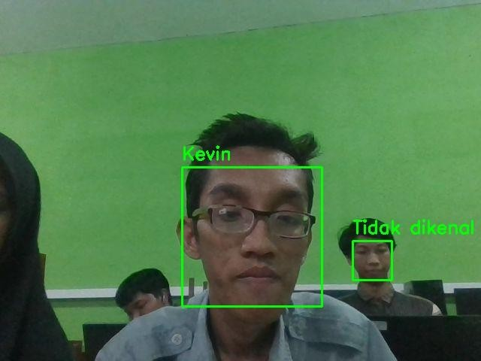
Sistem Absensi
!pip install face_recognition opencv-python pandas
import cv2
import face_recognition import pandas as pd
from datetime import datetime
from IPython.display import display, Javascript from google.colab.output import eval_js
from google.colab.patches import cv2_imshow
from base64 import b64decode from google.colab import files
# ===================================== # FOTO REFERENSI
# =====================================
foto_kevin = face_recognition.load_image_file( "/content/kevin.jpg"

)
encoding_kevin = face_recognition.face_encodings( foto_kevin
)[0]
# ===================================== # FUNCTION WEBCAM
# =====================================
def take_photo(filename='photo.jpg', quality=0.8):
js = Javascript('''
async function takePhoto(quality) {
const div = document.createElement('div');
const capture = document.createElement('button'); capture.textContent = 'Scan Absensi'; div.appendChild(capture);
const video = document.createElement('video'); video.style.display = 'block';
const stream = await navigator.mediaDevices.getUserMedia({ video: true
});
document.body.appendChild(div); div.appendChild(video); video.srcObject = stream;
await video.play();
google.colab.output.setIframeHeight( document.body.scrollHeight,
true
);
await new Promise((resolve) => capture.onclick = resolve
);
const canvas = document.createElement('canvas');
canvas.width = video.videoWidth; canvas.height = video.videoHeight;

canvas.getContext('2d').drawImage( video,
0,
0
);
stream.getTracks().forEach(track => track.stop()); div.remove();
return canvas.toDataURL('image/jpeg', quality);
}
''')
display(js)
data = eval_js('takePhoto({})'.format(quality)) binary = b64decode(data.split(',')[1])
with open(filename, 'wb') as f: f.write(binary)
return filename
# ===================================== # AMBIL FOTO WEBCAM
# =====================================
foto_test = take_photo()
# ===================================== # LOAD FOTO TEST
# =====================================
img_test = face_recognition.load_image_file( foto_test
)
lokasi_wajah = face_recognition.face_locations( img_test
)
encoding_test = face_recognition.face_encodings( img_test,
lokasi_wajah
)
img = cv2.cvtColor( img_test, cv2.COLOR_RGB2BGR
)

# ===================================== # LIST ABSENSI
# =====================================
data_absensi = []
# ===================================== # FACE RECOGNITION
# =====================================
for (top, right, bottom, left), face_encoding in zip( lokasi_wajah,
encoding_test
):
hasil = face_recognition.compare_faces( [encoding_kevin],
face_encoding
)
nama = "Tidak dikenal"
waktu = datetime.now().strftime( "%Y-%m-%d %H:%M:%S"
)
if hasil[0]:
nama = "Kevin"
data_absensi.append({ "Nama": nama, "Waktu": waktu, "Status": "Hadir"
})
# ================================= # TAMPILKAN KOTAK
# =================================
cv2.rectangle( img,
(left, top), (right, bottom), (0,255,0),
2
)
# ================================= # TAMPILKAN NAMA + WAKTU
# =================================
text = f"{nama} | {waktu}"

cv2.putText( img, text,
(left, top - 10), cv2.FONT_HERSHEY_SIMPLEX, 0.6,
(0,255,0),
2
)
# ===================================== # TAMPILKAN HASIL
# =====================================
cv2_imshow(img)
# ===================================== # SIMPAN CSV
# =====================================
df = pd.DataFrame(data_absensi)
csv_file = "absensi.csv" df.to_csv(csv_file, index=False)
print("Absensi berhasil disimpan") print(data_absensi)
# ===================================== # DOWNLOAD CSV
# =====================================
files.download(csv_file)
Requirement already satisfied: face_recognition in
/usr/local/lib/python3.12/dist-packages (1.3.0) Requirement already satisfied: opencv-python in
/usr/local/lib/python3.12/dist-packages (4.13.0.92) Requirement already satisfied: pandas in
/usr/local/lib/python3.12/dist-packages (2.2.2)
Requirement already satisfied: face-recognition-models>=0.3.0 in
/usr/local/lib/python3.12/dist-packages (from face_recognition) (0.3.0)
Requirement already satisfied: Click>=6.0 in
/usr/local/lib/python3.12/dist-packages (from face_recognition) (8.4.0)
Requirement already satisfied: dlib>=19.7 in
/usr/local/lib/python3.12/dist-packages (from face_recognition) (19.24.6)
Requirement already satisfied: numpy in
/usr/local/lib/python3.12/dist-packages (from face_recognition) (2.0.2)

Requirement already satisfied: Pillow in
/usr/local/lib/python3.12/dist-packages (from face_recognition) (11.3.0)
Requirement already satisfied: python-dateutil>=2.8.2 in
/usr/local/lib/python3.12/dist-packages (from pandas) (2.9.0.post0) Requirement already satisfied: pytz>=2020.1 in
/usr/local/lib/python3.12/dist-packages (from pandas) (2025.2) Requirement already satisfied: tzdata>=2022.7 in
/usr/local/lib/python3.12/dist-packages (from pandas) (2026.2) Requirement already satisfied: six>=1.5 in
/usr/local/lib/python3.12/dist-packages (from python-dateutil>=2.8.2-
>pandas) (1.17.0)
<IPython.core.display.Javascript object>
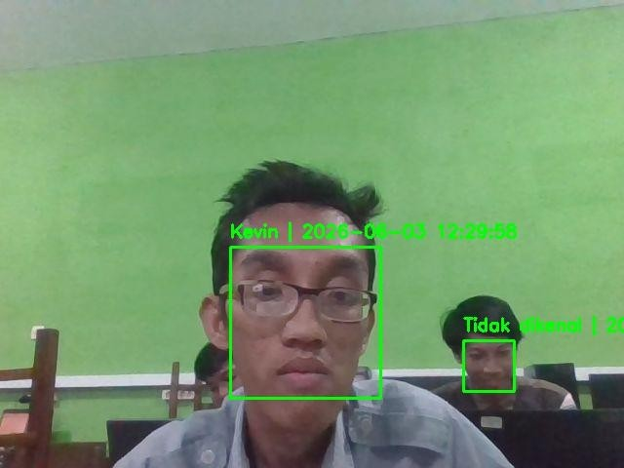
Absensi berhasil disimpan
[{'Nama': 'Kevin', 'Waktu': '2026-06-03 12:29:58', 'Status': 'Hadir'}]
<IPython.core.display.Javascript object>
<IPython.core.display.Javascript object>

- Gunakan library CNN citra komputer, dan ribuan gambar kucing dan anjing agar komputer bisa mendeteksi jenis kucing atau anjing.
bagian A : Install Library, download dataset dan Traning Model
!pip install opendatasets --quiet
import os import zipfile
import opendatasets as od import tensorflow as tf
from tensorflow.keras.models import Sequential
from tensorflow.keras.layers import Conv2D, MaxPooling2D, Flatten,
Dense, Dropout
from tensorflow.keras.preprocessing.image import ImageDataGenerator
# Unduh dataset
# Saat dijalankan, program akan meminta Username dan Key dari akun Kaggle Anda
dataset_url = "https://www.kaggle.com/datasets/karakaggle/kaggle-cat-
vs-dog-dataset" od.download(dataset_url)
# Tentukan jalur folder hasil ekstraksi dataset
base_dir =
"kaggle-cat-vs-dog-dataset/kagglecatsanddogs_3367a/PetImages" cat_dir = os.path.join(base_dir, "Cat")
dog_dir = os.path.join(base_dir, "Dog")
# data cleaning (bersihkan data korup)
def bersihkan_gambar_rusak(folder):
"""Menyeleksi dan menghapus file gambar tiruan/cacat agar model tidak eror"""
for root, _, files in os.walk(folder):
for file in files:
file_path = os.path.join(root, file) try:
with open(file_path, "rb") as f: is_jfif = b"JFIF" in f.read(10)
if not is_jfif: os.remove(file_path)
except:
os.remove(file_path)
print("\nSedang membersihkan data dari file gambar yang rusak...") bersihkan_gambar_rusak(cat_dir)
bersihkan_gambar_rusak(dog_dir)
# data prepocessing & generator
datagen = ImageDataGenerator(

rescale=1./255, rotation_range=20, width_shift_range=0.2, height_shift_range=0.2, shear_range=0.2, zoom_range=0.2, horizontal_flip=True, fill_mode='nearest', validation_split=0.2
)
train_generator = datagen.flow_from_directory( base_dir, target_size=(150, 150), batch_size=32,
class_mode='binary', subset='training'
)
val_generator = datagen.flow_from_directory( base_dir, target_size=(150, 150), batch_size=32,
class_mode='binary', subset='validation'
)
# arsitektur cnn
model = Sequential([
# Blok Konvolusi 1 & Max Pooling
Conv2D(32, (3, 3), activation='relu', input_shape=(150, 150, 3)),
MaxPooling2D(2, 2),
# Blok Konvolusi 2 & Max Pooling
Conv2D(64, (3, 3), activation='relu'),
MaxPooling2D(2, 2),
# Blok Konvolusi 3 & Max Pooling
Conv2D(128, (3, 3), activation='relu'),
MaxPooling2D(2, 2),
# Meratakan matriks 2D menjadi array linear 1D
Flatten(), Dropout(0.5),
# Fully Connected Layer (Jaringan Saraf Inti)
Dense(512, activation='relu'), Dense(1, activation='sigmoid')
])
model.compile(optimizer='adam', loss='binary_crossentropy', metrics=['accuracy'])
model.summary()
# training model agar akurat
print("\n--- Memulai Proses Training CNN Maksimal (5 Epochs) ---") history = model.fit(

train_generator,
steps_per_epoch=len(train_generator), # Membaca seluruh total steps data Kaggle
epochs=5, # Dilatih sebanyak 5
putaran penuh
validation_data=val_generator, validation_steps=len(val_generator)
)
print("--- Training Selesai Sempurna! ---")
# simpan model
model.save("model_hewan_kaggle.h5")
print("model disimpan dengan nama 'model_hewan_kaggle.h5'!")
Please provide your Kaggle credentials to download this dataset. Learn more: http://bit.ly/kaggle-creds
Your Kaggle username: kevinandrianpolitama Your Kaggle Key: ··········
Dataset URL: https://www.kaggle.com/datasets/karakaggle/kaggle-cat-vs- dog-dataset
Downloading kaggle-cat-vs-dog-dataset.zip to ./kaggle-cat-vs-dog- dataset
100%|██████████| 787M/787M [00:11<00:00, 74.2MB/s]

Sedang membersihkan data dari file gambar yang rusak... Found 18535 images belonging to 2 classes.
Found 4632 images belonging to 2 classes.
/usr/local/lib/python3.12/dist-packages/keras/src/layers/ convolutional/base_conv.py:113: UserWarning: Do not pass an
`input_shape`/`input_dim` argument to a layer. When using Sequential models, prefer using an `Input(shape)` object as the first layer in the model instead.
super(). init (activity_regularizer=activity_regularizer,
**kwargs)
Model: "sequential"
┏━━━━━━━━━━━━━━━━━━━━━━━━━━━━━━━━━┳━━━━━━━━━━━━━━━━━━━━━━━━┳━━━━━━━━━━
━━━━━┓
┃ Layer (type) ┃ Output Shape ┃
Param # ┃
┡━━━━━━━━━━━━━━━━━━━━━━━━━━━━━━━━━╇━━━━━━━━━━━━━━━━━━━━━━━━╇━━━━━━━━━━
━━━━━┩
│ conv2d (Conv2D) │ (None, 148, 148, 32) │
896 │
├─────────────────────────────────┼────────────────────────┼──────────
─────┤

│ max_pooling2d (MaxPooling2D) │ (None, 74, 74, 32) │
0 │
├─────────────────────────────────┼────────────────────────┼──────────
─────┤
│ conv2d_1 (Conv2D) │ (None, 72, 72, 64) │
18,496 │
├─────────────────────────────────┼────────────────────────┼──────────
─────┤
│ max_pooling2d_1 (MaxPooling2D) │ (None, 36, 36, 64) │
0 │
├─────────────────────────────────┼────────────────────────┼──────────
─────┤
│ conv2d_2 (Conv2D) │ (None, 34, 34, 128) │
73,856 │
├─────────────────────────────────┼────────────────────────┼──────────
─────┤
│ max_pooling2d_2 (MaxPooling2D) │ (None, 17, 17, 128) │
0 │
├─────────────────────────────────┼────────────────────────┼──────────
─────┤
│ flatten (Flatten) │ (None, 36992) │
0 │
├─────────────────────────────────┼────────────────────────┼──────────
─────┤
│ dropout (Dropout) │ (None, 36992) │
0 │
├─────────────────────────────────┼────────────────────────┼──────────
─────┤
│ dense (Dense) │ (None, 512) │
18,940,416 │
├─────────────────────────────────┼────────────────────────┼──────────
─────┤
│ dense_1 (Dense) │ (None, 1) │
513 │
└─────────────────────────────────┴────────────────────────┴──────────
─────┘
Total params: 19,034,177 (72.61 MB)
Trainable params: 19,034,177 (72.61 MB)
Non-trainable params: 0 (0.00 B)

--- Memulai Proses Training CNN Maksimal (5 Epochs) --- Epoch 1/5
580/580 ━━━━━━━━━━━━━━━━━━━━ 178s 295ms/step - accuracy: 0.5567 - loss: 0.6977 - val_accuracy: 0.6166 - val_loss: 0.6602
Epoch 2/5
580/580 ━━━━━━━━━━━━━━━━━━━━ 157s 271ms/step - accuracy: 0.6092 -

loss: 0.6597 - val_accuracy: 0.6492 - val_loss: 0.6361 Epoch 3/5
580/580 ━━━━━━━━━━━━━━━━━━━━ 158s 271ms/step - accuracy: 0.6588 - loss: 0.6226 - val_accuracy: 0.6865 - val_loss: 0.5945
Epoch 4/5
580/580 ━━━━━━━━━━━━━━━━━━━━ 156s 269ms/step - accuracy: 0.6970 - loss: 0.5720 - val_accuracy: 0.7174 - val_loss: 0.5494
Epoch 5/5
580/580 ━━━━━━━━━━━━━━━━━━━━ 156s 269ms/step - accuracy: 0.7189 - loss: 0.5516 - val_accuracy: 0.7545 - val_loss: 0.5029
WARNING:absl:You are saving your model as an HDF5 file via
`model.save()` or `keras.saving.save_model(model)`. This file format is considered legacy. We recommend using instead the native Keras format, e.g. `model.save('my_model.keras')` or
`keras.saving.save_model(model, 'my_model.keras')`.
--- Training Selesai Sempurna! ---
model disimpan dengan nama 'model_hewan_kaggle.h5'!
Versi Upload Manual
import os
import tensorflow as tf import numpy as np
import matplotlib.pyplot as plt import time
from google.colab import files
from tensorflow.keras.preprocessing import image
nama_model = "model_hewan_kaggle.h5"
# Memastikan file hasil training dari Bagian A sudah terkunci di sistem
if os.path.exists(nama_model):
print("🤔 Mengaktifkan model yang Sudah Terlatih...") model_matang = tf.keras.models.load_model(nama_model) print("🤔 model Aktif! Siap mendeteksi gambar.")
print("\n" + "="*60)
print("unggah gambar kucing / anjing") print("="*60)
uploaded = files.upload()
for nama_asli in uploaded.keys(): path_terbaca = nama_asli
# Gaya interaktif komputer sedang berpikir membedah matriks
piksel

print('\n"sedang menganalisis piksel dan bentuk gambar..."') time.sleep(1.5)
# Membuka gambar dan menormalisasi skala array-nya
img = image.load_img(path_terbaca, target_size=(150, 150)) img_array = image.img_to_array(img)
img_array = np.expand_dims(img_array, axis=0) / 255.0
# model memprediksi gambar secara langsung dalam hitungan milidetik
skor_prediksi = model_matang.predict(img_array)
# Menampilkan gambar yang Anda upload ke layar notebook
plt.figure(figsize=(4, 4)) plt.imshow(img) plt.axis('off')
plt.show()
# Konversi probabilitas biner ke format teks output persentase
if skor_prediksi[0][0] > 0.5:
persentase = skor_prediksi[0][0] * 100 print(f'🤔 "Gambar ini adalah ANJING!"')
print(f' (Tingkat Keyakinan Analisis: {persentase:.2f}

%)')

%)')
else:
else:
persentase = (1 - skor_prediksi[0][0]) * 100 print(f'🤔 "Gambar ini adalah KUCING!"')
print(f' (Tingkat Keyakinan Analisis: {persentase:.2f}

print("File model_hewan_kaggle.h5 tidak ditemukan! Silakan jalankan sel BAGIAN A terlebih dahulu sebanyak 1 kali untuk membuat berkas modelnya.")
- Mengaktifkan model yang Sudah Terlatih...
WARNING:absl:Compiled the loaded model, but the compiled metrics have yet to be built. `model.compile_metrics` will be empty until you train or evaluate the model.
- model Aktif! Siap mendeteksi gambar.
============================================================
unggah gambar kucing / anjing
============================================================
<IPython.core.display.HTML object> Saving 1006.jpg to 1006.jpg

"sedang menganalisis piksel dan bentuk gambar..." 1/1 ━━━━━━━━━━━━━━━━━━━━ 1s 653ms/step
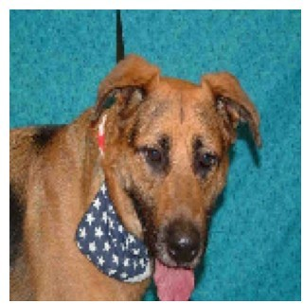
- "Gambar ini adalah ANJING!"
(Tingkat Keyakinan Analisis: 85.01%)

Versi Otomatis akan mendeteksi gambar random dengan jeda 5 detik
import os import random
import tensorflow as tf import numpy as np
import matplotlib.pyplot as plt import time
from tensorflow.keras.preprocessing import image from IPython.display import clear_output
nama_model = "model_hewan_kaggle.h5" base_dataset_dir =
"kaggle-cat-vs-dog-dataset/kagglecatsanddogs_3367a/PetImages"
# 1. Memastikan file hasil training dari Bagian A sudah terkunci di sistem
if os.path.exists(nama_model):
print("🤔 Mengaktifkan model yang Sudah Terlatih...") model_matang = tf.keras.models.load_model(nama_model) print("🤔 model Aktif!")
time.sleep(1)

# Tentukan path folder kucing dan anjing dari dataset asli Anda
folder_cat = os.path.join(base_dataset_dir, "Cat") folder_dog = os.path.join(base_dataset_dir, "Dog")
# Pastikan foldernya ada di Colab Anda
if not os.path.exists(folder_cat) or not os.path.exists(folder_dog):
print(f"🤔 Folder dataset tidak ditemukan di path:
{base_dataset_dir}")
print("🤔 Silakan jalankan ulang kode pengunduhan dataset Anda terlebih dahulu.")
else:
print("🤔 Dataset terdeteksi! Memulai perulangan deteksi acak 5 detik...")
time.sleep(1)
putaran = 1 try:
while True:
# Bersihkan layar lama agar hasil analisis gambar berikutnya rapi di atas
clear_output(wait=True)
print("="*60)
print(f" 🤔 DETEKSI OTOMATIS BERKALA - GAMBAR KE-

{putaran} 🤔 ")

folder_dog])
print("="*60)
# Pilih kategori acak (50% Kucing, 50% Anjing)
kategori_terpilih = random.choice([folder_cat,
label_asli = "KUCING" if kategori_terpilih ==

folder_cat else "ANJING"
# Ambil daftar file gambar valid di folder tersebut ekstensi_gambar = ('.png', '.jpg', '.jpeg') daftar_gambar = [f for f in
os.listdir(kategori_terpilih) if f.lower().endswith(ekstensi_gambar)]
if len(daftar_gambar) == 0: continue
# Pilih satu gambar secara acak
gambar_acak = random.choice(daftar_gambar) path_terbaca = os.path.join(kategori_terpilih,
gambar_acak)
print(f"🤔 [Label Asli Dataset: {label_asli}]") print('"Sedang menganalisis piksel dan bentuk
gambar..."')

try:
# Membuka gambar dan menormalisasi skala array-nya
img = image.load_img(path_terbaca, target_size=(150, 150))
img_array = image.img_to_array(img)
img_array = np.expand_dims(img_array, axis=0) /

255.0

verbose=0)

output persentase

# Model memprediksi gambar secara langsung
skor_prediksi = model_matang.predict(img_array,

# Menampilkan gambar ke layar notebook plt.figure(figsize=(4, 4)) plt.imshow(img)
plt.axis('off') plt.show()
# Konversi probabilitas biner ke format teks

# Bergantung pada bagaimana struktur kelas saat

training Anda dikunci
if skor_prediksi > 0.5:
persentase = skor_prediksi * 100 print(f'🤔 "Sistem mendeteksi gambar ini

sebagai ANJING!"')
{persentase:.2f}%)')
print(f' (Tingkat Keyakinan Analisis:

sebagai KUCING!"')
else:
persentase = (1 - skor_prediksi) * 100 print(f'🤔 "Sistem mendeteksi gambar ini
print(f' (Tingkat Keyakinan Analisis:

{persentase:.2f}%)')
# Evaluasi akurasi prediksi sistem
tebakan_tepat = (skor_prediksi > 0.5 and label_asli == "ANJING") or (skor_prediksi <= 0.5 and label_asli == "KUCING")

kaggle
berkas.")
if tebakan_tepat:
print("🤔 HASIL PREDIKSI: BENAR!")
else:
print("🤔 HASIL PREDIKSI: SALAH!")
except Exception as e:
# Lewati jika ada file corrupt di dataset bawaan
print(f"⚠️ Gambar dilewati karena masalah pemuatan

time.sleep(1) continue
print("\n🤔 Menunggu 5 detik untuk memuat gambar selanjutnya...")
print("(Klik tombol STOP bulat di sebelah kiri sel untuk menyudahi proses)")
putaran += 1
time.sleep(20) # Jeda waktu 5 detik sebelum gambar berikutnya diacak
except KeyboardInterrupt:
print("\n🤔 Deteksi berkala berhasil dihentikan oleh
pengguna!") else:
print(f"File {nama_model} tidak ditemukan! Silakan jalankan sel BAGIAN A terlebih dahulu sebanyak 1 kali untuk membuat berkas modelnya.")
============================================================
🤔 DETEKSI OTOMATIS BERKALA - GAMBAR KE-1 🤔
============================================================
- [Label Asli Dataset: ANJING]
"Sedang menganalisis piksel dan bentuk gambar..."
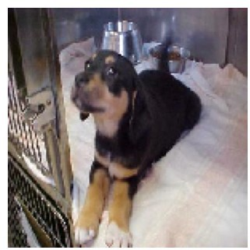
- "Sistem mendeteksi gambar ini sebagai ANJING!"
⚠ ️ Gambar dilewati karena masalah pemuatan berkas.
- Deteksi berkala berhasil dihentikan oleh pengguna!

Username : kevinandrianpolitama
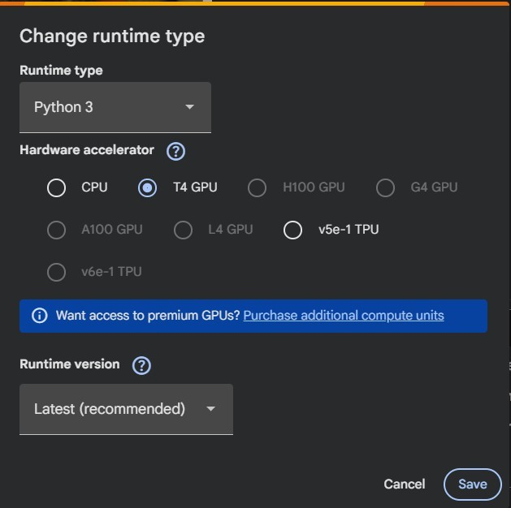
Api Token : KGAT_c52f27870c92f5ad39fe0d39d1f049ac NOTE : Untuk Runtime gunakan T4(Python 3)

