CyberTeaches Academy · Lesson 11 classwork

If / else
Name: ____________________________ Date: ______________
F = move forward
L = turn left
R = turn right
C = collect crystal
X = fire cannon
if path ahead [ F ] else [ R ] = if / else
until flag [ … ] = repeat until at flag

Part A · Trace the rover Follow the program one block at a time.
Draw the rover's path with a pencil.
1 | 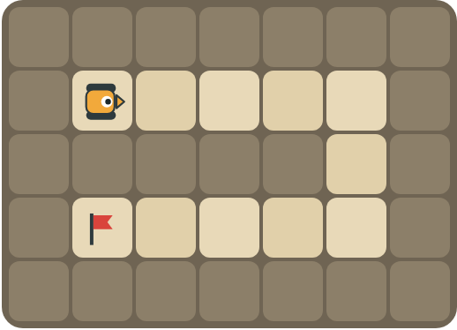 | Program: until flag [ if path ahead [ F ] else [ R ] ]  Draw the path. How many times does the rover turn right?  ______________________________

2 | 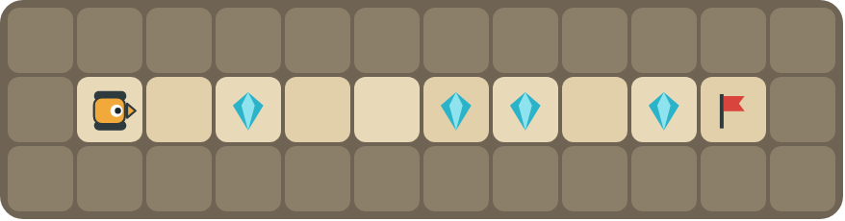 | Program: until flag [ F if crystal here [ C ] ]  How many crystals does it collect? Does it ever try to collect on an empty square?  ______________________________  ______________________________

Part B · Write the program Use the letters above.
Use if / else inside repeat until at flag. Write it like the key at the top.
3 | 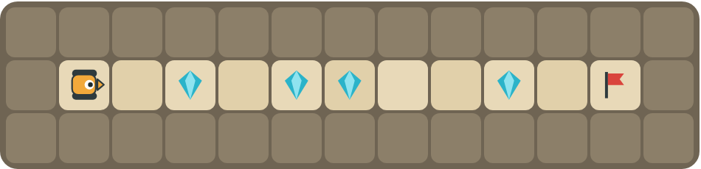 | If there is a crystal, collect it. Else, move forward.  ______________________________  ______________________________  How many blocks? ______

4 | 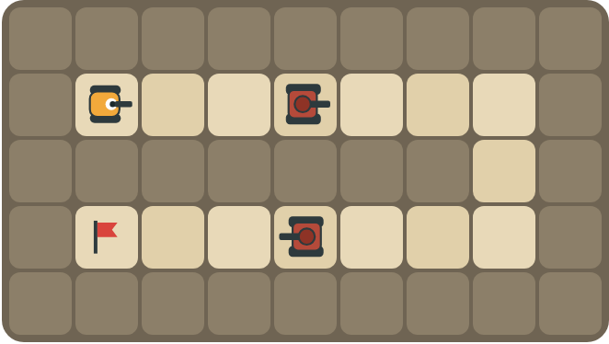 | Fire at tanks, move when the path is open, and turn right at walls.  ______________________________  ______________________________  How many blocks? ______

Part C · Complete the sentence If … else in words
Write each rule as an if / else for the rover.
# | Rule | If / else
5 | If the path ahead is open, move. Otherwise turn left.
6 | Collect a crystal when there is one here.
7 | Fire if a tank is ahead, otherwise move forward.
8 | Move if you can. If not, turn left if there is a path left, otherwise turn right.

Part D · Design your own Challenge
Draw a winding road from the rover to a flag (⚑), with rocks around it. Write one program with if / else that drives the whole road, then swap with a partner and test it.
 | My program:  ______________________________  ______________________________  ______________________________  Blocks: ______ Partner checked: ______

Reflect
Why is one if / else program better than a long list of moves for a new maze?
______________________________
______________________________

Part E · Words and pictures Language practice
Draw a line from each word to its meaning.
- if / else (si / si no)  - condition (condición)  - decision (decisión)  - nested if (condicional anidado)  - until (hasta que) | - choosing what to do  - keep going up to the moment something happens  - if yes, do one thing; if no, do another thing  - an if / else inside another if / else  - a question with a yes or no answer
Circle the best answer.
9. Which block makes a decision?
a)  b) 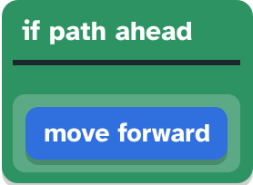 c) 
10. There is a wall ahead. What does if path ahead [ F ] else [ R ] do?
a) moves forward b) turns right
Finish each sentence. Use the word bank.
Word bank: [ Else ] [ condition ] [ then ]
11. If there is a path ahead, _______________ the rover moves forward.
12. _______________, the rover turns right.
13. The rover checks the _______________ at every step.

Lesson 11 classwork

Answer key
(TEACHER ONLY)

Lesson timing (50 minutes)
5 min Warm-up: Choose your path (slide 3)
10 min Direct instruction: slides 4 to 6
5 min Guided practice: think, pair, share and debugging tips (slides 7 to 8)
12 min Unplugged practice: this classwork, in pairs. Part D for early finishers
15 min Independent practice: code puzzles 11.1 to 11.10 at cyberteaches.com/academy
3 min Closure: exit ticket (last slide)

Part A
1. 2 times. It turns at the top-right corner (to face down) and at the bottom-right corner (to face left), then drives to the flag.
2. All 4. No. It only collects when there is a crystal here, so empty squares are skipped.

Part B
3. until flag [ if crystal here [ C ] else [ F ] ] · 4 blocks
4. until flag [ if tank ahead [ X ] else [ if path ahead [ F ] else [ R ] ] ] · 6 blocks

Part C
# | Answer
5 | if path ahead [ F ] else [ L ]
6 | if crystal here [ C ]
7 | if tank ahead [ X ] else [ F ]
8 | if path ahead [ F ] else [ if path left [ L ] else [ R ] ]

Part E
Matching: 1–c, 2–e, 3–a, 4–d, 5–b
9. b) if path aheadmove forward
10. b) turns right
11. then
12. Else
13. condition

Part D and Reflect
Answers vary. Look for a correct start direction, a program a partner can follow, and if / else inside repeat until. Reflection: the if / else decides at every step, so the same program works on roads it has never seen.

Exit ticket
if crystal here [ C ] else [ F ]

