CyberTeaches Academy · Lesson 7 classwork

Tank battle
Name: ____________________________ Date: ______________
F = move forward
L = turn left
R = turn right
X = fire cannon
if tank [ X ] = if tank ahead, fire
until no tanks [ … ] = repeat until no tanks left

Part A · Trace the rover Follow the program one block at a time.
Draw the rover's path. Cross out each tank it destroys.
1 | 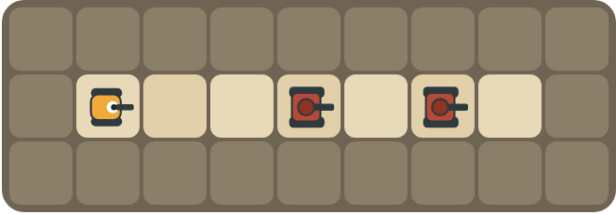 | Program: X X  How many tanks are destroyed? Why does the second shell hit the second tank?  ______________________________  ______________________________

2 | 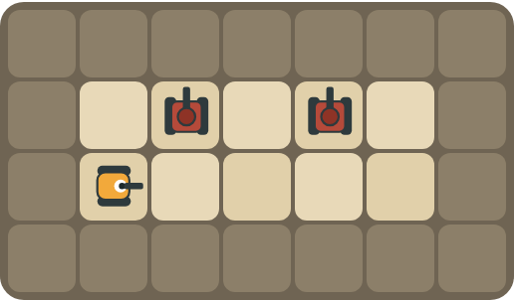 | Program: repeat 4 [ F L if tank [ X ] R ]  At which squares does the rover fire? How many shells does it use?  ______________________________  ______________________________

Part B · Write the program Use the letters above.
Face each tank before you fire. Use X for fire cannon.
3 | 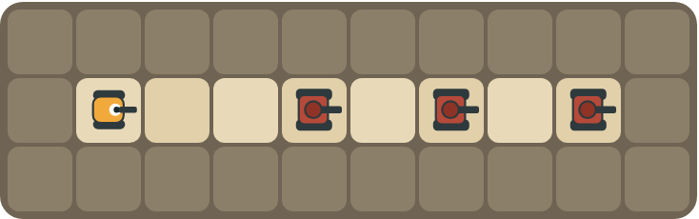 | Destroy all 3 tanks.  ______________________________  ______________________________  How many blocks? ______

4 | 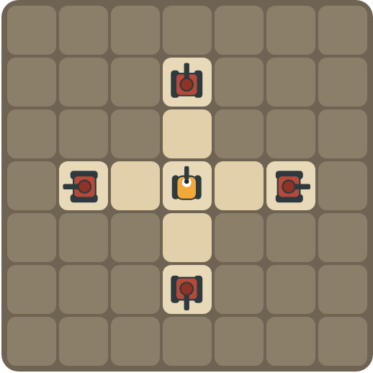 | The rover faces up. Tanks are on every side. Destroy them all.  ______________________________  ______________________________  How many blocks? ______

Part C · If or not? Does the patrol need an if?
For each patrol, say whether the rover needs if tank ahead before it fires, and why.
# | Patrol | Need "if tank ahead"? Why?
5 | A tank above every square of the road.
6 | Tanks above some squares only.
7 | You don't know how many tanks there are.
8 | One tank, straight ahead.

Part D · Design your own Challenge
Draw a rover (with an arrow), rocks (shade the square) and enemy tanks (draw a box with an arrow for its cannon). Write a program that destroys every tank, then swap with a partner.
 | My program:  ______________________________  ______________________________  ______________________________  Blocks: ______ Partner checked: ______

Reflect
Explain the red ! warning. What should the rover do next?
______________________________
______________________________

Part E · Words and pictures Language practice
Draw a line from each word to its meaning.
- enemy tank (tanque enemigo)  - fire (disparar)  - condition (condición)  - loop (bucle)  - debug (depurar) | - a question with a yes or no answer  - find a mistake and fix it  - a tank the rover must stop with its cannon  - a block that repeats the blocks inside it  - shoot the cannon straight ahead
Circle the best answer.
9. Which block shoots the cannon?
a)  b)  c) 
10. Which block checks for a tank first?
a) 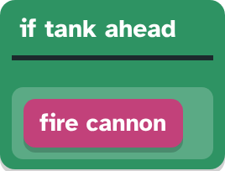 b) 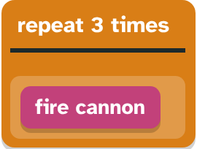
Finish each sentence. Use the word bank.
Word bank: [ fires ] [ straight ] [ tanks ]
11. If a tank is ahead, then the rover _______________.
12. The shell flies _______________ until it hits a tank or a rock.
13. The loop stops when no _______________ are left.

Lesson 7 classwork

Answer key
(TEACHER ONLY)

Lesson timing (50 minutes)
5 min Warm-up: Look before you act (slide 3)
10 min Direct instruction: slides 4 to 7
5 min Guided practice: think, pair, share and debugging tips (slides 8 to 9)
12 min Unplugged practice: this classwork, in pairs. Part D for early finishers
15 min Independent practice: code puzzles 7.1 to 7.10 at cyberteaches.com/academy
3 min Closure: exit ticket (last slide)

Part A
1. 2 tanks. The first shell hits the nearest tank. Then the path is clear, so the second shell flies to the next tank.
2. It fires at the 1st and 3rd squares. 2 shells. It looks up at every square but only fires when a tank is ahead.

Part B
3. repeat 3 [ X ] · 2 blocks
4. repeat 4 [ X R ] · 3 blocks

Part C
# | Answer
5 | No: there is always a tank, so fire every time (but if tank ahead also works).
6 | Yes: otherwise the rover wastes shells on empty squares.
7 | Yes, and use repeat until no tanks left.
8 | No: just fire once.

Part E
Matching: 1–c, 2–e, 3–a, 4–d, 5–b
9. b) fire cannon
10. a) if tank aheadfire cannon
11. fires
12. straight
13. tanks

Part D and Reflect
Answers vary. Look for a correct start direction, a program a partner can follow, and a working patrol. Reflection: a tank has spotted the rover. On the next move, the rover must fire at it or move out of its line of fire.

Exit ticket
So the rover only fires when a tank is there and does not waste its limited shells.

