CyberTeaches Academy · Lesson 9 classwork

Tank patrols
Name: ____________________________ Date: ______________
F = move forward
L = turn left
R = turn right
X = fire cannon
if tank [ X ] = if tank ahead, fire
until no tanks [ … ] = repeat until no tanks left

Part A · Trace the rover Follow the program one block at a time.
Draw the rover's path. Cross out each tank it destroys.
1 | 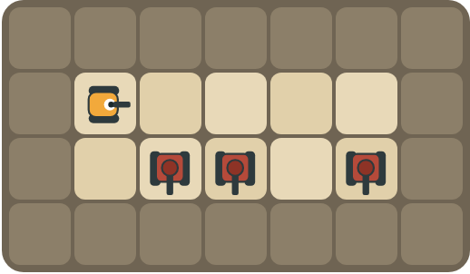 | Program: repeat 4 [ F R if tank [ X ] L ]  At which squares does the rover fire? How many tanks are destroyed?  ______________________________  ______________________________

2 | 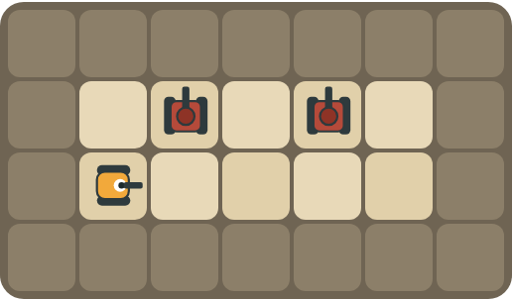 | Program: until no tanks [ F L if tank [ X ] ]  This patrol forgot to turn back. What goes wrong?  ______________________________  ______________________________

Part B · Write the program Use the letters above.
Use a patrol pattern. Use repeat until no tanks left when you don't want to count.
3 | 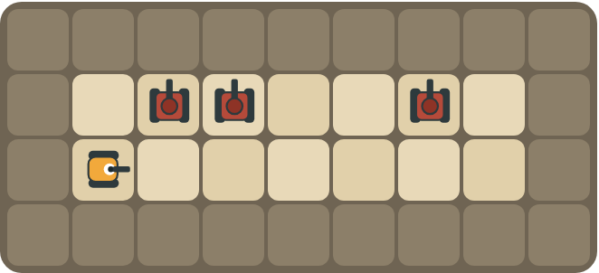 | Patrol until no tanks are left.  ______________________________  ______________________________  How many blocks? ______

4 | 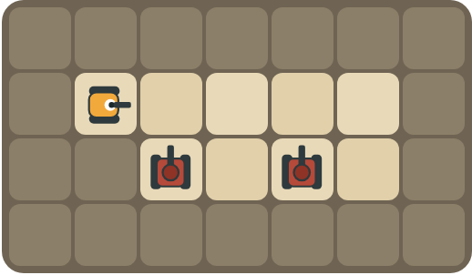 | Two guards watch the road. Get behind them and fire from the side.  ______________________________  ______________________________  How many blocks? ______

Part C · Fix the patrol Each patrol has a bug.
Read the patrol and the problem. Write the fixed patrol.
# | Patrol and problem | Fixed patrol
5 | until no tanks [ F L X R ]  Tanks are only above some squares. The rover runs out of shells.
6 | until no tanks [ F L if tank [ X ] ]  The rover drives up into the rocks.
7 | until no tanks [ F L if tank [ X ] R ]  The tanks are below the road.
8 | repeat 2 [ F L if tank [ X ] R ]  There are 6 squares with tanks somewhere above them.

Part D · Design your own Challenge
Draw a rover (with an arrow), rocks (shade the square) and enemy tanks (draw a box with an arrow for its cannon). Write a program that destroys every tank, then swap with a partner.
 | My program:  ______________________________  ______________________________  ______________________________  Blocks: ______ Partner checked: ______

Reflect
Why does the rover turn back after it looks for a tank?
______________________________
______________________________

Part E · Words and pictures Language practice
Draw a line from each word to its meaning.
- condition (condición)  - enemy tank (tanque enemigo)  - fire (disparar)  - loop (bucle)  - debug (depurar) | - shoot the cannon straight ahead  - find a mistake and fix it  - a question with a yes or no answer  - a block that repeats the blocks inside it  - a tank the rover must stop with its cannon
Circle the best answer.
9. Tanks are below the road. Which turn looks at them?
a)  b) 
10. Which loop stops when every tank is gone?
a) 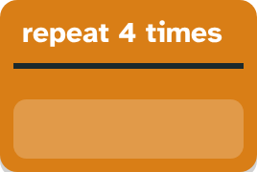 b) 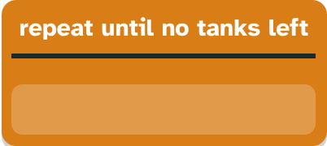
Finish each sentence. Use the word bank.
Word bank: [ back ] [ left ] [ then ]
11. At every square, the rover looks. If a tank is there, _______________ it fires.
12. After it looks up, the rover turns _______________.
13. The patrol stops when no tanks are _______________.

Lesson 9 classwork

Answer key
(TEACHER ONLY)

Lesson timing (50 minutes)
5 min Warm-up: Security guard (slide 3)
10 min Direct instruction: slides 4 to 6
5 min Guided practice: think, pair, share and debugging tips (slides 7 to 8)
12 min Unplugged practice: this classwork, in pairs. Part D for early finishers
15 min Independent practice: code puzzles 9.1 to 9.10 at cyberteaches.com/academy
3 min Closure: exit ticket (last slide)

Part A
1. At squares 1, 2 and 4. All 3 tanks. It looks down at every square and fires only where a tank is.
2. It destroys the first tank, then drives in a small circle forever. Without R, every lap turns left again, so the rover goes around one little square and never reaches the second tank.

Part B
3. until no tanks [ F L if tank [ X ] R ] · 6 blocks
4. repeat 4 [ F ] R F R repeat 2 [ X ] · 7 blocks

Part C
# | Answer
5 | until no tanks [ F L if tank [ X ] R ]
6 | until no tanks [ F L if tank [ X ] R ] (turn back)
7 | until no tanks [ F R if tank [ X ] L ]
8 | until no tanks [ F L if tank [ X ] R ] (or repeat 6)

Part E
Matching: 1–c, 2–e, 3–a, 4–d, 5–b
9. b) turn right
10. b) repeat until no tanks left
11. then
12. back
13. left

Part D and Reflect
Answers vary. Look for a correct start direction, a program a partner can follow, and a patrol that turns back. Reflection: so it faces along the road again and the next move forward goes to the next square.

Exit ticket
until no tanks [ F R if tank [ X ] L ]

