CyberTeaches Academy · Lesson 1 classwork · Easy level (digital)

Repeat and collect
Name: ______________________ Date: ____________
Block letters: F = move forward · L = turn left · R = turn right · C = collect crystal · repeat 3 [ F C ] = do F C three times

Part A · Trace the rover · Follow the program one block at a time.
Follow the program on the map one block at a time. Type your answers in the shaded boxes.

Question 1
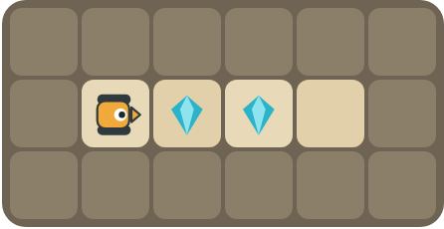
Program: F C F F
How many crystals does the rover collect? Which crystal is left? Why?

Question 2
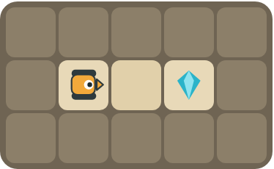
Program: repeat 2 [ F ] C
Does the rover collect the crystal? Where does it stop?

Part B · Write the program · Use the letters above.
Look at which way the rover faces. Left and right are from the rover's point of view.

Question 3
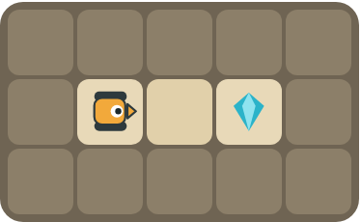
Write the program.
How many blocks?

Question 4
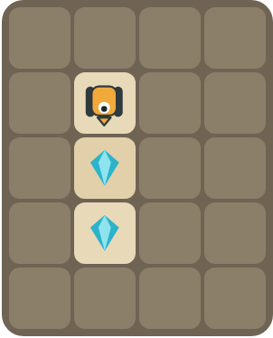
The rover faces down. Collect both crystals with 3 blocks.
How many blocks?

Part C · Find the pattern · Make each program shorter with repeat.
Find the pattern. Rewrite the program with a repeat block and count the blocks. A repeat counts as 1 block, plus the blocks inside it.
# | Long program | With repeat | Blocks before → after
5 | F C F C F C |  | 6 → ____
6 | F C F C F C F C F C |  | 10 → ____
7 | F F C F F C |  | 6 → ____
8 | R F C F C F C |  | 7 → ____

Part D · Design your own · Challenge
Build a map in the grid below with a rover, rocks and crystals (◆). Write the shortest program you can with a repeat, then swap with a partner and check each other's work.
Build your map: click a square and type a symbol. R> R< R^ Rv = rover and the way it faces, # = rock, C = crystal, F = flag. You can also fill a square with color (Format → Table → Table properties → Cell background color).
My program:
Blocks:
Partner checked (partner's name):

Reflect
In your own words, when should you use a repeat block?

Part E · Words and pictures · Language practice
Type the letter of the matching meaning in the box next to each word.
Meanings
a) steps that happen again and again
b) find a mistake and fix it
c) a list of steps for a computer
d) a block that repeats the blocks inside it
e) steps that happen in order, one after another
# | Word | Letter
1 | program (programa)
2 | sequence (secuencia)
3 | pattern (patrón)
4 | loop (bucle)
5 | debug (depurar)
Type the letter of the best answer in the box.
9. Which block picks up a crystal?
a) 
b) 
c) 
Answer:
10. Which program is shorter?
a) F C F C F C
b) repeat 3 [ F C ]
Answer:
Finish each sentence. Type the missing words in the box. Use the word bank.
Word bank: [ collects ] [ forward ] [ pattern ] [ repeat ]
11. First, the rover moves ______. Then it ______ the crystal.
12. The same steps happen again and again. This is a ______.
13. I use a ______ block to make my program shorter.

