CyberTeaches Academy · Lesson 1 classwork · Medium level

Repeat and collect
Name: ____________________________ Date: ______________
F = move forward
L = turn left
R = turn right
C = collect crystal
repeat 3 [ F C ] = do F C three times

Part A · Trace the rover Follow the program one block at a time.
Draw the rover's path with a pencil.
1 | 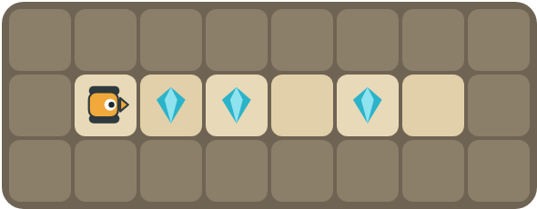 | Program: F C F C F F  Circle the crystals it collects. Which crystal is not collected? Why?  ______________________________  ______________________________

2 | 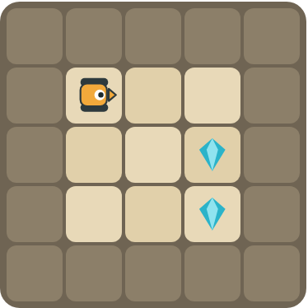 | Program: repeat 2 [ F ] R repeat 2 [ F C ]  Does the rover collect both crystals? Mark the square where it stops.  ______________________________

Part B · Write the program Use the letters above.
Look at which way the rover faces. Left and right are from the rover's point of view.
3 | 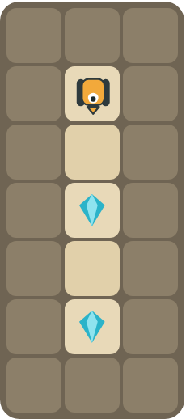 | The rover faces down. There is an empty square before each crystal. Write the shortest program.  ______________________________  ______________________________  How many blocks? ______

4 | 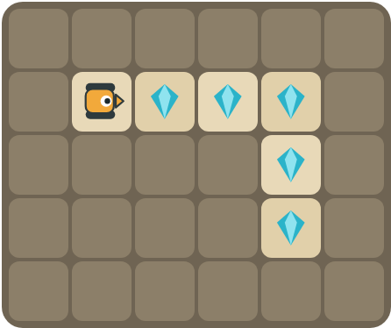 | Collect the top row, turn right, and collect the 2 crystals going down.  ______________________________  ______________________________  How many blocks? ______

Part C · Find the pattern Make each program shorter with repeat.
Underline the pattern. Rewrite the program with a repeat block and count the blocks. A repeat counts as 1 block, plus the blocks inside it.
# | Long program | With repeat | Blocks before → after
5 | F C F C F C F C F C |  | 10 → ____
6 | F F C F F C F F C |  | 9 → ____
7 | F C R F C L F C R F C L |  | 12 → ____
8 | F C F C F C R F C F C F C R  Challenge: use a repeat inside a repeat. |  | 14 → ____

Part D · Design your own Challenge
Draw a rover (with an arrow for the way it faces), some rocks (shade the square) and crystals (◆). Write the shortest program you can with a repeat, then swap with a partner and check each other's work.
 | My program:  ______________________________  ______________________________  ______________________________  Blocks: ______ Partner checked: ______

Reflect
In your own words, when should you use a repeat block?
______________________________
______________________________

Part E · Words and pictures Language practice
Draw a line from each word to its meaning.
- program (programa)  - sequence (secuencia)  - pattern (patrón)  - loop (bucle)  - debug (depurar) | - steps that happen again and again  - find a mistake and fix it  - a list of steps for a computer  - a block that repeats the blocks inside it  - steps that happen in order, one after another
Circle the best answer.
9. Which block picks up a crystal?
a)  b)  c) 
10. Which program is shorter?
a) F C F C F C b) repeat 3 [ F C ]
Finish each sentence. Use the word bank.
Word bank: [ collects ] [ forward ] [ pattern ] [ repeat ]
11. First, the rover moves _______________. Then it _______________ the crystal.
12. The same steps happen again and again. This is a _______________.
13. I use a _______________ block to make my program shorter.

Lesson 1 classwork · Medium level

Answer key
(TEACHER ONLY)

Lesson timing (50 minutes)
5 min Warm-up: Be the robot (slide 3)
10 min Direct instruction: slides 4 to 10
5 min Guided practice: think, pair, share and debugging tips (slides 11 to 12)
12 min Unplugged practice: this classwork, in pairs. Part D for early finishers
15 min Independent practice: code puzzles 1.1 to 1.10 at cyberteaches.com/academy
3 min Closure: exit ticket (last slide)

Part A
1. The last crystal is not collected. The program drives onto it with F F but never uses C there.
2. Yes, both. F F moves right, R turns to face down, then F C twice collects both. It stops on the bottom crystal.

Part B
3. repeat 2 [ F F C ] · 4 blocks
4. repeat 3 [ F C ] R repeat 2 [ F C ] · 7 blocks

Part C
# | Answer
5 | repeat 5 [ F C ] · 10 → 3
6 | repeat 3 [ F F C ] · 9 → 4
7 | repeat 2 [ F C R F C L ] · 12 → 7
8 | repeat 2 [ repeat 3 [ F C ] R ] · 14 → 5

Part E
Matching: 1–c, 2–e, 3–a, 4–d, 5–b
9. b) collect crystal
10. b) repeat 3 [ F C ]
11. forward / collects
12. pattern
13. repeat

Part D and Reflect
Answers vary. Look for a correct start direction, a program a partner can follow, and a repeat used for any pattern. Reflection: use a repeat when the same steps happen again and again; it makes the program shorter and easier to read and fix.

Exit ticket
repeat 5 [ F C ] · 3 blocks

