CyberTeaches Academy · Lesson 12 classwork · Medium level (digital)

If / else practice
Name: ______________________ Date: ____________
Block letters: F = move forward · L = turn left · R = turn right · C = collect crystal · X = fire cannon · if path ahead [ F ] else [ R ] = if / else · until flag [ … ] = repeat until at flag

Part A · Trace the rover · Follow the program one block at a time.
Follow the program on the map one block at a time. Type your answers in the shaded boxes.

Question 1
Program: until flag [ if crystal here [ C ] else [ F ] ]
How many times does the rover collect? How many times does it move?

Question 2
Program: until flag [ if tank ahead [ X ] else [ F ] ]
When does the rover fire its first shell?

Part B · Write the program · Use the letters above.
Choose the right question for the if / else.

Question 3
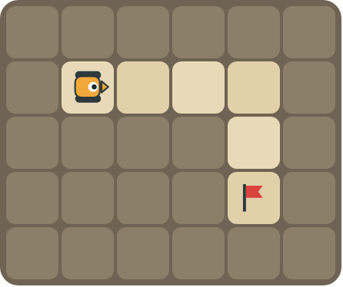
Turn right at the wall. Reach the flag.
How many blocks?

Question 4
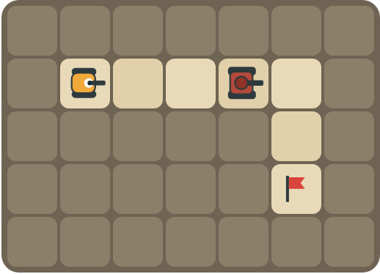
Fire at the tank and turn right at the wall.
How many blocks?

Part C · Which question? · Choose the condition
Look at what the rover must handle. Write the condition (path ahead, path left, path right, crystal here or tank ahead) and the if / else.
# | The road has… | If / else
5 | walls where it must turn right
6 | crystals on some squares
7 | tanks blocking the road
8 | turns both left and right

Part D · Design your own · Challenge
Build a winding road in the grid below from the rover to a flag (⚑), with rocks around it. Write one program with if / else that drives the whole road, then swap with a partner and test it.
Build your map: click a square and type a symbol. R> R< R^ Rv = rover and the way it faces, # = rock, C = crystal, F = flag. You can also fill a square with color (Format → Table → Table properties → Cell background color).
My program:
Blocks:
Partner checked (partner's name):

Reflect
How do you choose which question the rover should ask?

Part E · Words and pictures · Language practice
Type the letter of the matching meaning in the box next to each word.
Meanings
a) choosing what to do
b) find a mistake and fix it
c) if yes, do one thing; if no, do another thing
d) keep going up to the moment something happens
e) a question with a yes or no answer
# | Word | Letter
1 | if / else (si / si no)
2 | condition (condición)
3 | decision (decisión)
4 | until (hasta que)
5 | debug (depurar)
Type the letter of the best answer in the box.
9. The road has crystals on some squares. Which question?
a) path ahead
b) crystal here
c) tank ahead
Answer:
10. The road turns left at the wall. What goes in the else part?
a) 
b) 
c) 
Answer:
Finish each sentence. Type the missing words in the box. Use the word bank.
Word bank: [ collects ] [ fires ] [ turn left ]
11. If there is a crystal here, the rover ______ it.
12. If there is a tank ahead, the rover ______. Else it moves.
13. The road turns left, so the else part is ______.

