CyberTeaches Academy · Lesson 13 classwork · Easy level

If / else challenges
Name: ____________________________ Date: ______________
F = move forward
L = turn left
R = turn right
C = collect crystal
X = fire cannon
if path ahead [ F ] else [ R ] = if / else
until flag [ … ] = repeat until at flag

Part A · Trace the rover Follow the program one block at a time.
Draw the rover's path with a pencil.
1 | 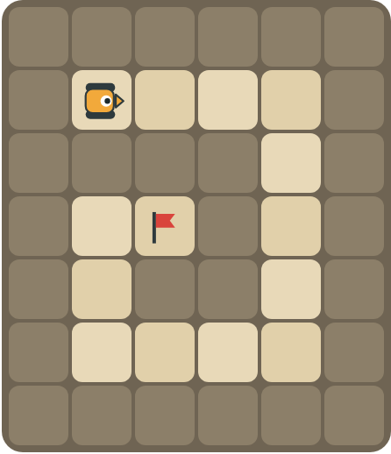 | Program: until flag [ if path ahead [ F ] else [ R ] ]  Follow the spiral. How many right turns does the rover make?  ______________________________

2 |  | Program: until flag [ if tank ahead [ X ] else [ F ] ]  Does the rover reach the flag? Does it collect the crystal?  ______________________________

Part B · Write the program Use the letters above.
Use if / else inside repeat until at flag. Think about the order of your checks.
3 | 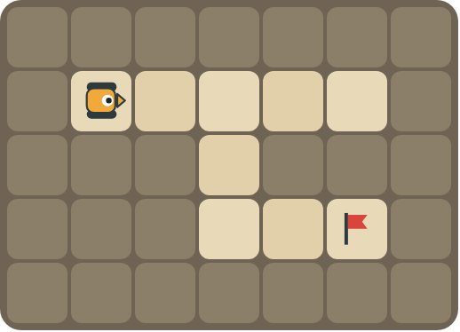 | Keep your right hand on the wall all the way to the flag.  ______________________________  ______________________________  How many blocks? ______

4 | 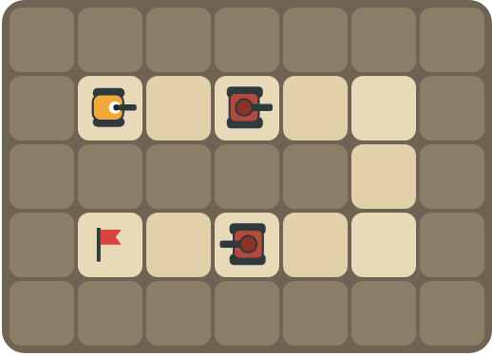 | Fire at tanks on both roads and turn right at walls.  ______________________________  ______________________________  How many blocks? ______

Part C · Order the checks Most important first
Number the checks in the best order (1 = check first), and explain why.
# | Checks | Order and reason
5 | path ahead · tank ahead
6 | crystal here · path ahead
7 | path right · path ahead · (else) turn left
8 | path ahead · crystal here · tank ahead

Part D · Design your own Challenge
Draw a winding road from the rover to a flag (⚑), with rocks around it. Write one program with if / else that drives the whole road, then swap with a partner and test it.
 | My program:  ______________________________  ______________________________  ______________________________  Blocks: ______ Partner checked: ______

Reflect
Why does the order of your if / else checks matter?
______________________________
______________________________

Part E · Words and pictures Language practice
Draw a line from each word to its meaning.
- nested if (condicional anidado)  - if / else (si / si no)  - condition (condición)  - algorithm (algoritmo)  - decision (decisión) | - a question with a yes or no answer  - choosing what to do  - an if / else inside another if / else  - a plan of steps to solve a problem  - if yes, do one thing; if no, do another thing
Circle the best answer.
9. Which should the rover check first?
a) path ahead b) tank ahead
10. The right-hand rule says: if there is a path right, …
a) turn right and move b) turn left c) stop
Finish each sentence. Use the word bank.
Word bank: [ first ] [ nested ] [ right ]
11. I check for a tank _______________ because it blocks the path.
12. If there is a path to the right, the rover turns _______________.
13. An if / else inside another if / else is a _______________ if.

Lesson 13 classwork · Easy level

Answer key
(TEACHER ONLY)

Lesson timing (50 minutes)
5 min Warm-up: Most important first (slide 3)
10 min Direct instruction: slides 4 to 5
5 min Guided practice: think, pair, share and debugging tips (slides 6 to 7)
12 min Unplugged practice: this classwork, in pairs. Part D for early finishers
15 min Independent practice: code puzzles 13.1 to 13.10 at cyberteaches.com/academy
3 min Closure: exit ticket (last slide)

Part A
1. 4 right turns. It turns at each corner of the spiral and reaches the flag after the fourth turn.
2. It reaches the flag but never collects the crystal. There is no crystal check in the program, so it drives over the crystal.

Part B
3. until flag [ if path right [ R F ] else [ if path ahead [ F ] else [ L ] ] ] · 7 blocks
4. until flag [ if tank ahead [ X ] else [ if path ahead [ F ] else [ R ] ] ] · 6 blocks

Part C
# | Answer
5 | 1 tank ahead, 2 path ahead: a tank blocks the path.
6 | 1 crystal here, 2 path ahead: collect before you leave the square.
7 | 1 path right, 2 path ahead, 3 turn left: the right-hand rule.
8 | 1 tank ahead, 2 crystal here, 3 path ahead.

Part E
Matching: 1–c, 2–e, 3–a, 4–d, 5–b
9. b) tank ahead
10. a) turn right and move
11. first
12. right
13. nested

Part D and Reflect
Answers vary. Look for a correct start direction, a program a partner can follow, and checks in a sensible order. Reflection: the first check that is true decides the action, so the most important thing (like a tank) must be checked first.

Exit ticket
tank ahead → crystal here → path ahead (most important first)

