CyberTeaches Academy · Lesson 6 classwork · Medium level

Repeat until patterns
Name: ____________________________ Date: ______________
F = move forward
L = turn left
R = turn right
C = collect crystal
until flag [ F ] = repeat until at flag

Part A · Trace the rover Follow the program one block at a time.
Draw the rover's path with a pencil.
1 | 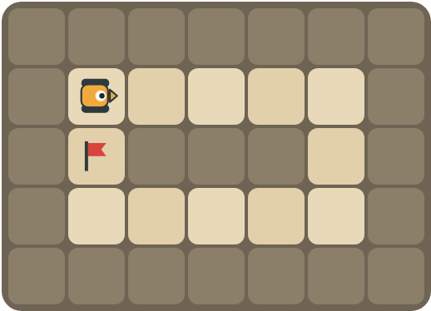 | Program: until flag [ repeat 4 [ F ] R repeat 2 [ F ] R ]  Draw the path. Does it reach the flag?  ______________________________

2 |  | Program: until flag [ F C F C F ]  How many times does the loop run? How many crystals are collected?  ______________________________  ______________________________

Part B · Write the program Use the letters above.
Find one copy of the pattern. You can use a repeat inside repeat until.
3 | 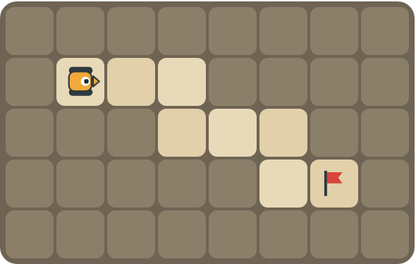 | Each step of the stairs is two squares wide. Drive to the flag.  ______________________________  ______________________________  How many blocks? ______

4 | 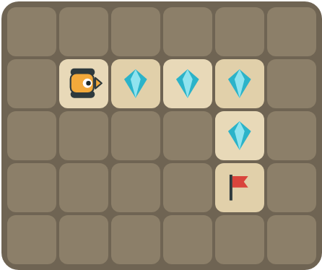 | Collect the crystals along the top, then turn and collect down to the flag.  ______________________________  ______________________________  How many blocks? ______

Part C · Find the pattern Then use repeat until.
Each long program ends at a flag. Rewrite it with repeat until at flag (and a repeat inside if it helps).
# | Long program (ends at the flag) | With repeat until
5 | F C F F C F F C F
6 | F F R F L F F R F L F F R F L
7 | F F F R F F F R F F F R
8 | F C F C F C R F F F F

Part D · Design your own Challenge
Draw a rover (with an arrow for the way it faces), rocks (shade the square), crystals (◆) and a flag (⚑). Write a program that uses repeat until at flag, then swap with a partner.
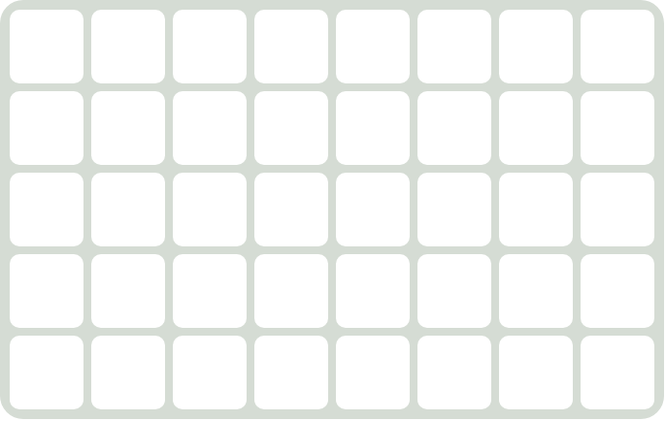 | My program:  ______________________________  ______________________________  ______________________________  Blocks: ______ Partner checked: ______

Reflect
When do you use a plain repeat and repeat until in the same program?
______________________________
______________________________

Part E · Words and pictures Language practice
Draw a line from each word to its meaning.
- pattern (patrón)  - nested loop (bucle anidado)  - until (hasta que)  - flag (bandera)  - algorithm (algoritmo) | - keep going up to the moment something happens  - a plan of steps to solve a problem  - steps that happen again and again  - the goal square the rover must reach  - a loop inside another loop
Circle the best answer.
9. Which program has a repeat inside repeat until?
a) until flag [ F ] b) until flag [ repeat 4 [ F ] R ]
10. Which part of this program do we count: repeat 3 [ F C ] R until flag [ F ]?
a) repeat 3 [ F C ] b) until flag [ F ]
Finish each sentence. Use the word bank.
Word bank: [ F C F ] [ flag ] [ then ]
11. Inside the loop, the pattern is _______________.
12. I count the first part, _______________ I use repeat until.
13. The rover stops when it reaches the _______________.

Lesson 6 classwork · Medium level

Answer key
(TEACHER ONLY)

Lesson timing (50 minutes)
5 min Warm-up: Lap the track (slide 3)
10 min Direct instruction: slides 4 to 5
5 min Guided practice: think, pair, share and debugging tips (slides 6 to 7)
12 min Unplugged practice: this classwork, in pairs. Part D for early finishers
15 min Independent practice: code puzzles 6.1 to 6.10 at cyberteaches.com/academy
3 min Closure: exit ticket (last slide)

Part A
1. Yes. Long side (4), turn, short side (2), turn, long side back, turn, and it reaches the flag on the short side.
2. 3 times, 6 crystals. Each time it collects 2 crystals and steps over the gap. After 3 times it is on the flag.

Part B
3. until flag [ F F R F L ] · 6 blocks
4. repeat 3 [ F C ] R until flag [ F C ] · 7 blocks

Part C
# | Answer
5 | until flag [ F C F ]
6 | until flag [ F F R F L ]
7 | until flag [ repeat 3 [ F ] R ] (if the flag is at the end of a side)
8 | repeat 3 [ F C ] R until flag [ F ]

Part E
Matching: 1–c, 2–e, 3–a, 4–d, 5–b
9. b) until flag [ repeat 4 [ F ] R ]
10. a) repeat 3 [ F C ]
11. F C F
12. then
13. flag

Part D and Reflect
Answers vary. Look for a correct start direction, a program a partner can follow, and a mix of repeat and repeat until. Reflection: use a plain repeat for the part you can count, and repeat until at flag for the part that goes all the way to the flag.

Exit ticket
It drives 3 squares and turns right, again and again, until it reaches the flag (a square path).

