CyberTeaches Academy · Lesson 8 classwork · Medium level

Tank practice
Name: ____________________________ Date: ______________
F = move forward
L = turn left
R = turn right
X = fire cannon

Part A · Trace the rover Follow the program one block at a time.
Draw the rover's path. Cross out each tank it destroys.
1 | 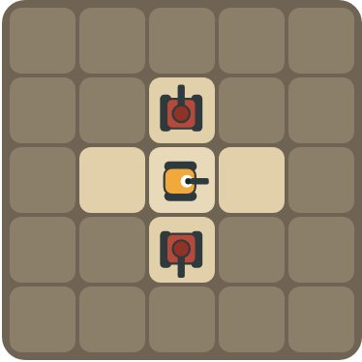 | Program: L X R R X  Which tanks are destroyed? Which way does the rover face at the end?  ______________________________  ______________________________

2 | 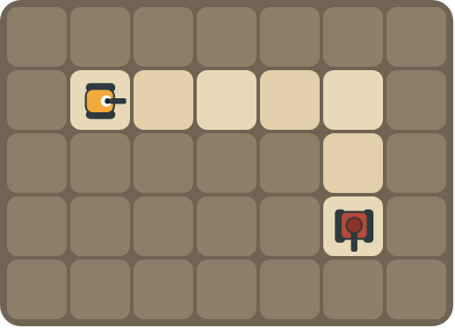 | Program: repeat 4 [ F ] X  Does the rover destroy the tank? Why or why not?  ______________________________  ______________________________

Part B · Write the program Use the letters above.
Turn to face the tank, then fire. Use X for fire cannon.
3 |  | The tank is behind the rover. Turn around and fire.  ______________________________  ______________________________  How many blocks? ______

4 | 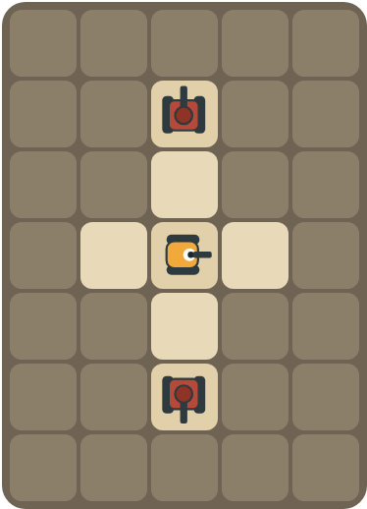 | One tank above, one below. Destroy both with 5 blocks.  ______________________________  ______________________________  How many blocks? ______

Part C · Which way? Turns to face the tank
The rover faces the first direction. Write the turns it needs to face the tank (use L and R). Try to use as few turns as possible.
# | Rover faces → tank is | Turns
5 | right → up
6 | up → right
7 | right → left (behind)
8 | down → right

Part D · Design your own Challenge
Draw a rover (with an arrow), rocks (shade the square) and enemy tanks (draw a box with an arrow for its cannon). Write a program that destroys every tank, then swap with a partner.
 | My program:  ______________________________  ______________________________  ______________________________  Blocks: ______ Partner checked: ______

Reflect
How do you know which way to turn before you fire?
______________________________
______________________________

Part E · Words and pictures Language practice
Draw a line from each word to its meaning.
- fire (disparar)  - enemy tank (tanque enemigo)  - sequence (secuencia)  - debug (depurar)  - pattern (patrón) | - steps that happen in order, one after another  - steps that happen again and again  - shoot the cannon straight ahead  - find a mistake and fix it  - a tank the rover must stop with its cannon
Circle the best answer.
9. The rover faces right. The tank is up. Which turn?
a)  b) 
10. How many right turns make the rover face the other way?
a) 1 b) 2 c) 4
Finish each sentence. Use the word bank.
Word bank: [ first ] [ right ] [ turns ]
11. The tank is behind the rover, so it turns _______________ two times.
12. First the rover _______________. Then it fires.
13. The shell hits the _______________ tank in the line.

Lesson 8 classwork · Medium level

Answer key
(TEACHER ONLY)

Lesson timing (50 minutes)
5 min Warm-up: Point and shoot (slide 3)
10 min Direct instruction: slides 4 to 6
5 min Guided practice: think, pair, share and debugging tips (slides 7 to 8)
12 min Unplugged practice: this classwork, in pairs. Part D for early finishers
15 min Independent practice: code puzzles 8.1 to 8.10 at cyberteaches.com/academy
3 min Closure: exit ticket (last slide)

Part A
1. Both tanks. It faces down. Left turns it up (fire), then two right turns face down (fire).
2. No. After driving it still faces right, toward a rock. It needs to turn right (face down) before firing.

Part B
3. R R X · 3 blocks
4. L X R R X · 5 blocks

Part C
# | Answer
5 | L
6 | R
7 | R R (or L L)
8 | L (facing down, the rover's left is the right side of the page)

Part E
Matching: 1–c, 2–e, 3–a, 4–d, 5–b
9. a) turn left
10. b) 2
11. right
12. turns
13. first

Part D and Reflect
Answers vary. Look for a correct start direction, a program a partner can follow, and turns before each fire. Reflection: imagine you are the rover. Turn the way that points your cannon at the tank, from the rover's point of view.

Exit ticket
L X · 2 blocks

