CyberTeaches Academy · Lesson 12 classwork · Easy level

If / else practice
Name: ____________________________ Date: ______________
F = move forward
L = turn left
R = turn right
C = collect crystal
X = fire cannon
if path ahead [ F ] else [ R ] = if / else
until flag [ … ] = repeat until at flag

Part A · Trace the rover Follow the program one block at a time.
Draw the rover's path with a pencil.
1 | 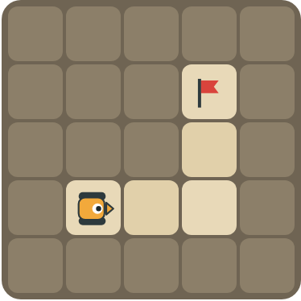 | Program: until flag [ if path ahead [ F ] else [ R ] ]  The road turns left, but the else part turns right. What happens?  ______________________________

2 |  | Program: until flag [ if tank ahead [ X ] else [ F ] ]  How many shells does it fire? Does it reach the flag?  ______________________________

Part B · Write the program Use the letters above.
Choose the right question for the if / else.
3 | 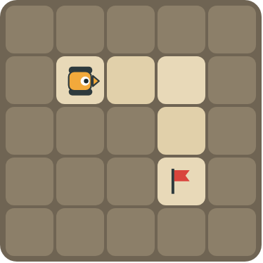 | Turn right at the wall. Reach the flag.  ______________________________  ______________________________  How many blocks? ______

4 | 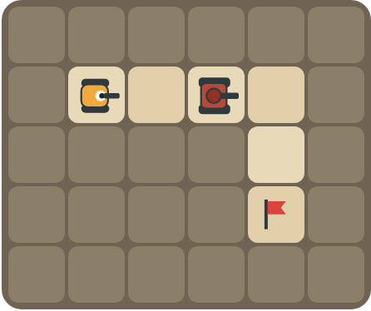 | Fire at the tank and turn right at the wall.  ______________________________  ______________________________  How many blocks? ______

Part C · Which question? Choose the condition
Look at what the rover must handle. Write the condition (path ahead, path left, path right, crystal here or tank ahead) and the if / else.
# | The road has… | If / else
5 | walls where it must turn right
6 | crystals on some squares
7 | tanks blocking the road
8 | turns both left and right

Part D · Design your own Challenge
Draw a winding road from the rover to a flag (⚑), with rocks around it. Write one program with if / else that drives the whole road, then swap with a partner and test it.
 | My program:  ______________________________  ______________________________  ______________________________  Blocks: ______ Partner checked: ______

Reflect
How do you choose which question the rover should ask?
______________________________
______________________________

Part E · Words and pictures Language practice
Draw a line from each word to its meaning.
- if / else (si / si no)  - condition (condición)  - decision (decisión)  - until (hasta que)  - debug (depurar) | - choosing what to do  - find a mistake and fix it  - if yes, do one thing; if no, do another thing  - keep going up to the moment something happens  - a question with a yes or no answer
Circle the best answer.
9. The road has crystals on some squares. Which question?
a) path ahead b) crystal here c) tank ahead
10. The road turns left at the wall. What goes in the else part?
a)  b)  c) 
Finish each sentence. Use the word bank.
Word bank: [ collects ] [ fires ] [ turn left ]
11. If there is a crystal here, the rover _______________ it.
12. If there is a tank ahead, the rover _______________. Else it moves.
13. The road turns left, so the else part is _______________.

Lesson 12 classwork · Easy level

Answer key
(TEACHER ONLY)

Lesson timing (50 minutes)
5 min Warm-up: Thumbs up, thumbs down (slide 3)
10 min Direct instruction: slides 4 to 6
5 min Guided practice: think, pair, share and debugging tips (slides 7 to 8)
12 min Unplugged practice: this classwork, in pairs. Part D for early finishers
15 min Independent practice: code puzzles 12.1 to 12.10 at cyberteaches.com/academy
3 min Closure: exit ticket (last slide)

Part A
1. The rover gets stuck turning at the corner. At the wall it turns right into another wall, and keeps turning. It never reaches the flag.
2. 1 shell, and yes. The tank is ahead at the start, so it fires once. After that the path is clear and it moves to the flag.

Part B
3. until flag [ if path ahead [ F ] else [ R ] ] · 4 blocks
4. until flag [ if tank ahead [ X ] else [ if path ahead [ F ] else [ R ] ] ] · 6 blocks

Part C
# | Answer
5 | if path ahead [ F ] else [ R ]
6 | F then if crystal here [ C ]
7 | if tank ahead [ X ] else [ F ]
8 | if path ahead [ F ] else [ if path left [ L ] else [ R ] ]

Part E
Matching: 1–c, 2–e, 3–a, 4–d, 5–b
9. b) crystal here
10. a) turn left
11. collects
12. fires
13. turn left

Part D and Reflect
Answers vary. Look for a correct start direction, a program a partner can follow, and a sensible condition. Reflection: look at what changes on the map from square to square (walls, crystals or tanks) and ask about that.

Exit ticket
if tank ahead [ X ] else [ F ]

