CyberTeaches Academy · Lesson 8 classwork · Easy level (digital)

Tank practice
Name: ______________________ Date: ____________
Block letters: F = move forward · L = turn left · R = turn right · X = fire cannon

Part A · Trace the rover · Follow the program one block at a time.
Follow the program on the map one block at a time. Keep track of each tank it destroys. Type your answers in the shaded boxes.

Question 1
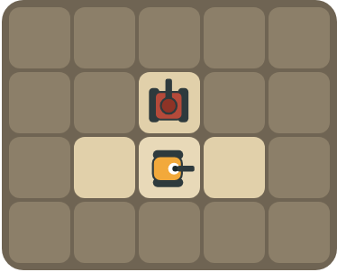
Program: R X
Does the rover hit the tank? Which way does it face after R?

Question 2

Program: X R R X
How many tanks are destroyed? Which way does the rover face at the end?

Part B · Write the program · Use the letters above.
Turn to face the tank, then fire. Use X for fire cannon.

Question 3
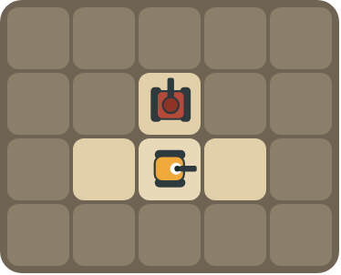
The rover faces right. The tank is above. Destroy it.
How many blocks?

Question 4
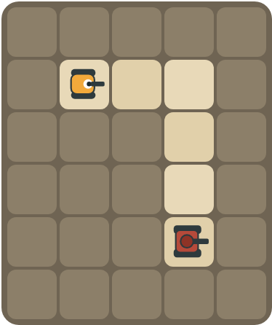
Drive to the corner and destroy the tank down the hall.
How many blocks?

Part C · Which way? · Turns to face the tank
The rover faces the first direction. Write the turns it needs to face the tank (use L and R). Try to use as few turns as possible.
# | Rover faces → tank is | Turns
5 | right → up
6 | up → right
7 | right → left (behind)
8 | down → right

Part D · Design your own · Challenge
Build a map in the grid below with a rover, rocks and enemy tanks. Write a program that destroys every tank, then swap with a partner.
Build your map: click a square and type a symbol. R> R< R^ Rv = rover and the way it faces, # = rock, T> T< T^ Tv = enemy tank and the way its cannon points. You can also fill a square with color (Format → Table → Table properties → Cell background color).
My program:
Blocks:
Partner checked (partner's name):

Reflect
How do you know which way to turn before you fire?

Part E · Words and pictures · Language practice
Type the letter of the matching meaning in the box next to each word.
Meanings
a) steps that happen in order, one after another
b) steps that happen again and again
c) shoot the cannon straight ahead
d) find a mistake and fix it
e) a tank the rover must stop with its cannon
# | Word | Letter
1 | fire (disparar)
2 | enemy tank (tanque enemigo)
3 | sequence (secuencia)
4 | debug (depurar)
5 | pattern (patrón)
Type the letter of the best answer in the box.
9. The rover faces right. The tank is up. Which turn?
a) 
b) 
Answer:
10. How many right turns make the rover face the other way?
a) 1
b) 2
c) 4
Answer:
Finish each sentence. Type the missing words in the box. Use the word bank.
Word bank: [ first ] [ right ] [ turns ]
11. The tank is behind the rover, so it turns ______ two times.
12. First the rover ______. Then it fires.
13. The shell hits the ______ tank in the line.

