CyberTeaches Academy · Lesson 3 classwork

Repeat patterns
Name: ____________________________ Date: ______________
F = move forward
L = turn left
R = turn right
C = collect crystal
repeat 2 [ repeat 3 [ F C ] R ] = a repeat inside a repeat

Part A · Trace the rover Follow the program one block at a time.
Draw the rover's path with a pencil.
1 | 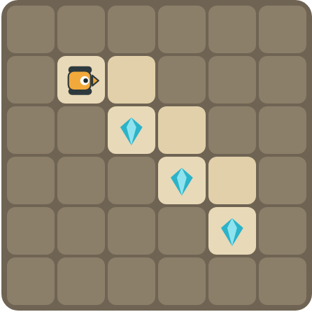 | Program: repeat 3 [ F R F C L ]  Draw the path. Does it collect all 3 crystals?  ______________________________

2 | 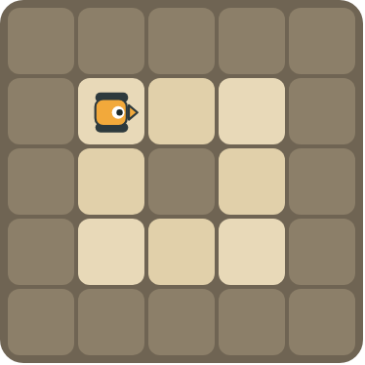 | Program: repeat 4 [ repeat 2 [ F ] R ]  Draw the path. Where does the rover stop, and which way does it face?  ______________________________  ______________________________

Part B · Write the program Use the letters above.
Find one copy of the pattern first. You may need a repeat inside a repeat.
3 | 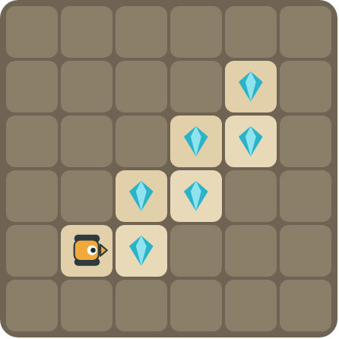 | Climb the stairs and collect every crystal.  ______________________________  ______________________________  How many blocks? ______

4 | 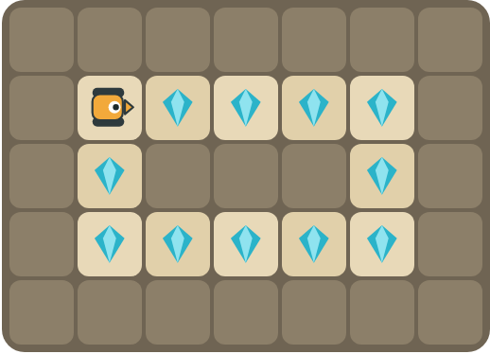 | Drive around the rectangle and collect every crystal. Challenge: use a repeat inside a repeat.  ______________________________  ______________________________  How many blocks? ______

Part C · Find one copy Then write it with repeat.
Draw a box around one copy of the pattern. Write the program with repeat and count the blocks.
# | Long program | With repeat | Blocks before → after
5 | F C F F C F F C F |  | 9 → ____
6 | F R F C L F R F C L |  | 10 → ____
7 | F C F C R F C F C R F C F C R |  | 15 → ____
8 | F F F L F F F L F F F L F F F L |  | 16 → ____

Part D · Design your own Challenge
Draw a rover (with an arrow for the way it faces), some rocks (shade the square) and crystals (◆). Write the shortest program you can with a repeat, then swap with a partner and check each other's work.
 | My program:  ______________________________  ______________________________  ______________________________  Blocks: ______ Partner checked: ______

Reflect
What is a nested loop? Give an example from the puzzles.
______________________________
______________________________

Part E · Words and pictures Language practice
Draw a line from each word to its meaning.
- pattern (patrón)  - nested loop (bucle anidado)  - loop (bucle)  - algorithm (algoritmo)  - debug (depurar) | - a block that repeats the blocks inside it  - find a mistake and fix it  - steps that happen again and again  - a plan of steps to solve a problem  - a loop inside another loop
Circle the best answer.
9. Which program has a repeat inside a repeat?
a) repeat 3 [ F C ] b) repeat 2 [ repeat 3 [ F ] R ]
10. A square has 4 sides. How many times does the outer repeat run?
a) 2 b) 3 c) 4
Finish each sentence. Use the word bank.
Word bank: [ F C F ] [ nested ] [ side ]
11. One copy of the pattern is _______________.
12. A loop inside another loop is a _______________ loop.
13. The inner loop does one _______________. The outer loop does all of them.

Lesson 3 classwork

Answer key
(TEACHER ONLY)

Lesson timing (50 minutes)
5 min Warm-up: What comes next? (slide 3)
10 min Direct instruction: slides 4 to 5
5 min Guided practice: think, pair, share and debugging tips (slides 6 to 7)
12 min Unplugged practice: this classwork, in pairs. Part D for early finishers
15 min Independent practice: code puzzles 3.1 to 3.10 at cyberteaches.com/academy
3 min Closure: exit ticket (last slide)

Part A
1. Yes, all 3. Each repeat goes down one step of the stairs and collects one crystal.
2. Back at the start, facing right. It drives 2 squares on each of the 4 sides of the square and turns right 4 times.

Part B
3. repeat 3 [ F C L F C R ] · 7 blocks
4. repeat 2 [ repeat 4 [ F C ] R repeat 2 [ F C ] R ] · 9 blocks

Part C
# | Answer
5 | repeat 3 [ F C F ] · 9 → 4
6 | repeat 2 [ F R F C L ] · 10 → 6
7 | repeat 3 [ repeat 2 [ F C ] R ] · 15 → 5
8 | repeat 4 [ repeat 3 [ F ] L ] · 16 → 4

Part E
Matching: 1–c, 2–e, 3–a, 4–d, 5–b
9. b) repeat 2 [ repeat 3 [ F ] R ]
10. c) 4
11. F C F
12. nested
13. side

Part D and Reflect
Answers vary. Look for a correct start direction, a program a partner can follow, and a nested loop. Reflection: a loop inside another loop. The inner loop does one part (one side) and the outer loop repeats that part (all sides).

Exit ticket
The rover drives around a square, 3 steps on each side · 5 blocks

