CyberTeaches Academy · Lesson 10 classwork (digital)

Tank missions
Name: ______________________ Date: ____________
Block letters: F = move forward · L = turn left · R = turn right · X = fire cannon · if tank [ X ] = if tank ahead, fire

Part A · Trace the rover · Follow the program one block at a time.
Follow the program on the map one block at a time. Keep track of each tank it destroys. Type your answers in the shaded boxes.

Question 1
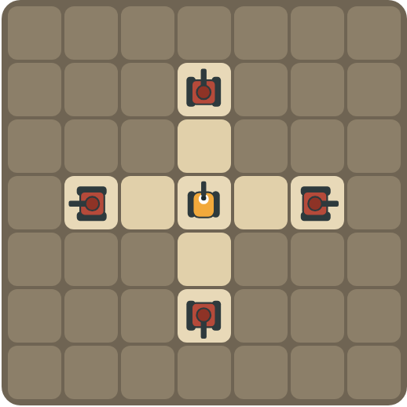
Program: repeat 4 [ X R ]
How many shells are used? Which way does the rover face at the end?

Question 2
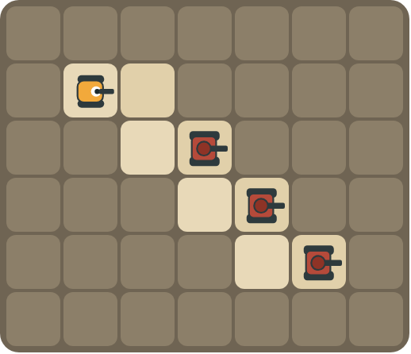
Program: repeat 3 [ F R F L X ]
Follow the path down the stairs. How many tanks are destroyed?

Part B · Write the program · Use the letters above.
Write a program that fits inside the block limit. Use X for fire cannon.

Question 3
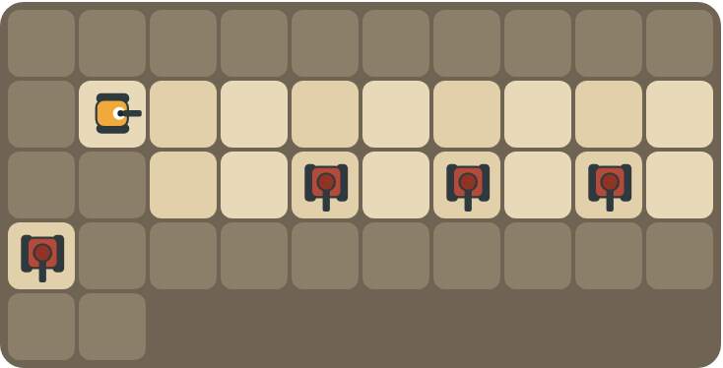
Tanks below every other square. Limit: 10 blocks.
How many blocks? (goal: 6)

Question 4
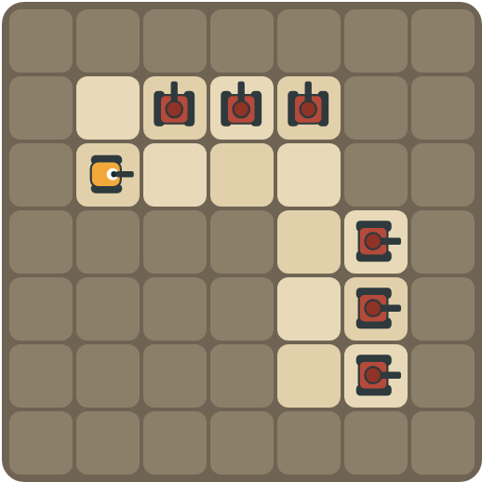
Clear the top road, turn, clear the side road. Limit: 11 blocks.
How many blocks? (goal: 7)

Part C · Will it fit? · Block limits
Count the blocks. Does the program fit inside the limit? If not, write a shorter program.
# | Program and limit | Fits? Shorter program | Blocks
5 | X X X X X X X X · limit 6 |  | 8
6 | F L X R F L X R F L X R · limit 9 |  | 12
7 | repeat 4 [ X R ] · limit 7 |  | 3
8 | X X X X R X X X X · limit 8 |  | 9

Part D · Design your own · Challenge
Build a map in the grid below with a rover, rocks and enemy tanks. Write a program that destroys every tank, then swap with a partner.
Build your map: click a square and type a symbol. R> R< R^ Rv = rover and the way it faces, # = rock, T> T< T^ Tv = enemy tank and the way its cannon points. You can also fill a square with color (Format → Table → Table properties → Cell background color).
My program:
Blocks:
Partner checked (partner's name):

Reflect
How does a repeat help you stay inside a block limit?

Part E · Words and pictures · Language practice
Type the letter of the matching meaning in the box next to each word.
Meanings
a) a block that repeats the blocks inside it
b) a tank the rover must stop with its cannon
c) the most you are allowed to use
d) a loop inside another loop
e) does the job with fewer steps
# | Word | Letter
1 | limit (límite)
2 | efficient (eficiente)
3 | loop (bucle)
4 | nested loop (bucle anidado)
5 | enemy tank (tanque enemigo)
Type the letter of the best answer in the box.
9. The limit is 6 blocks. Which program fits?
a) X X X X X X X X
b) repeat 8 [ X ]
Answer:
10. You have 4 shells and 4 tanks. How many shells can you miss?
a) 0
b) 1
c) 2
Answer:
Finish each sentence. Type the missing words in the box. Use the word bank.
Word bank: [ efficient ] [ if ] [ six ]
11. The limit is ______ blocks, so I use a repeat.
12. My program is ______ because it uses fewer blocks.
13. I fire only ______ a tank is ahead.

