CyberTeaches Academy · Lesson 11 classwork (digital)

If / else
Name: ______________________ Date: ____________
Block letters: F = move forward · L = turn left · R = turn right · C = collect crystal · X = fire cannon · if path ahead [ F ] else [ R ] = if / else · until flag [ … ] = repeat until at flag

Part A · Trace the rover · Follow the program one block at a time.
Follow the program on the map one block at a time. Type your answers in the shaded boxes.

Question 1
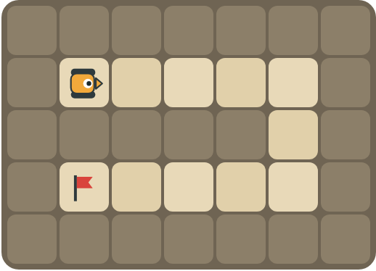
Program: until flag [ if path ahead [ F ] else [ R ] ]
Follow the path. How many times does the rover turn right?

Question 2
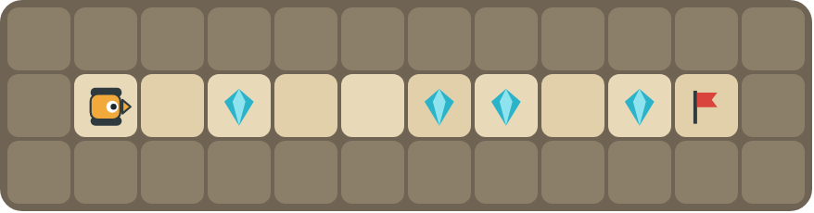
Program: until flag [ F if crystal here [ C ] ]
How many crystals does it collect? Does it ever try to collect on an empty square?

Part B · Write the program · Use the letters above.
Use if / else inside repeat until at flag. Write it like the key at the top.

Question 3
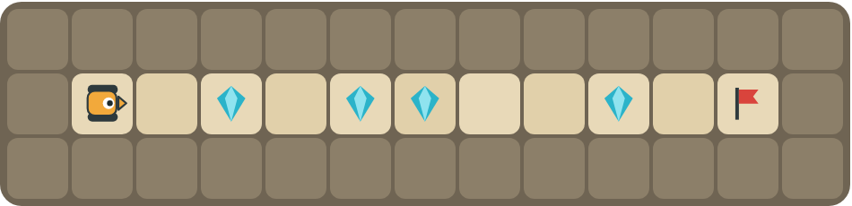
If there is a crystal, collect it. Else, move forward.
How many blocks?

Question 4
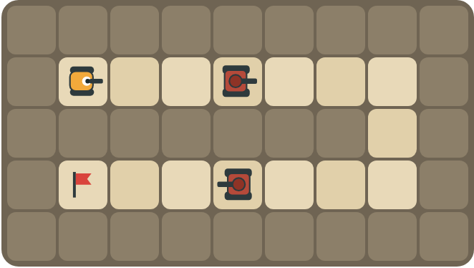
Fire at tanks, move when the path is open, and turn right at walls.
How many blocks?

Part C · Complete the sentence · If … else in words
Write each rule as an if / else for the rover.
# | Rule | If / else
5 | If the path ahead is open, move. Otherwise turn left.
6 | Collect a crystal when there is one here.
7 | Fire if a tank is ahead, otherwise move forward.
8 | Move if you can. If not, turn left if there is a path left, otherwise turn right.

Part D · Design your own · Challenge
Build a winding road in the grid below from the rover to a flag (⚑), with rocks around it. Write one program with if / else that drives the whole road, then swap with a partner and test it.
Build your map: click a square and type a symbol. R> R< R^ Rv = rover and the way it faces, # = rock, C = crystal, F = flag. You can also fill a square with color (Format → Table → Table properties → Cell background color).
My program:
Blocks:
Partner checked (partner's name):

Reflect
Why is one if / else program better than a long list of moves for a new maze?

Part E · Words and pictures · Language practice
Type the letter of the matching meaning in the box next to each word.
Meanings
a) choosing what to do
b) keep going up to the moment something happens
c) if yes, do one thing; if no, do another thing
d) an if / else inside another if / else
e) a question with a yes or no answer
# | Word | Letter
1 | if / else (si / si no)
2 | condition (condición)
3 | decision (decisión)
4 | nested if (condicional anidado)
5 | until (hasta que)
Type the letter of the best answer in the box.
9. Which block makes a decision?
a) 
b) 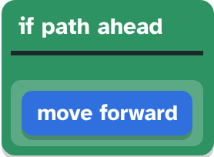
c) 
Answer:
10. There is a wall ahead. What does if path ahead [ F ] else [ R ] do?
a) moves forward
b) turns right
Answer:
Finish each sentence. Type the missing words in the box. Use the word bank.
Word bank: [ Else ] [ condition ] [ then ]
11. If there is a path ahead, ______ the rover moves forward.
12. ______, the rover turns right.
13. The rover checks the ______ at every step.

