CyberTeaches Academy · Lesson 13 classwork (digital)

If / else challenges
Name: ______________________ Date: ____________
Block letters: F = move forward · L = turn left · R = turn right · C = collect crystal · X = fire cannon · if path ahead [ F ] else [ R ] = if / else · until flag [ … ] = repeat until at flag

Part A · Trace the rover · Follow the program one block at a time.
Follow the program on the map one block at a time. Type your answers in the shaded boxes.

Question 1
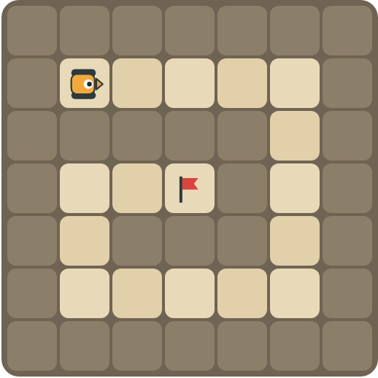
Program: until flag [ if path ahead [ F ] else [ R ] ]
Follow the spiral path. How many right turns does the rover make?

Question 2
Program: until flag [ if crystal here [ C ] if tank ahead [ X ] else [ F ] ]
What is the rover's first action? Why?

Part B · Write the program · Use the letters above.
Use if / else inside repeat until at flag. Think about the order of your checks.

Question 3
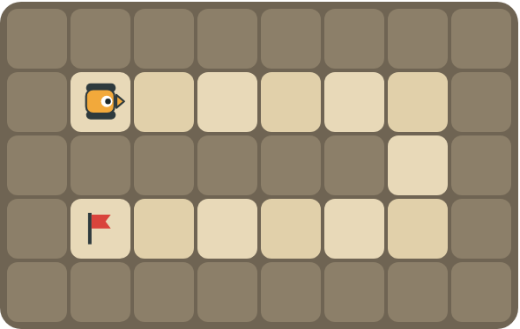
Drive the long snake to the flag.
How many blocks?

Question 4
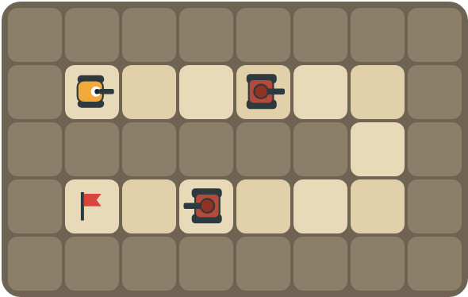
Fire at tanks on both roads and turn right at walls.
How many blocks?

Part C · Order the checks · Most important first
Type a number for each check in the best order (1 = check first), and explain why.
# | Checks | Order and reason
5 | path ahead · tank ahead
6 | crystal here · path ahead
7 | path right · path ahead · (else) turn left
8 | path ahead · crystal here · tank ahead

Part D · Design your own · Challenge
Build a winding road in the grid below from the rover to a flag (⚑), with rocks around it. Write one program with if / else that drives the whole road, then swap with a partner and test it.
Build your map: click a square and type a symbol. R> R< R^ Rv = rover and the way it faces, # = rock, C = crystal, F = flag. You can also fill a square with color (Format → Table → Table properties → Cell background color).
My program:
Blocks:
Partner checked (partner's name):

Reflect
Why does the order of your if / else checks matter?

Part E · Words and pictures · Language practice
Type the letter of the matching meaning in the box next to each word.
Meanings
a) a question with a yes or no answer
b) choosing what to do
c) an if / else inside another if / else
d) a plan of steps to solve a problem
e) if yes, do one thing; if no, do another thing
# | Word | Letter
1 | nested if (condicional anidado)
2 | if / else (si / si no)
3 | condition (condición)
4 | algorithm (algoritmo)
5 | decision (decisión)
Type the letter of the best answer in the box.
9. Which should the rover check first?
a) path ahead
b) tank ahead
Answer:
10. The right-hand rule says: if there is a path right, …
a) turn right and move
b) turn left
c) stop
Answer:
Finish each sentence. Type the missing words in the box. Use the word bank.
Word bank: [ first ] [ nested ] [ right ]
11. I check for a tank ______ because it blocks the path.
12. If there is a path to the right, the rover turns ______.
13. An if / else inside another if / else is a ______ if.

