CyberTeaches Academy · Lesson 9 classwork (digital)

Tank patrols
Name: ______________________ Date: ____________
Block letters: F = move forward · L = turn left · R = turn right · X = fire cannon · if tank [ X ] = if tank ahead, fire · until no tanks [ … ] = repeat until no tanks left

Part A · Trace the rover · Follow the program one block at a time.
Follow the program on the map one block at a time. Keep track of each tank it destroys. Type your answers in the shaded boxes.

Question 1
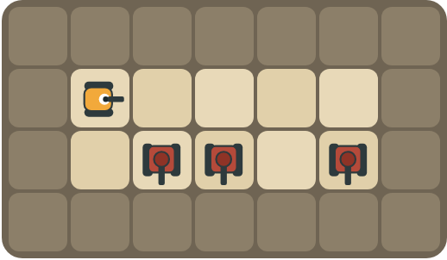
Program: repeat 4 [ F R if tank [ X ] L ]
At which squares does the rover fire? How many tanks are destroyed?

Question 2
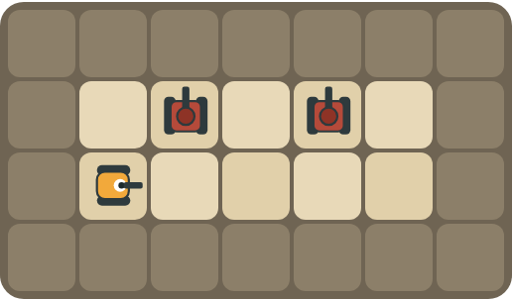
Program: until no tanks [ F L if tank [ X ] ]
This patrol forgot to turn back. What goes wrong?

Part B · Write the program · Use the letters above.
Use a patrol pattern. Use repeat until no tanks left when you don't want to count.

Question 3
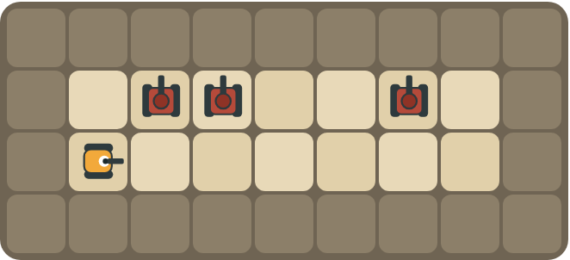
Patrol until no tanks are left.
How many blocks?

Question 4
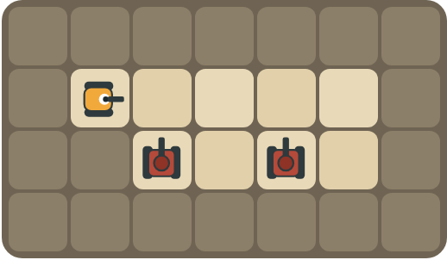
Two guards watch the road. Get behind them and fire from the side.
How many blocks?

Part C · Fix the patrol · Each patrol has a bug.
Read the patrol and the problem. Write the fixed patrol.
# | Patrol and problem | Fixed patrol
5 | until no tanks [ F L X R ]  Tanks are only above some squares. The rover runs out of shells.
6 | until no tanks [ F L if tank [ X ] ]  The rover drives up into the rocks.
7 | until no tanks [ F L if tank [ X ] R ]  The tanks are below the road.
8 | repeat 2 [ F L if tank [ X ] R ]  There are 6 squares with tanks somewhere above them.

Part D · Design your own · Challenge
Build a map in the grid below with a rover, rocks and enemy tanks. Write a program that destroys every tank, then swap with a partner.
Build your map: click a square and type a symbol. R> R< R^ Rv = rover and the way it faces, # = rock, T> T< T^ Tv = enemy tank and the way its cannon points. You can also fill a square with color (Format → Table → Table properties → Cell background color).
My program:
Blocks:
Partner checked (partner's name):

Reflect
Why does the rover turn back after it looks for a tank?

Part E · Words and pictures · Language practice
Type the letter of the matching meaning in the box next to each word.
Meanings
a) shoot the cannon straight ahead
b) find a mistake and fix it
c) a question with a yes or no answer
d) a block that repeats the blocks inside it
e) a tank the rover must stop with its cannon
# | Word | Letter
1 | condition (condición)
2 | enemy tank (tanque enemigo)
3 | fire (disparar)
4 | loop (bucle)
5 | debug (depurar)
Type the letter of the best answer in the box.
9. Tanks are below the road. Which turn looks at them?
a) 
b) 
Answer:
10. Which loop stops when every tank is gone?
a) 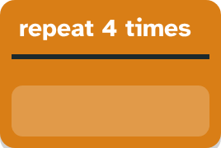
b) 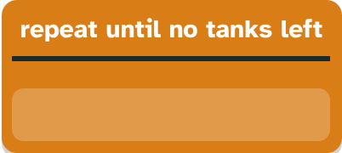
Answer:
Finish each sentence. Type the missing words in the box. Use the word bank.
Word bank: [ back ] [ left ] [ then ]
11. At every square, the rover looks. If a tank is there, ______ it fires.
12. After it looks up, the rover turns ______.
13. The patrol stops when no tanks are ______.

