CyberTeaches Academy · Lesson 4 classwork · Medium level

Repeat until
Name: ____________________________ Date: ______________
F = move forward
L = turn left
R = turn right
C = collect crystal
until flag [ F ] = repeat until at flag

Part A · Trace the rover Follow the program one block at a time.
Draw the rover's path with a pencil.
1 | 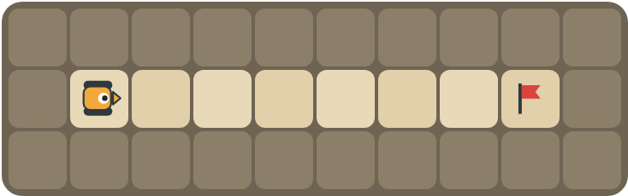 | Program: until flag [ F ]  How many times does move forward run?  ______________________________

2 | 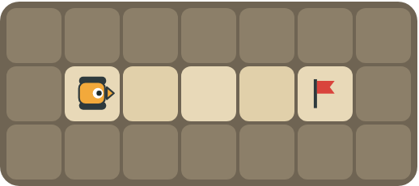 | Program: until flag [ F F ]  Does the rover stop at the flag? Explain.  ______________________________  ______________________________

Part B · Write the program Use the letters above.
Use repeat until at flag. You can also use a plain repeat for the part you can count.
3 | 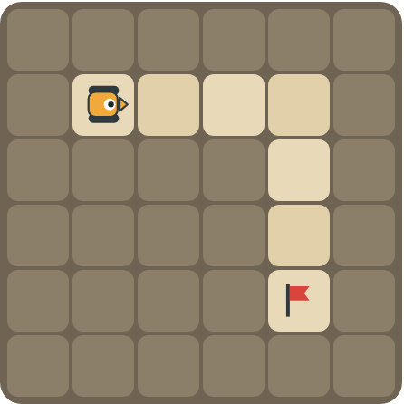 | Drive 3 squares, turn right, then keep going to the flag.  ______________________________  ______________________________  How many blocks? ______

4 | 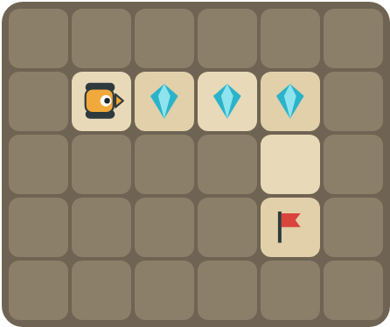 | Collect the crystals first, then drive to the flag.  ______________________________  ______________________________  How many blocks? ______

Part C · Repeat or repeat until? Choose the best loop.
For each situation, write repeat (you know how many times) or repeat until (keep going until something happens), and explain why.
# | Situation | repeat or repeat until? Why?
5 | Jump 10 times.
6 | Stir the soup until it boils.
7 | Drive to the flag, but you don't know how far it is.
8 | Collect 4 crystals in a row.

Part D · Design your own Challenge
Draw a rover (with an arrow for the way it faces), rocks (shade the square), crystals (◆) and a flag (⚑). Write a program that uses repeat until at flag, then swap with a partner.
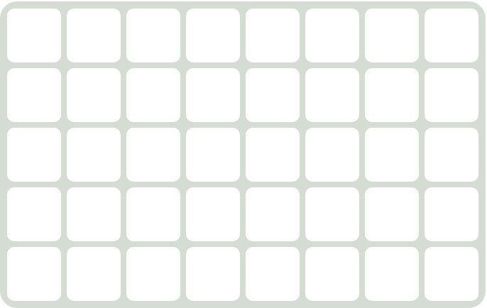 | My program:  ______________________________  ______________________________  ______________________________  Blocks: ______ Partner checked: ______

Reflect
What is an infinite loop? How can you avoid one?
______________________________
______________________________

Part E · Words and pictures Language practice
Draw a line from each word to its meaning.
- until (hasta que)  - flag (bandera)  - loop (bucle)  - infinite loop (bucle infinito)  - condition (condición) | - a block that repeats the blocks inside it  - a question with a yes or no answer  - keep going up to the moment something happens  - a loop that never stops  - the goal square the rover must reach
Circle the best answer.
9. Which loop stops by itself at the flag?
a) 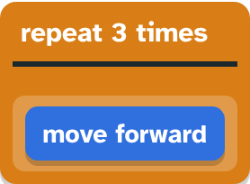 b) 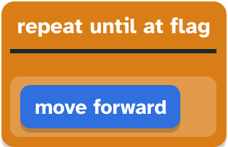
10. Which program never stops?
a) until flag [ F ] b) until flag [ R ]
Finish each sentence. Use the word bank.
Word bank: [ how many ] [ infinite ] [ until ]
11. The rover moves forward _______________ it reaches the flag.
12. A loop that never stops is an _______________ loop.
13. I use repeat until because I don't know _______________ times.

Lesson 4 classwork · Medium level

Answer key
(TEACHER ONLY)

Lesson timing (50 minutes)
5 min Warm-up: Walk until the wall (slide 3)
10 min Direct instruction: slides 4 to 6
5 min Guided practice: think, pair, share and debugging tips (slides 7 to 8)
12 min Unplugged practice: this classwork, in pairs. Part D for early finishers
15 min Independent practice: code puzzles 4.1 to 4.10 at cyberteaches.com/academy
3 min Closure: exit ticket (last slide)

Part A
1. 7 times. The flag is 7 squares away. The loop stops when the rover reaches it.
2. Yes. It moves 2 squares each time: 2, then 4 = the flag. The game checks after every step, so it stops on the flag.

Part B
3. repeat 3 [ F ] R until flag [ F ] · 5 blocks
4. repeat 3 [ F C ] R until flag [ F ] · 6 blocks

Part C
# | Answer
5 | repeat: you know it is 10 times.
6 | repeat until: you stop when it boils, not after a number.
7 | repeat until at flag.
8 | repeat 4 [ F C ] (repeat until also works if a flag is at the end).

Part E
Matching: 1–c, 2–e, 3–a, 4–d, 5–b
9. b) repeat until at flagmove forward
10. b) until flag [ R ]
11. until
12. infinite
13. how many

Part D and Reflect
Answers vary. Look for a correct start direction, a program a partner can follow, and repeat until at flag that really reaches the flag. Reflection: a loop that never stops. Make sure the blocks inside move the rover closer to the flag every time.

Exit ticket
It stops by itself at the flag, so it works for any distance. You don't need to count.

