CyberTeaches Academy · Lesson 5 classwork · Medium level (digital)

Repeat until practice
Name: ______________________ Date: ____________
Block letters: F = move forward · L = turn left · R = turn right · C = collect crystal · until flag [ F ] = repeat until at flag

Part A · Trace the rover · Follow the program one block at a time.
Follow the program on the map one block at a time. Type your answers in the shaded boxes.

Question 1

Program: until flag [ F C ]
How many crystals does it collect? Does it reach the flag?

Question 2
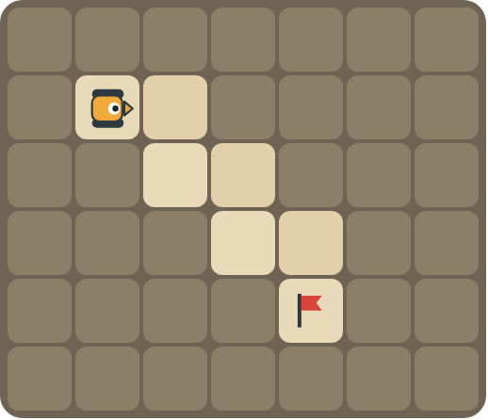
Program: until flag [ F R F L ]
Follow the path down the stairs. How many times does the loop run?

Part B · Write the program · Use the letters above.
Use repeat until at flag. Turn first if you need to.

Question 3
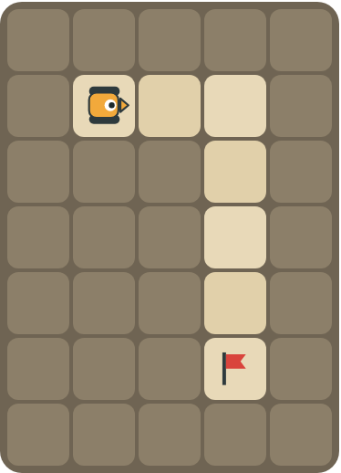
Drive 2 squares, turn, then keep going to the flag.
How many blocks?

Question 4
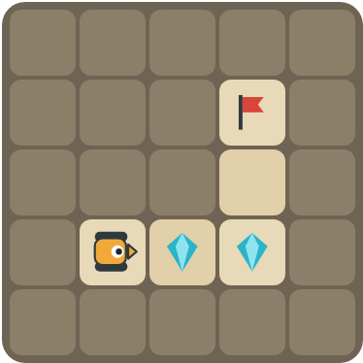
Collect the 2 crystals, turn left, then drive to the flag.
How many blocks?

Part C · Fix the bug · Each program has a mistake.
Read the program and the problem. Write a fixed program.
# | Program and problem | Fixed program
5 | until flag [ R ]  The rover spins forever.
6 | until flag [ F ]  The rover faces up but the flag is to the right. It crashes into a rock.
7 | until flag [ F ]  There is a crystal on every square. The rover reaches the flag but the crystals are still there.
8 | repeat 3 [ F ]  The flag is 8 squares away. The rover stops too early.

Part D · Design your own · Challenge
Build a map in the grid below with a rover, rocks, crystals (◆) and a flag (⚑). Write a program that uses repeat until at flag, then swap with a partner.
Build your map: click a square and type a symbol. R> R< R^ Rv = rover and the way it faces, # = rock, C = crystal, F = flag. You can also fill a square with color (Format → Table → Table properties → Cell background color).
My program:
Blocks:
Partner checked (partner's name):

Reflect
What does the word "until" mean in your own words?

Part E · Words and pictures · Language practice
Type the letter of the matching meaning in the box next to each word.
Meanings
a) a block that repeats the blocks inside it
b) a loop that never stops
c) keep going up to the moment something happens
d) find a mistake and fix it
e) the goal square the rover must reach
# | Word | Letter
1 | until (hasta que)
2 | flag (bandera)
3 | loop (bucle)
4 | debug (depurar)
5 | infinite loop (bucle infinito)
Type the letter of the best answer in the box.
9. The rover faces up. The flag is to the right. What is the first block?
a) 
b) 
c) 
Answer:
10. Which program collects crystals on the way to the flag?
a) until flag [ F ]
b) until flag [ F C ]
Answer:
Finish each sentence. Type the missing words in the box. Use the word bank.
Word bank: [ fix ] [ flag ] [ right ] [ stops ]
11. First the rover turns ______. Then it moves forward until the ______.
12. The program has a bug. I ______ it.
13. The loop ______ when the rover is on the flag.

