CyberTeaches Academy · Lesson 4 classwork (digital)

Repeat until
Name: ______________________ Date: ____________
Block letters: F = move forward · L = turn left · R = turn right · C = collect crystal · until flag [ F ] = repeat until at flag

Part A · Trace the rover · Follow the program one block at a time.
Follow the program on the map one block at a time. Type your answers in the shaded boxes.

Question 1
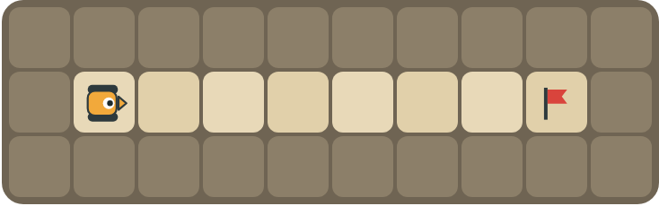
Program: until flag [ F ]
How many times does move forward run?

Question 2
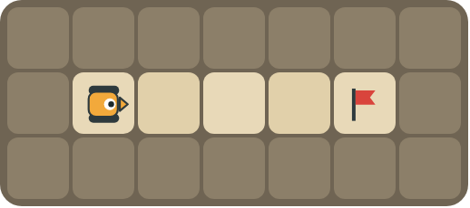
Program: until flag [ F F ]
Does the rover stop at the flag? Explain.

Part B · Write the program · Use the letters above.
Use repeat until at flag. You can also use a plain repeat for the part you can count.

Question 3
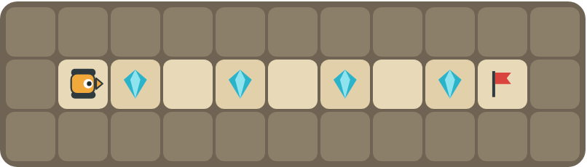
Collect every crystal on the way to the flag.
How many blocks?

Question 4
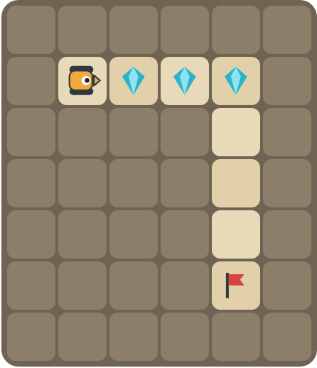
Collect the crystals first, then drive to the flag.
How many blocks?

Part C · Repeat or repeat until? · Choose the best loop.
For each situation, write repeat (you know how many times) or repeat until (keep going until something happens), and explain why.
# | Situation | repeat or repeat until? Why?
5 | Jump 10 times.
6 | Stir the soup until it boils.
7 | Drive to the flag, but you don't know how far it is.
8 | Collect 4 crystals in a row.

Part D · Design your own · Challenge
Build a map in the grid below with a rover, rocks, crystals (◆) and a flag (⚑). Write a program that uses repeat until at flag, then swap with a partner.
Build your map: click a square and type a symbol. R> R< R^ Rv = rover and the way it faces, # = rock, C = crystal, F = flag. You can also fill a square with color (Format → Table → Table properties → Cell background color).
My program:
Blocks:
Partner checked (partner's name):

Reflect
What is an infinite loop? How can you avoid one?

Part E · Words and pictures · Language practice
Type the letter of the matching meaning in the box next to each word.
Meanings
a) a block that repeats the blocks inside it
b) a question with a yes or no answer
c) keep going up to the moment something happens
d) a loop that never stops
e) the goal square the rover must reach
# | Word | Letter
1 | until (hasta que)
2 | flag (bandera)
3 | loop (bucle)
4 | infinite loop (bucle infinito)
5 | condition (condición)
Type the letter of the best answer in the box.
9. Which loop stops by itself at the flag?
a) 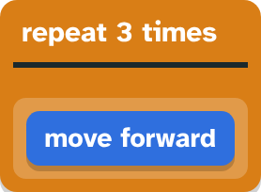
b) 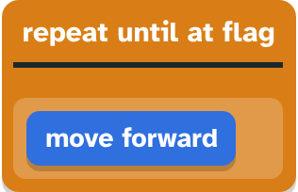
Answer:
10. Which program never stops?
a) until flag [ F ]
b) until flag [ R ]
Answer:
Finish each sentence. Type the missing words in the box. Use the word bank.
Word bank: [ how many ] [ infinite ] [ until ]
11. The rover moves forward ______ it reaches the flag.
12. A loop that never stops is an ______ loop.
13. I use repeat until because I don't know ______ times.

