CyberTeaches Academy · Lesson 6 classwork (digital)

Repeat until patterns
Name: ______________________ Date: ____________
Block letters: F = move forward · L = turn left · R = turn right · C = collect crystal · until flag [ F ] = repeat until at flag

Part A · Trace the rover · Follow the program one block at a time.
Follow the program on the map one block at a time. Type your answers in the shaded boxes.

Question 1
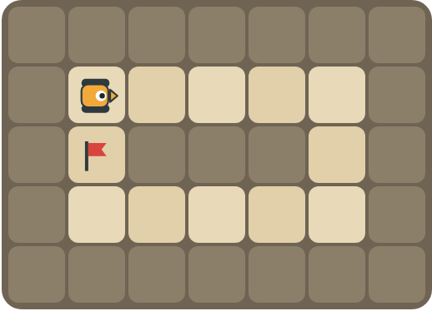
Program: until flag [ repeat 4 [ F ] R repeat 2 [ F ] R ]
Follow the path. Does it reach the flag?

Question 2
Program: until flag [ F C F C F ]
How many times does the loop run? How many crystals are collected?

Part B · Write the program · Use the letters above.
Find one copy of the pattern. You can use a repeat inside repeat until.

Question 3
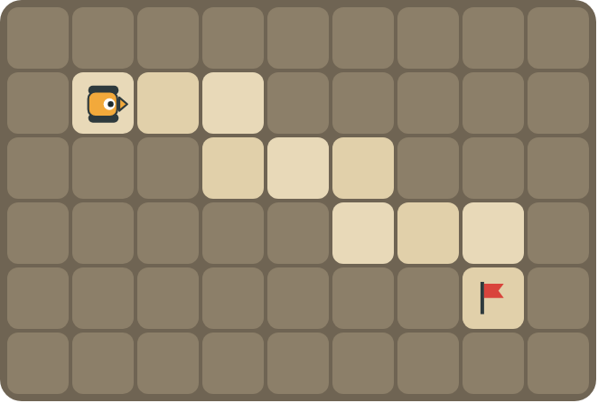
Each step of the stairs is two squares wide. Drive to the flag.
How many blocks?

Question 4
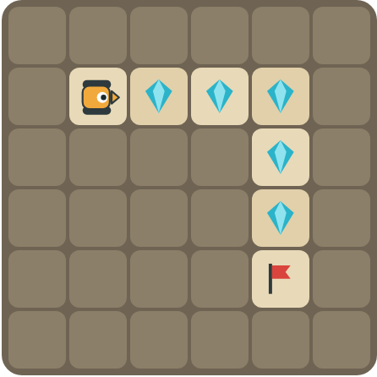
Collect the crystals along the top, then down the side to the flag.
How many blocks?

Part C · Find the pattern · Then use repeat until.
Each long program ends at a flag. Rewrite it with repeat until at flag (and a repeat inside if it helps).
# | Long program (ends at the flag) | With repeat until
5 | F C F F C F F C F
6 | F F R F L F F R F L F F R F L
7 | F F F R F F F R F F F R
8 | F C F C F C R F F F F

Part D · Design your own · Challenge
Build a map in the grid below with a rover, rocks, crystals (◆) and a flag (⚑). Write a program that uses repeat until at flag, then swap with a partner.
Build your map: click a square and type a symbol. R> R< R^ Rv = rover and the way it faces, # = rock, C = crystal, F = flag. You can also fill a square with color (Format → Table → Table properties → Cell background color).
My program:
Blocks:
Partner checked (partner's name):

Reflect
When do you use a plain repeat and repeat until in the same program?

Part E · Words and pictures · Language practice
Type the letter of the matching meaning in the box next to each word.
Meanings
a) keep going up to the moment something happens
b) a plan of steps to solve a problem
c) steps that happen again and again
d) the goal square the rover must reach
e) a loop inside another loop
# | Word | Letter
1 | pattern (patrón)
2 | nested loop (bucle anidado)
3 | until (hasta que)
4 | flag (bandera)
5 | algorithm (algoritmo)
Type the letter of the best answer in the box.
9. Which program has a repeat inside repeat until?
a) until flag [ F ]
b) until flag [ repeat 4 [ F ] R ]
Answer:
10. Which part of this program do we count: repeat 3 [ F C ] R until flag [ F ]?
a) repeat 3 [ F C ]
b) until flag [ F ]
Answer:
Finish each sentence. Type the missing words in the box. Use the word bank.
Word bank: [ F C F ] [ flag ] [ then ]
11. Inside the loop, the pattern is ______.
12. I count the first part, ______ I use repeat until.
13. The rover stops when it reaches the ______.

