CyberTeaches Academy · Lesson 14 classwork (digital)

Variables
Name: ______________________ Date: ____________
Block letters: F = move forward · L = turn left · R = turn right · C = collect crystal · X = fire cannon · set 3 = set steps to 3 · change +1 = change steps by +1 · repeat steps [ F ] = repeat steps times

Part A · Trace the rover · Follow the program one block at a time.
Follow the program on the map one block at a time. Type your answers in the shaded boxes.

Question 1
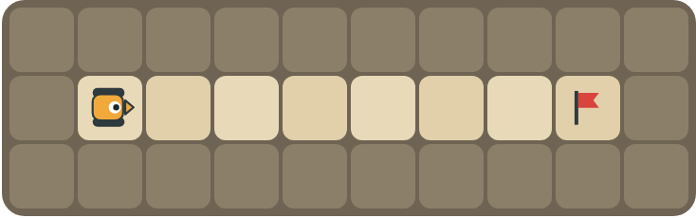
Program: set 3 repeat steps [ F ] change +1 repeat steps [ F ]
How many squares does the rover move in all? What is in the box at the end?

Question 2
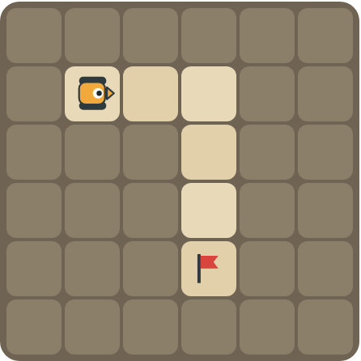
Program: set 2 repeat 2 [ repeat steps [ F ] R change +1 ]
What is in the box on each lap? Mark where the rover stops.

Part B · Write the program · Use the letters above.
Use set, change and repeat steps. Write the number you put in the box.

Question 3
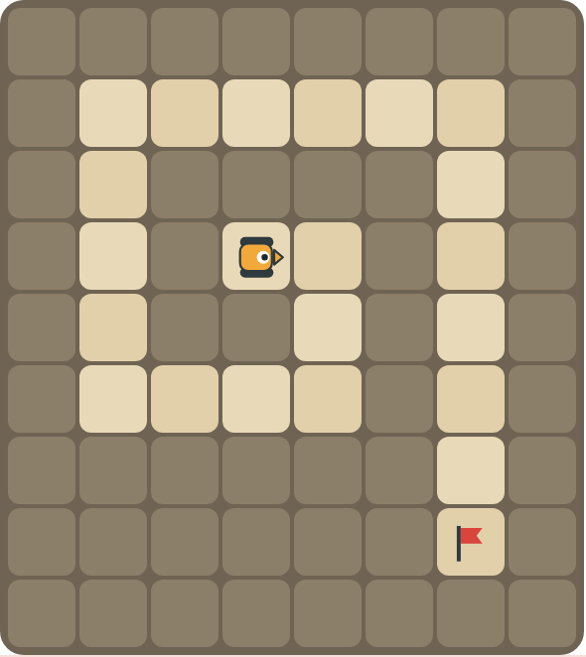
Write the spiral program. Each lap is one square longer.
How many blocks?

Question 4
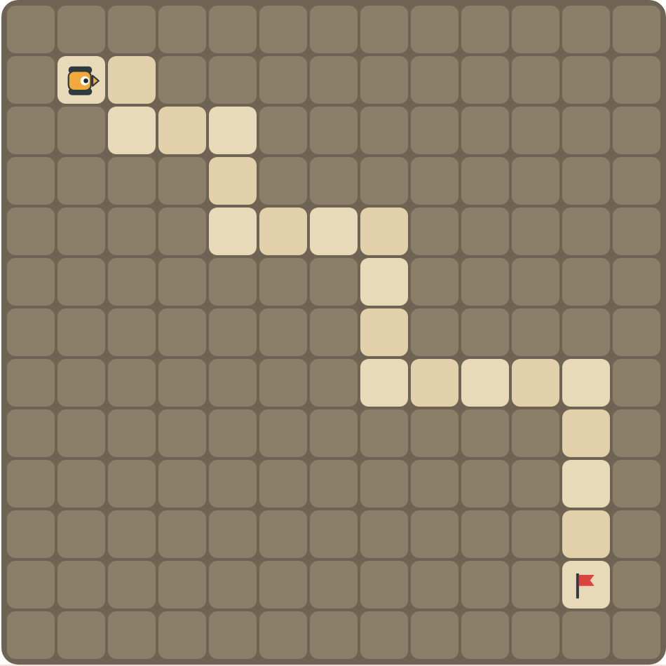
Write a program for the growing stairs.
How many blocks?

Part C · What is in the box? · Trace the variable
Read each program. Write how many squares the rover moves in all, and what is in the box at the end.
# | Program | Squares moved · box at the end
5 | set 4 · repeat steps [ F ]
6 | set 2 · change +3 · repeat steps [ F ]
7 | set 1 · repeat 3 [ repeat steps [ F ] R change +1 ]
8 | set 5 · repeat 2 [ repeat steps [ F ] L change -2 ]

Part D · Design your own · Challenge
Draw a spiral or stairs where every lap is a different length, with a flag (⚑) at the end. Write one program with set, change and repeat steps that drives it, then swap with a partner and trace the box together.
Build your map: click a square and type a symbol. R> R< R^ Rv = rover and the way it faces, # = rock, C = crystal, F = flag. You can also fill a square with color (Format → Table → Table properties → Cell background color).
My program:
Blocks:
Partner checked (partner's name):

Reflect
When is a variable better than a plain repeat number?

Part E · Words and pictures · Language practice
Type the letter of the matching meaning in the box next to each word.
Meanings
a) put a number in the box
b) a block that repeats the blocks inside it
c) a named box that holds a number
d) add to or take away from the number in the box
e) the number inside the box
# | Word | Letter
1 | variable (variable)
2 | value (valor)
3 | set (asignar)
4 | change by (cambiar)
5 | loop (bucle)
Type the letter of the best answer in the box.
9. The box holds 2. After change steps by +1, what is in the box?
a) 1
b) 2
c) 3
Answer:
10. Which block repeats as many times as the number in the box?
a) repeat 3 times
b) repeat steps times
c) repeat until at flag
Answer:
Finish each sentence. Type the missing words in the box. Use the word bank.
Word bank: [ 3 ] [ bigger ] [ box ]
11. A variable is a named ______ that holds a number.
12. set steps to 3 puts the number ______ in the box.
13. change steps by +1 makes the number ______.

