CyberTeaches Academy · Lesson 14 classwork · Medium level

Variables
Name: ____________________________ Date: ______________
F = move forward
L = turn left
R = turn right
C = collect crystal
X = fire cannon
set 3 = set steps to 3
change +1 = change steps by +1
repeat steps [ F ] = repeat steps times

Part A · Trace the rover Follow the program one block at a time.
Draw the rover's path with a pencil.
1 | 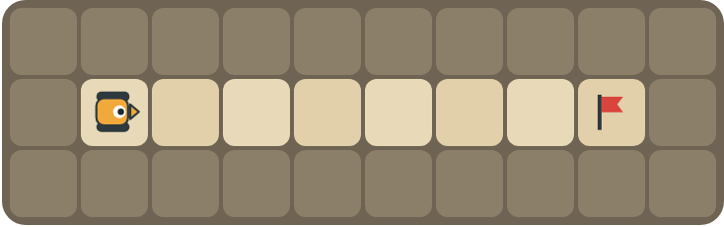 | Program: set 3 repeat steps [ F ] change +1 repeat steps [ F ]  How many squares does the rover move in all? What is in the box at the end?  ______________________________  ______________________________

2 | 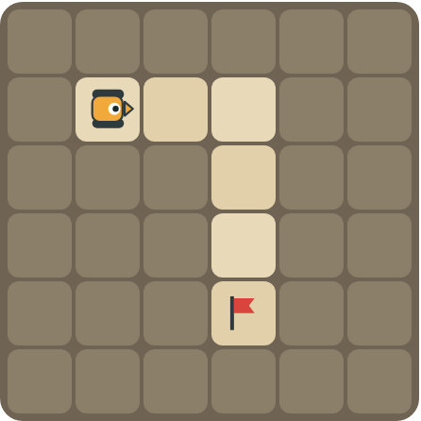 | Program: set 2 repeat 2 [ repeat steps [ F ] R change +1 ]  What is in the box on each lap? Mark where the rover stops.  ______________________________

Part B · Write the program Use the letters above.
Use set, change and repeat steps. Write the number you put in the box.
3 | 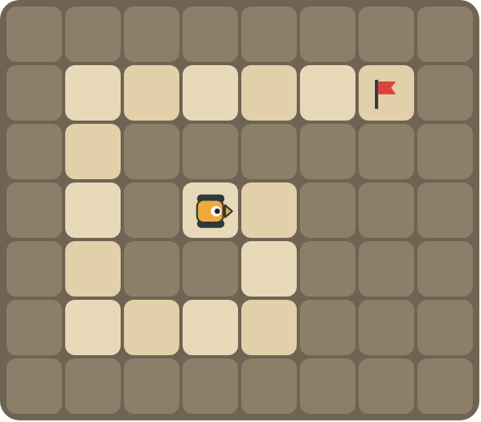 | Write the spiral program. Each lap is one square longer.  ______________________________  ______________________________  How many blocks? ______

4 | 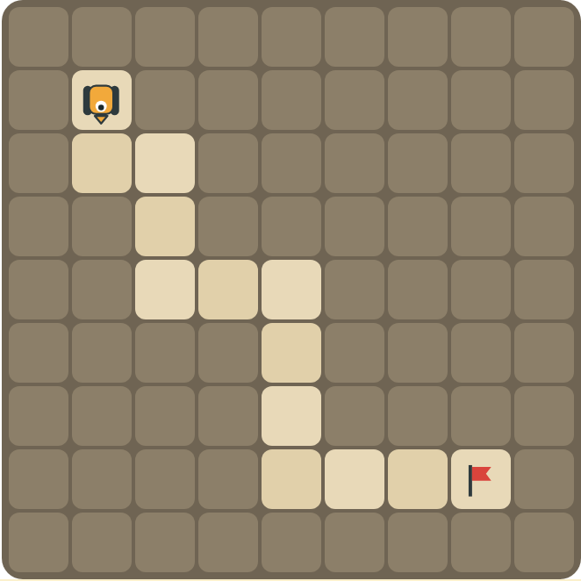 | The rover faces down. Write a program for the growing stairs.  ______________________________  ______________________________  How many blocks? ______

Part C · What is in the box? Trace the variable
Read each program. Write how many squares the rover moves in all, and what is in the box at the end.
# | Program | Squares moved · box at the end
5 | set 4 · repeat steps [ F ]
6 | set 2 · change +3 · repeat steps [ F ]
7 | set 1 · repeat 3 [ repeat steps [ F ] R change +1 ]
8 | set 5 · repeat 2 [ repeat steps [ F ] L change -2 ]

Part D · Design your own Challenge
Draw a spiral or stairs where every lap is a different length, with a flag (⚑) at the end. Write one program with set, change and repeat steps that drives it, then swap with a partner and trace the box together.
 | My program:  ______________________________  ______________________________  ______________________________  Blocks: ______ Partner checked: ______

Reflect
When is a variable better than a plain repeat number?
______________________________
______________________________

Part E · Words and pictures Language practice
Draw a line from each word to its meaning.
- variable (variable)  - value (valor)  - set (asignar)  - change by (cambiar)  - loop (bucle) | - put a number in the box  - a block that repeats the blocks inside it  - a named box that holds a number  - add to or take away from the number in the box  - the number inside the box
Circle the best answer.
9. The box holds 2. After change steps by +1, what is in the box?
a) 1 b) 2 c) 3
10. Which block repeats as many times as the number in the box?
a) repeat 3 times b) repeat steps times c) repeat until at flag
Finish each sentence. Use the word bank.
Word bank: [ 3 ] [ bigger ] [ box ]
11. A variable is a named _______________ that holds a number.
12. set steps to 3 puts the number _______________ in the box.
13. change steps by +1 makes the number _______________.

Lesson 14 classwork · Medium level

Answer key
(TEACHER ONLY)

Lesson timing (50 minutes)
5 min Warm-up: The counting box (slide 3)
10 min Direct instruction: slides 4 to 6
5 min Guided practice: think, pair, share and debugging tips (slides 7 to 8)
12 min Unplugged practice: this classwork, in pairs. Part D for early finishers
15 min Independent practice: code puzzles 14.1 to 14.10 at cyberteaches.com/academy
3 min Closure: exit ticket (last slide)

Part A
1. 7 squares; the box holds 4. The first loop moves 3 squares. Change makes the box 4, so the second loop moves 4 more squares: 3 + 4 = 7.
2. Lap 1: 2. Lap 2: 3. It stops on the flag. It moves 2, turns right, then moves 3 down to the flag. The program stops as soon as the rover reaches the flag, so the box still holds 3.

Part B
3. set 1 repeat 5 [ repeat steps [ F ] R change +1 ] · 6 blocks
4. set 1 repeat 3 [ repeat steps [ F ] L repeat steps [ F ] R change +1 ] · 9 blocks

Part C
# | Answer
5 | 4 squares · box = 4
6 | 5 squares · box = 5
7 | 1 + 2 + 3 = 6 squares · box = 4
8 | 5 + 3 = 8 squares · box = 1

Part E
Matching: 1–c, 2–e, 3–a, 4–d, 5–b
9. c) 3
10. b) repeat steps times
11. box
12. 3
13. bigger

Part D and Reflect
Answers vary. Look for a correct start direction, a program a partner can follow, and a growing or shrinking pattern. Reflection: when the number changes while the program runs, such as a spiral or stairs that get longer each lap; a plain repeat always uses the same number.

Exit ticket
5 squares (3 + 2 = 5).

