CyberTeaches Academy · Lesson 10 classwork · Easy level

Tank missions
Name: ____________________________ Date: ______________
F = move forward
L = turn left
R = turn right
X = fire cannon
if tank [ X ] = if tank ahead, fire

Part A · Trace the rover Follow the program one block at a time.
Draw the rover's path. Cross out each tank it destroys.
1 |  | Program: repeat 3 [ X ]  How many shells does this use? Does it fit a limit of 6 blocks?  ______________________________

2 | 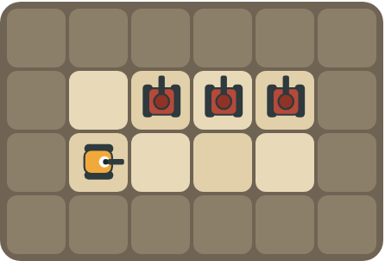 | Program: F L X R F L X R F L X R  Does this program work? Does it fit a limit of 9 blocks?  ______________________________

Part B · Write the program Use the letters above.
Write a program that fits inside the block limit. Use X for fire cannon.
3 | 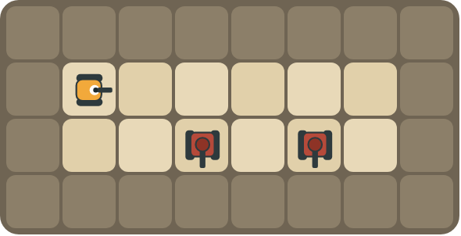 | Tanks below every other square. Limit: 10 blocks.  ______________________________  ______________________________  How many blocks? ______ (goal: 6)

4 | 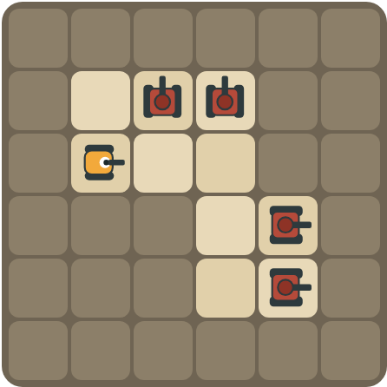 | Clear the top road, turn, clear the side road. Limit: 11 blocks.  ______________________________  ______________________________  How many blocks? ______ (goal: 7)

Part C · Will it fit? Block limits
Count the blocks. Does the program fit inside the limit? If not, write a shorter program.
# | Program and limit | Fits? Shorter program | Blocks
5 | X X X X · limit 4 |  | ____
6 | F L X R F L X R · limit 6 |  | ____
7 | repeat 2 [ X R ] · limit 6 |  | ____
8 | X X R X X · limit 5 |  | ____

Part D · Design your own Challenge
Draw a rover (with an arrow), rocks (shade the square) and enemy tanks (draw a box with an arrow for its cannon). Write a program that destroys every tank, then swap with a partner.
 | My program:  ______________________________  ______________________________  ______________________________  Blocks: ______ Partner checked: ______

Reflect
How does a repeat help you stay inside a block limit?
______________________________
______________________________

Part E · Words and pictures Language practice
Draw a line from each word to its meaning.
- limit (límite)  - efficient (eficiente)  - loop (bucle)  - nested loop (bucle anidado)  - enemy tank (tanque enemigo) | - a block that repeats the blocks inside it  - a tank the rover must stop with its cannon  - the most you are allowed to use  - a loop inside another loop  - does the job with fewer steps
Circle the best answer.
9. The limit is 6 blocks. Which program fits?
a) X X X X X X X X b) repeat 8 [ X ]
10. You have 4 shells and 4 tanks. How many shells can you miss?
a) 0 b) 1 c) 2
Finish each sentence. Use the word bank.
Word bank: [ efficient ] [ if ] [ six ]
11. The limit is _______________ blocks, so I use a repeat.
12. My program is _______________ because it uses fewer blocks.
13. I fire only _______________ a tank is ahead.

Lesson 10 classwork · Easy level

Answer key
(TEACHER ONLY)

Lesson timing (50 minutes)
5 min Warm-up: Packing list (slide 3)
10 min Direct instruction: slides 4 to 6
5 min Guided practice: think, pair, share and debugging tips (slides 7 to 8)
12 min Unplugged practice: this classwork, in pairs. Part D for early finishers
15 min Independent practice: code puzzles 10.1 to 10.10 at cyberteaches.com/academy
3 min Closure: exit ticket (last slide)

Part A
1. 3 shells, and yes (2 blocks). Each shell destroys the next tank in line. A repeat with one block inside counts as 2 blocks.
2. It works but it does not fit (12 blocks). The same 4 blocks happen 3 times. With a repeat it is 5 blocks.

Part B
3. repeat 2 [ F F R X L ] · 6 blocks
4. repeat 2 [ repeat 2 [ F L X R ] R ] · 7 blocks

Part C
# | Answer
5 | Fits (4). Shorter: repeat 4 [ X ] · 2
6 | No (8). repeat 2 [ F L X R ] · 5
7 | Fits (3 blocks).
8 | Fits (5). Shorter: repeat 2 [ X ] R repeat 2 [ X ] · 5, or repeat 2 [ repeat 2 [ X ] R ] · 4

Part E
Matching: 1–c, 2–e, 3–a, 4–d, 5–b
9. b) repeat 8 [ X ]
10. a) 0
11. six
12. efficient
13. if

Part D and Reflect
Answers vary. Look for a correct start direction, a program a partner can follow, and a program that fits the limit. Reflection: the repeat holds one copy of the pattern, so many actions take only a few blocks.

Exit ticket
repeat 6 [ X ] · 2 blocks

