CyberTeaches Academy · Lesson 2 classwork · Easy level (digital)

Repeat practice
Name: ______________________ Date: ____________
Block letters: F = move forward · L = turn left · R = turn right · C = collect crystal · repeat 3 [ F C ] = do F C three times

Part A · Trace the rover · Follow the program one block at a time.
Follow the program on the map one block at a time. Type your answers in the shaded boxes.

Question 1
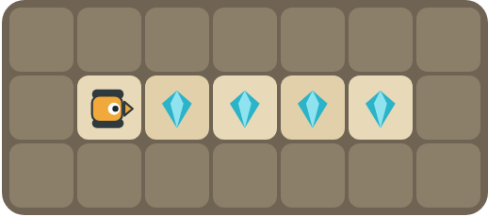
Program: repeat 2 [ F C ]
How many crystals are left after the program runs?

Question 2
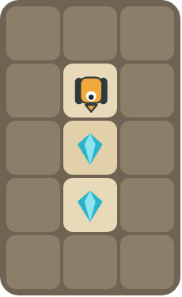
Program: repeat 2 [ F C ]
Does it collect every crystal? Where does it stop?

Part B · Write the program · Use the letters above.
Count the crystals first. Use one repeat block.

Question 3
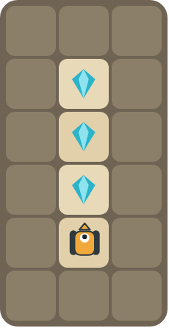
The rover faces up. Write the shortest program.
How many blocks?

Question 4
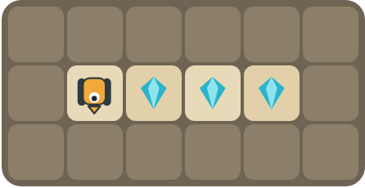
The rover faces down. Turn first, then collect.
How many blocks?

Part C · Count and repeat · Write the repeat number.
Each long program is a pattern. Write it with one repeat block and count the blocks.
# | Long program | With repeat | Blocks before → after
5 | F C F C |  | 4 → ____
6 | F C F C F C F C F C F C |  | 12 → ____
7 | F F C F F C F F C |  | 9 → ____
8 | L F C F C F C |  | 7 → ____

Part D · Design your own · Challenge
Build a map in the grid below with a rover, rocks and crystals (◆). Write the shortest program you can with a repeat, then swap with a partner and check each other's work.
Build your map: click a square and type a symbol. R> R< R^ Rv = rover and the way it faces, # = rock, C = crystal, F = flag. You can also fill a square with color (Format → Table → Table properties → Cell background color).
My program:
Blocks:
Partner checked (partner's name):

Reflect
Why do you count the crystals before you choose the repeat number?

Part E · Words and pictures · Language practice
Type the letter of the matching meaning in the box next to each word.
Meanings
a) steps that happen again and again
b) find a mistake and fix it
c) do the same thing again
d) steps that happen in order, one after another
e) a block that repeats the blocks inside it
# | Word | Letter
1 | repeat (repetir)
2 | loop (bucle)
3 | pattern (patrón)
4 | sequence (secuencia)
5 | debug (depurar)
Type the letter of the best answer in the box.
9. There are 4 crystals in a row. Which number goes in the repeat?
a) 2
b) 4
c) 8
Answer:
10. Which block happens only one time in this program: R repeat 5 [ F C ]?
a) 
b) 
c) 
Answer:
Finish each sentence. Type the missing words in the box. Use the word bank.
Word bank: [ five ] [ inside ] [ right ]
11. There are ______ crystals, so I repeat ______ times.
12. The rover turns ______ first.
13. The blocks ______ the repeat run again and again.

