CyberTeaches Academy · Lesson 3 classwork · Easy level (digital)

Repeat patterns
Name: ______________________ Date: ____________
Block letters: F = move forward · L = turn left · R = turn right · C = collect crystal · repeat 2 [ repeat 3 [ F C ] R ] = a repeat inside a repeat

Part A · Trace the rover · Follow the program one block at a time.
Follow the program on the map one block at a time. Type your answers in the shaded boxes.

Question 1
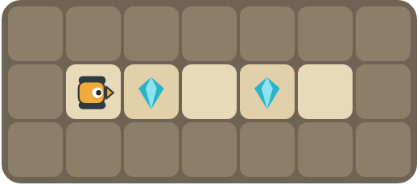
Program: repeat 2 [ F C F ]
Does it collect both crystals? Where does it stop?

Question 2
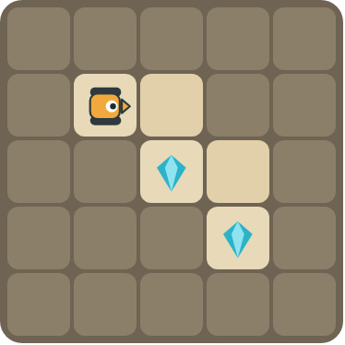
Program: repeat 2 [ F R F C L ]
Follow the stairs. Does it collect both crystals?

Part B · Write the program · Use the letters above.
Find one copy of the pattern first. You may need a repeat inside a repeat.

Question 3
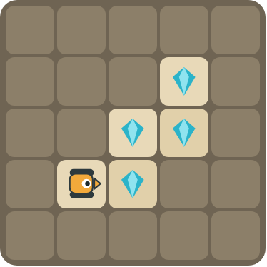
Climb the stairs and collect every crystal.
How many blocks?

Question 4
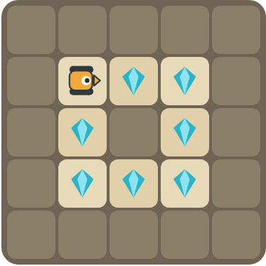
Collect the crystals around the rock. Challenge: use a repeat inside a repeat.
How many blocks?

Part C · Find one copy · Then write it with repeat.
Find one copy of the pattern. Write the program with repeat and count the blocks.
# | Long program | With repeat | Blocks before → after
5 | F C F F C F F C F |  | 9 → ____
6 | F R F C L F R F C L |  | 10 → ____
7 | F C F C R F C F C R |  | 10 → ____
8 | F F L F F L F F L  Challenge: use a repeat inside a repeat. |  | 9 → ____

Part D · Design your own · Challenge
Build a map in the grid below with a rover, rocks and crystals (◆). Write the shortest program you can with a repeat, then swap with a partner and check each other's work.
Build your map: click a square and type a symbol. R> R< R^ Rv = rover and the way it faces, # = rock, C = crystal, F = flag. You can also fill a square with color (Format → Table → Table properties → Cell background color).
My program:
Blocks:
Partner checked (partner's name):

Reflect
What is a nested loop? Give an example from the puzzles.

Part E · Words and pictures · Language practice
Type the letter of the matching meaning in the box next to each word.
Meanings
a) a block that repeats the blocks inside it
b) find a mistake and fix it
c) steps that happen again and again
d) a plan of steps to solve a problem
e) a loop inside another loop
# | Word | Letter
1 | pattern (patrón)
2 | nested loop (bucle anidado)
3 | loop (bucle)
4 | algorithm (algoritmo)
5 | debug (depurar)
Type the letter of the best answer in the box.
9. Which program has a repeat inside a repeat?
a) repeat 3 [ F C ]
b) repeat 2 [ repeat 3 [ F ] R ]
Answer:
10. A square has 4 sides. How many times does the outer repeat run?
a) 2
b) 3
c) 4
Answer:
Finish each sentence. Type the missing words in the box. Use the word bank.
Word bank: [ F C F ] [ nested ] [ side ]
11. One copy of the pattern is ______.
12. A loop inside another loop is a ______ loop.
13. The inner loop does one ______. The outer loop does all of them.

