CyberTeaches Academy · Lesson 3 classwork · Easy level

Repeat patterns
Name: ____________________________ Date: ______________
F = move forward
L = turn left
R = turn right
C = collect crystal
repeat 2 [ repeat 3 [ F C ] R ] = a repeat inside a repeat

Part A · Trace the rover Follow the program one block at a time.
Draw the rover's path with a pencil.
1 | 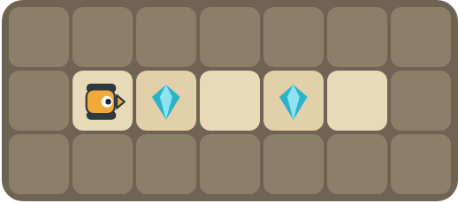 | Program: repeat 2 [ F C F ]  Does it collect both crystals? Where does it stop?  ______________________________

2 | 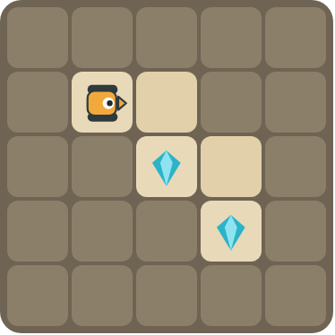 | Program: repeat 2 [ F R F C L ]  Follow the stairs. Does it collect both crystals?  ______________________________

Part B · Write the program Use the letters above.
Find one copy of the pattern first. You may need a repeat inside a repeat.
3 | 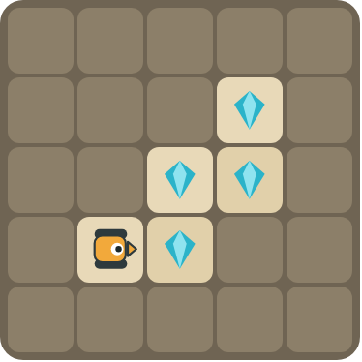 | Climb the stairs and collect every crystal.  ______________________________  ______________________________  How many blocks? ______

4 | 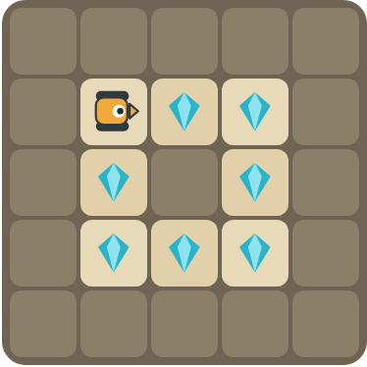 | Collect the crystals around the rock. Challenge: use a repeat inside a repeat.  ______________________________  ______________________________  How many blocks? ______

Part C · Find one copy Then write it with repeat.
Draw a box around one copy of the pattern. Write the program with repeat and count the blocks.
# | Long program | With repeat | Blocks before → after
5 | F C F F C F F C F |  | 9 → ____
6 | F R F C L F R F C L |  | 10 → ____
7 | F C F C R F C F C R |  | 10 → ____
8 | F F L F F L F F L  Challenge: use a repeat inside a repeat. |  | 9 → ____

Part D · Design your own Challenge
Draw a rover (with an arrow for the way it faces), some rocks (shade the square) and crystals (◆). Write the shortest program you can with a repeat, then swap with a partner and check each other's work.
 | My program:  ______________________________  ______________________________  ______________________________  Blocks: ______ Partner checked: ______

Reflect
What is a nested loop? Give an example from the puzzles.
______________________________
______________________________

Part E · Words and pictures Language practice
Draw a line from each word to its meaning.
- pattern (patrón)  - nested loop (bucle anidado)  - loop (bucle)  - algorithm (algoritmo)  - debug (depurar) | - a block that repeats the blocks inside it  - find a mistake and fix it  - steps that happen again and again  - a plan of steps to solve a problem  - a loop inside another loop
Circle the best answer.
9. Which program has a repeat inside a repeat?
a) repeat 3 [ F C ] b) repeat 2 [ repeat 3 [ F ] R ]
10. A square has 4 sides. How many times does the outer repeat run?
a) 2 b) 3 c) 4
Finish each sentence. Use the word bank.
Word bank: [ F C F ] [ nested ] [ side ]
11. One copy of the pattern is _______________.
12. A loop inside another loop is a _______________ loop.
13. The inner loop does one _______________. The outer loop does all of them.

Lesson 3 classwork · Easy level

Answer key
(TEACHER ONLY)

Lesson timing (50 minutes)
5 min Warm-up: What comes next? (slide 3)
10 min Direct instruction: slides 4 to 5
5 min Guided practice: think, pair, share and debugging tips (slides 6 to 7)
12 min Unplugged practice: this classwork, in pairs. Part D for early finishers
15 min Independent practice: code puzzles 3.1 to 3.10 at cyberteaches.com/academy
3 min Closure: exit ticket (last slide)

Part A
1. Yes, both. Each copy of F C F collects one crystal and moves past the gap. It stops on the last empty square.
2. Yes, both. Each repeat goes down one step of the stairs and collects one crystal.

Part B
3. repeat 2 [ F C L F C R ] · 7 blocks
4. repeat 4 [ repeat 2 [ F C ] R ] · 5 blocks

Part C
# | Answer
5 | repeat 3 [ F C F ] · 9 → 4
6 | repeat 2 [ F R F C L ] · 10 → 6
7 | repeat 2 [ F C F C R ] · 10 → 6
8 | repeat 3 [ repeat 2 [ F ] L ] · 9 → 4

Part E
Matching: 1–c, 2–e, 3–a, 4–d, 5–b
9. b) repeat 2 [ repeat 3 [ F ] R ]
10. c) 4
11. F C F
12. nested
13. side

Part D and Reflect
Answers vary. Look for a correct start direction, a program a partner can follow, and a nested loop. Reflection: a loop inside another loop. The inner loop does one part (one side) and the outer loop repeats that part (all sides).

Exit ticket
The rover drives around a square, 2 crystals on each side · 5 blocks

