CyberTeaches Academy · Lesson 5 classwork · Easy level

Repeat until practice
Name: ____________________________ Date: ______________
F = move forward
L = turn left
R = turn right
C = collect crystal
until flag [ F ] = repeat until at flag

Part A · Trace the rover Follow the program one block at a time.
Draw the rover's path with a pencil.
1 |  | Program: until flag [ F ]  The rover faces left. What happens?  ______________________________

2 |  | Program: until flag [ F C ]  How many crystals does it collect? Does it reach the flag?  ______________________________

Part B · Write the program Use the letters above.
Use repeat until at flag. Turn first if you need to.
3 | 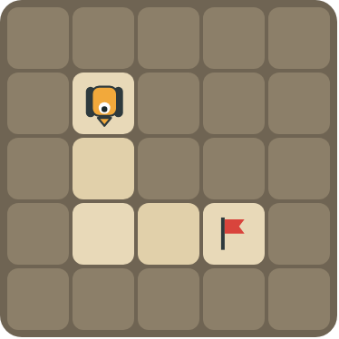 | Drive down, turn, then keep going to the flag.  ______________________________  ______________________________  How many blocks? ______

4 | 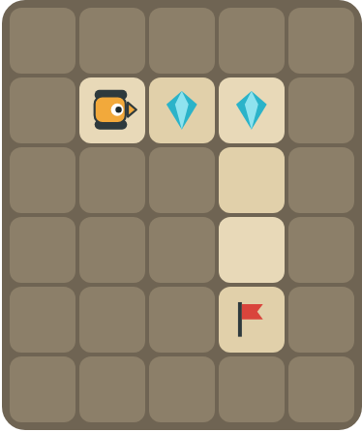 | Collect the 2 crystals, then drive to the flag.  ______________________________  ______________________________  How many blocks? ______

Part C · Fix the bug Each program has a mistake.
Read the program and the problem. Write a fixed program.
# | Program and problem | Fixed program
5 | until flag [ R ]  The rover spins forever.
6 | until flag [ F ]  The rover faces up but the flag is to the right. It crashes into a rock.
7 | until flag [ F ]  There is a crystal on every square. The rover reaches the flag but the crystals are still there.
8 | repeat 3 [ F ]  The flag is 8 squares away. The rover stops too early.

Part D · Design your own Challenge
Draw a rover (with an arrow for the way it faces), rocks (shade the square), crystals (◆) and a flag (⚑). Write a program that uses repeat until at flag, then swap with a partner.
 | My program:  ______________________________  ______________________________  ______________________________  Blocks: ______ Partner checked: ______

Reflect
What does the word "until" mean in your own words?
______________________________
______________________________

Part E · Words and pictures Language practice
Draw a line from each word to its meaning.
- until (hasta que)  - flag (bandera)  - loop (bucle)  - debug (depurar)  - infinite loop (bucle infinito) | - a block that repeats the blocks inside it  - a loop that never stops  - keep going up to the moment something happens  - find a mistake and fix it  - the goal square the rover must reach
Circle the best answer.
9. The rover faces up. The flag is to the right. What is the first block?
a)  b)  c) 
10. Which program collects crystals on the way to the flag?
a) until flag [ F ] b) until flag [ F C ]
Finish each sentence. Use the word bank.
Word bank: [ fix ] [ flag ] [ right ] [ stops ]
11. First the rover turns _______________. Then it moves forward until the _______________.
12. The program has a bug. I _______________ it.
13. The loop _______________ when the rover is on the flag.

Lesson 5 classwork · Easy level

Answer key
(TEACHER ONLY)

Lesson timing (50 minutes)
5 min Warm-up: Until you hear stop (slide 3)
10 min Direct instruction: slides 4 to 6
5 min Guided practice: think, pair, share and debugging tips (slides 7 to 8)
12 min Unplugged practice: this classwork, in pairs. Part D for early finishers
15 min Independent practice: code puzzles 5.1 to 5.10 at cyberteaches.com/academy
3 min Closure: exit ticket (last slide)

Part A
1. It crashes into the wall. The rover faces away from the flag, so the first F hits the rock.
2. 2 crystals, and yes. Each loop moves and collects. When F lands on the flag the loop stops.

Part B
3. repeat 2 [ F ] L until flag [ F ] · 5 blocks
4. repeat 2 [ F C ] R until flag [ F ] · 6 blocks

Part C
# | Answer
5 | until flag [ F ] (it needs to move)
6 | R until flag [ F ]
7 | until flag [ F C ]
8 | until flag [ F ] (or repeat 8 [ F ])

Part E
Matching: 1–c, 2–e, 3–a, 4–d, 5–b
9. b) turn right
10. b) until flag [ F C ]
11. right / flag
12. fix
13. stops

Part D and Reflect
Answers vary. Look for a correct start direction, a program a partner can follow, and repeat until at flag. Reflection: keep doing something, and stop at the moment something happens (the rover reaches the flag).

Exit ticket
R until flag [ F ] · 3 blocks

