CyberTeaches Academy · Lesson 7 classwork · Easy level (digital)

Tank battle
Name: ______________________ Date: ____________
Block letters: F = move forward · L = turn left · R = turn right · X = fire cannon · if tank [ X ] = if tank ahead, fire · until no tanks [ … ] = repeat until no tanks left

Part A · Trace the rover · Follow the program one block at a time.
Follow the program on the map one block at a time. Keep track of each tank it destroys. Type your answers in the shaded boxes.

Question 1

Program: X
How many tanks are destroyed? Why not both?

Question 2
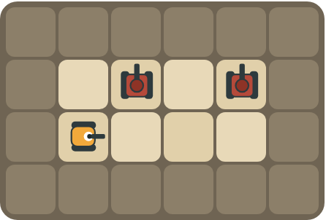
Program: repeat 3 [ F L if tank [ X ] R ]
At which squares does the rover fire? How many shells does it use?

Part B · Write the program · Use the letters above.
Face each tank before you fire. Use X for fire cannon.

Question 3

Destroy all 3 tanks with 2 blocks.
How many blocks?

Question 4
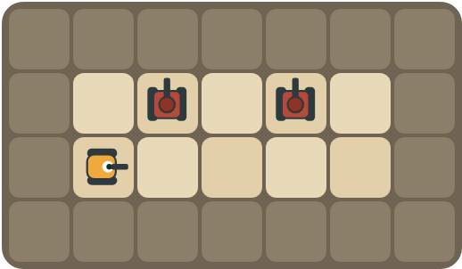
Stop under each tank, look up, fire, and move on.
How many blocks?

Part C · If or not? · Does the patrol need an if?
For each patrol, say whether the rover needs if tank ahead before it fires, and why.
# | Patrol | Need "if tank ahead"? Why?
5 | A tank above every square of the road.
6 | Tanks above some squares only.
7 | You don't know how many tanks there are.
8 | One tank, straight ahead.

Part D · Design your own · Challenge
Build a map in the grid below with a rover, rocks and enemy tanks. Write a program that destroys every tank, then swap with a partner.
Build your map: click a square and type a symbol. R> R< R^ Rv = rover and the way it faces, # = rock, T> T< T^ Tv = enemy tank and the way its cannon points. You can also fill a square with color (Format → Table → Table properties → Cell background color).
My program:
Blocks:
Partner checked (partner's name):

Reflect
Explain the red ! warning. What should the rover do next?

Part E · Words and pictures · Language practice
Type the letter of the matching meaning in the box next to each word.
Meanings
a) a question with a yes or no answer
b) find a mistake and fix it
c) a tank the rover must stop with its cannon
d) a block that repeats the blocks inside it
e) shoot the cannon straight ahead
# | Word | Letter
1 | enemy tank (tanque enemigo)
2 | fire (disparar)
3 | condition (condición)
4 | loop (bucle)
5 | debug (depurar)
Type the letter of the best answer in the box.
9. Which block shoots the cannon?
a) 
b) 
c) 
Answer:
10. Which block checks for a tank first?
a) 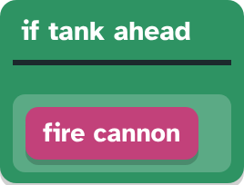
b) 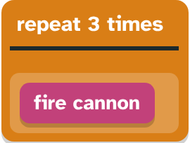
Answer:
Finish each sentence. Type the missing words in the box. Use the word bank.
Word bank: [ fires ] [ straight ] [ tanks ]
11. If a tank is ahead, then the rover ______.
12. The shell flies ______ until it hits a tank or a rock.
13. The loop stops when no ______ are left.

