CyberTeaches Academy · Lesson 10 classwork · Medium level

Tank missions
Name: ____________________________ Date: ______________
F = move forward
L = turn left
R = turn right
X = fire cannon
if tank [ X ] = if tank ahead, fire

Part A · Trace the rover Follow the program one block at a time.
Draw the rover's path. Cross out each tank it destroys.
1 | 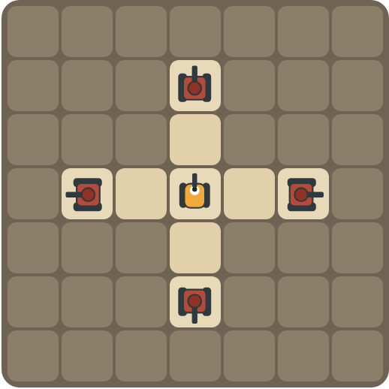 | Program: repeat 4 [ X R ]  How many shells are used? Which way does the rover face at the end?  ______________________________  ______________________________

2 | 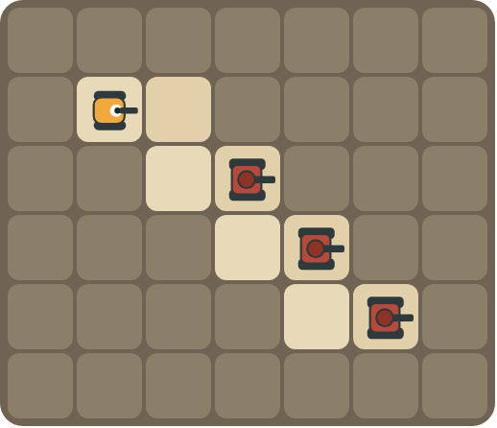 | Program: repeat 3 [ F R F L X ]  Draw the path down the stairs. How many tanks are destroyed?  ______________________________  ______________________________

Part B · Write the program Use the letters above.
Write a program that fits inside the block limit. Use X for fire cannon.
3 | 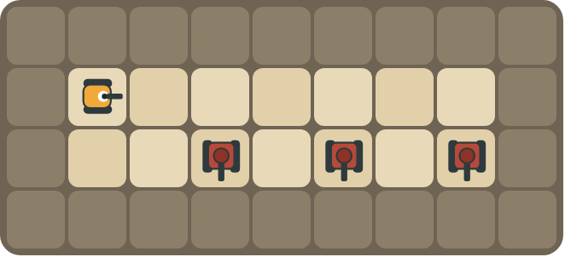 | Tanks below every other square. 3 shells. Limit: 10 blocks.  ______________________________  ______________________________  How many blocks? ______ (goal: 6)

4 | 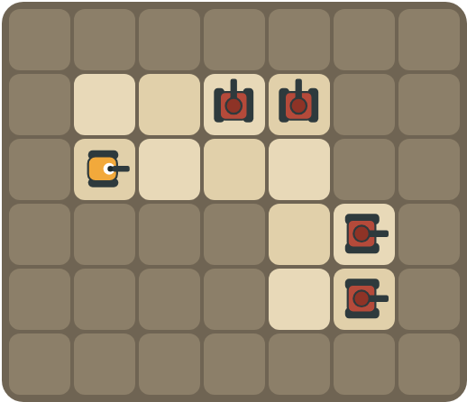 | Clear the top road, turn, clear the side road. 4 shells. Limit: 12 blocks.  ______________________________  ______________________________  How many blocks? ______ (goal: 8)

Part C · Will it fit? Block limits
Count the blocks. Does the program fit inside the limit? If not, write a shorter program.
# | Program and limit | Fits? Shorter program | Blocks
5 | X X X X X X X X · limit 6 |  | 8
6 | F L X R F L X R F L X R · limit 9 |  | 12
7 | repeat 4 [ X R ] · limit 7 |  | 3
8 | X X X X R X X X X · limit 8 |  | 9

Part D · Design your own Challenge
Draw a rover (with an arrow), rocks (shade the square) and enemy tanks (draw a box with an arrow for its cannon). Write a program that destroys every tank, then swap with a partner.
 | My program:  ______________________________  ______________________________  ______________________________  Blocks: ______ Partner checked: ______

Reflect
How does a repeat help you stay inside a block limit?
______________________________
______________________________

Part E · Words and pictures Language practice
Draw a line from each word to its meaning.
- limit (límite)  - efficient (eficiente)  - loop (bucle)  - nested loop (bucle anidado)  - enemy tank (tanque enemigo) | - a block that repeats the blocks inside it  - a tank the rover must stop with its cannon  - the most you are allowed to use  - a loop inside another loop  - does the job with fewer steps
Circle the best answer.
9. The limit is 6 blocks. Which program fits?
a) X X X X X X X X b) repeat 8 [ X ]
10. You have 4 shells and 4 tanks. How many shells can you miss?
a) 0 b) 1 c) 2
Finish each sentence. Use the word bank.
Word bank: [ efficient ] [ if ] [ six ]
11. The limit is _______________ blocks, so I use a repeat.
12. My program is _______________ because it uses fewer blocks.
13. I fire only _______________ a tank is ahead.

Lesson 10 classwork · Medium level

Answer key
(TEACHER ONLY)

Lesson timing (50 minutes)
5 min Warm-up: Packing list (slide 3)
10 min Direct instruction: slides 4 to 6
5 min Guided practice: think, pair, share and debugging tips (slides 7 to 8)
12 min Unplugged practice: this classwork, in pairs. Part D for early finishers
15 min Independent practice: code puzzles 10.1 to 10.10 at cyberteaches.com/academy
3 min Closure: exit ticket (last slide)

Part A
1. 4 shells, all tanks destroyed. It faces left. Fire up, turn right, fire right, turn, fire down, turn, fire left. The mission is won right after the last shell, so the last turn never runs.
2. All 3. Each repeat goes down one step and fires at the tank on that step.

Part B
3. repeat 3 [ F F R X L ] · 6 blocks
4. F repeat 2 [ repeat 2 [ F L X R ] R ] · 8 blocks

Part C
# | Answer
5 | No. repeat 8 [ X ], 2 blocks
6 | No. repeat 3 [ F L X R ], 5 blocks
7 | Yes, 3 blocks.
8 | No. repeat 2 [ repeat 4 [ X ] R ], 4 blocks

Part E
Matching: 1–c, 2–e, 3–a, 4–d, 5–b
9. b) repeat 8 [ X ]
10. a) 0
11. six
12. efficient
13. if

Part D and Reflect
Answers vary. Look for a correct start direction, a program a partner can follow, and a program that fits the limit. Reflection: the repeat holds one copy of the pattern, so many actions take only a few blocks.

Exit ticket
repeat 8 [ X ] · 2 blocks

