CyberTeaches Academy · Lesson 13 classwork · Medium level

If / else challenges
Name: ____________________________ Date: ______________
F = move forward
L = turn left
R = turn right
C = collect crystal
X = fire cannon
if path ahead [ F ] else [ R ] = if / else
until flag [ … ] = repeat until at flag

Part A · Trace the rover Follow the program one block at a time.
Draw the rover's path with a pencil.
1 | 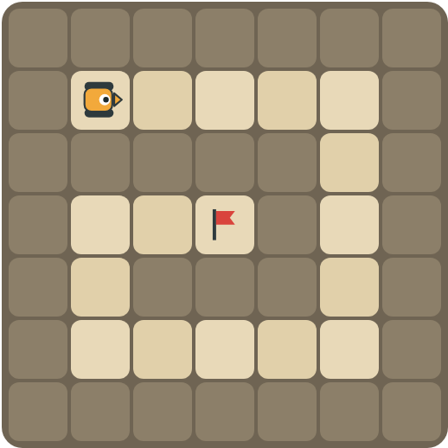 | Program: until flag [ if path ahead [ F ] else [ R ] ]  Draw the spiral path. How many right turns does the rover make?  ______________________________

2 |  | Program: until flag [ if crystal here [ C ] if tank ahead [ X ] else [ F ] ]  What is the rover's first action? Why?  ______________________________  ______________________________

Part B · Write the program Use the letters above.
Use if / else inside repeat until at flag. Think about the order of your checks.
3 | 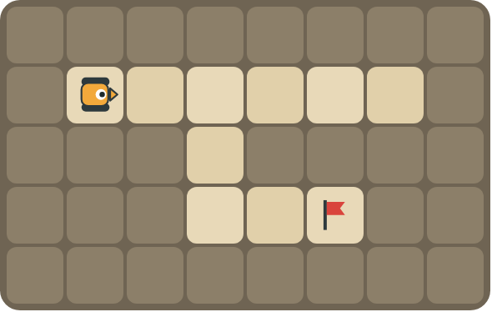 | Keep your right hand on the wall all the way to the flag.  ______________________________  ______________________________  How many blocks? ______

4 | 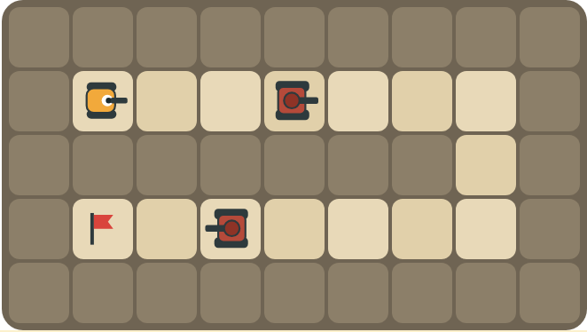 | Fire at tanks on both roads and turn right at walls.  ______________________________  ______________________________  How many blocks? ______

Part C · Order the checks Most important first
Number the checks in the best order (1 = check first), and explain why.
# | Checks | Order and reason
5 | path ahead · tank ahead
6 | crystal here · path ahead
7 | path right · path ahead · (else) turn left
8 | path ahead · crystal here · tank ahead

Part D · Design your own Challenge
Draw a winding road from the rover to a flag (⚑), with rocks around it. Write one program with if / else that drives the whole road, then swap with a partner and test it.
 | My program:  ______________________________  ______________________________  ______________________________  Blocks: ______ Partner checked: ______

Reflect
Why does the order of your if / else checks matter?
______________________________
______________________________

Part E · Words and pictures Language practice
Draw a line from each word to its meaning.
- nested if (condicional anidado)  - if / else (si / si no)  - condition (condición)  - algorithm (algoritmo)  - decision (decisión) | - a question with a yes or no answer  - choosing what to do  - an if / else inside another if / else  - a plan of steps to solve a problem  - if yes, do one thing; if no, do another thing
Circle the best answer.
9. Which should the rover check first?
a) path ahead b) tank ahead
10. The right-hand rule says: if there is a path right, …
a) turn right and move b) turn left c) stop
Finish each sentence. Use the word bank.
Word bank: [ first ] [ nested ] [ right ]
11. I check for a tank _______________ because it blocks the path.
12. If there is a path to the right, the rover turns _______________.
13. An if / else inside another if / else is a _______________ if.

Lesson 13 classwork · Medium level

Answer key
(TEACHER ONLY)

Lesson timing (50 minutes)
5 min Warm-up: Most important first (slide 3)
10 min Direct instruction: slides 4 to 5
5 min Guided practice: think, pair, share and debugging tips (slides 6 to 7)
12 min Unplugged practice: this classwork, in pairs. Part D for early finishers
15 min Independent practice: code puzzles 13.1 to 13.10 at cyberteaches.com/academy
3 min Closure: exit ticket (last slide)

Part A
1. 4 right turns. It turns at each corner of the spiral: top right, bottom right, bottom left, and the inside corner, then reaches the flag.
2. It fires. There is no crystal on the start square, and a tank is in its line of fire, so it fires before moving.

Part B
3. until flag [ if path right [ R F ] else [ if path ahead [ F ] else [ L ] ] ] · 7 blocks
4. until flag [ if tank ahead [ X ] else [ if path ahead [ F ] else [ R ] ] ] · 6 blocks

Part C
# | Answer
5 | 1 tank ahead, 2 path ahead: a tank blocks the path.
6 | 1 crystal here, 2 path ahead: collect before you leave the square.
7 | 1 path right, 2 path ahead, 3 turn left: the right-hand rule.
8 | 1 tank ahead, 2 crystal here, 3 path ahead.

Part E
Matching: 1–c, 2–e, 3–a, 4–d, 5–b
9. b) tank ahead
10. a) turn right and move
11. first
12. right
13. nested

Part D and Reflect
Answers vary. Look for a correct start direction, a program a partner can follow, and checks in a sensible order. Reflection: the first check that is true decides the action, so the most important thing (like a tank) must be checked first.

Exit ticket
tank ahead → crystal here → path ahead (most important first)

