CyberTeaches Academy · Lesson 2 classwork · Medium level

Repeat practice
Name: ____________________________ Date: ______________
F = move forward
L = turn left
R = turn right
C = collect crystal
repeat 3 [ F C ] = do F C three times

Part A · Trace the rover Follow the program one block at a time.
Draw the rover's path with a pencil.
1 | 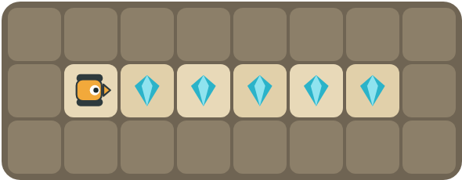 | Program: repeat 3 [ F C ]  How many crystals are left after the program runs?  ______________________________

2 | 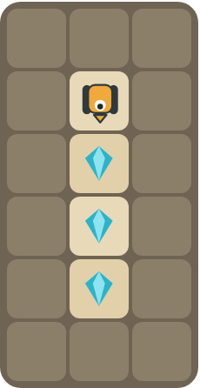 | Program: repeat 3 [ F C ]  Does it collect every crystal? Mark where it stops.  ______________________________

Part B · Write the program Use the letters above.
Count the crystals first. Use one repeat block.
3 | 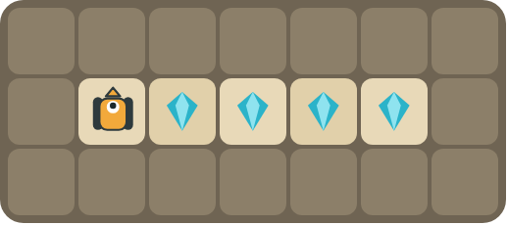 | The rover faces up. Turn first, then collect the row.  ______________________________  ______________________________  How many blocks? ______

4 | 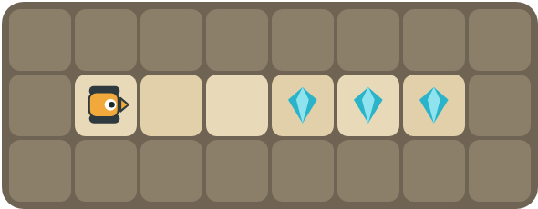 | Walk past the empty squares, then collect the 3 crystals. Use two repeats.  ______________________________  ______________________________  How many blocks? ______

Part C · Count and repeat Write the repeat number.
Each long program is a pattern. Write it with one repeat block and count the blocks.
# | Long program | With repeat | Blocks before → after
5 | F C F C F C |  | 6 → ____
6 | F C F C F C F C F C F C F C F C |  | 16 → ____
7 | F F C F F C F F C F F C |  | 12 → ____
8 | R F C F C F C F C |  | 9 → ____

Part D · Design your own Challenge
Draw a rover (with an arrow for the way it faces), some rocks (shade the square) and crystals (◆). Write the shortest program you can with a repeat, then swap with a partner and check each other's work.
 | My program:  ______________________________  ______________________________  ______________________________  Blocks: ______ Partner checked: ______

Reflect
Why do you count the crystals before you choose the repeat number?
______________________________
______________________________

Part E · Words and pictures Language practice
Draw a line from each word to its meaning.
- repeat (repetir)  - loop (bucle)  - pattern (patrón)  - sequence (secuencia)  - debug (depurar) | - steps that happen again and again  - find a mistake and fix it  - do the same thing again  - steps that happen in order, one after another  - a block that repeats the blocks inside it
Circle the best answer.
9. There are 4 crystals in a row. Which number goes in the repeat?
a) 2 b) 4 c) 8
10. Which block happens only one time in this program: R repeat 5 [ F C ]?
a)  b)  c) 
Finish each sentence. Use the word bank.
Word bank: [ five ] [ inside ] [ right ]
11. There are _______________ crystals, so I repeat _______________ times.
12. The rover turns _______________ first.
13. The blocks _______________ the repeat run again and again.

Lesson 2 classwork · Medium level

Answer key
(TEACHER ONLY)

Lesson timing (50 minutes)
5 min Warm-up: Clap the pattern (slide 3)
10 min Direct instruction: slides 4 to 6
5 min Guided practice: think, pair, share and debugging tips (slides 7 to 8)
12 min Unplugged practice: this classwork, in pairs. Part D for early finishers
15 min Independent practice: code puzzles 2.1 to 2.10 at cyberteaches.com/academy
3 min Closure: exit ticket (last slide)

Part A
1. 2 crystals are left. The repeat runs 3 times, so it collects only 3 of the 5 crystals.
2. Yes, all 3. The rover faces down, so F C three times collects the whole column. It stops on the bottom crystal.

Part B
3. R repeat 4 [ F C ] · 4 blocks
4. repeat 2 [ F ] repeat 3 [ F C ] · 5 blocks

Part C
# | Answer
5 | repeat 3 [ F C ] · 6 → 3
6 | repeat 8 [ F C ] · 16 → 3
7 | repeat 4 [ F F C ] · 12 → 4
8 | R repeat 4 [ F C ] · 9 → 4

Part E
Matching: 1–c, 2–e, 3–a, 4–d, 5–b
9. b) 4
10. a) turn right
11. five / five
12. right
13. inside

Part D and Reflect
Answers vary. Look for a correct start direction, a program a partner can follow, and one repeat with the right number. Reflection: the number in the repeat must match how many times the pattern happens, or the rover stops too early or goes too far.

Exit ticket
repeat 6 [ F C ] · 3 blocks

