**WHEN THE SMS NOTIFICATION / ALERT WORKS:-**

-------------------------------------------------------------------------------------------------------------

All of the SMS related settings are available in the Display setting page.

There are two types of SMS alert available:-

* The SMS scheduler sends the SMS to the client before starting his/her tern when the client wait at the position 3/4 (based on the application setting).

**Actually**, At the token creation time, the SMS is created but not sent. cause, you have already printed a token for the client. When the client is waiting at the position 3 (you can set any waiting position number in the setting page) then the SMS is sent to remind him.

* The SMS scheduler sends the SMS to the client when the officer clicking on the recall button.

**Actually**, The SMS notification works when you have re-called a client.

**ITEM/PRODUCT SUPPORT BY THE AUTHOR**

-------------------------------------------------------------------------------------------------------------

According to the Envato support:-

**Item support includes:**

* Availability of the author to answer questions
* Get assistance with reported bugs and issues
* Help with included 3rd party assets

**Item support does not include:**

* Customizations and installations

But I will help you to install it to the server.

Could you share your **TeamViewer** credentials.

**LICENSE**

-------------------------------------------------------------------------------------------------------------

There are two types of license available:-

**1. Regular License**: You will get the full source code and you can modify the application as you but you can use it only on one domain.

**2. Standard License**: You will get the full source code with the copyright license then you can do anything as you wish and also can use it on unlimited domain also can resale it to others.

**HOW TO GET THE PURCHASE CODE**

-------------------------------------------------------------------------------------------------------------

Please follow the tutorial to get the purchase key <https://help.market.envato.com/hc/en-us/articles/202822600-Where-Is-My-Purchase-Code->

**HOW TO HEAR/LISTEN THE VOICE NOTIFICATION**

-------------------------------------------------------------------------------------------------------------

Just follow some steps:-  
1. Open the display screen in a new tab.  
2. In the current tab, goto current token list and complete a token from the list which is showing on the display screen at now serving portion.  
3. Now, you can hear/listen the voice notification sound.

**HOW THE QUEUE MANAGEMENT SYSTEM WORKS?**

-------------------------------------------------------------------------------------------------------------

Just follow some steps:-

1. Create department, counter, and register the officer.

2. Setup an auto-token setting (where you have to assign a department and counter to an officer).

3. In the auto-token page, create randomly token. create more than 5 tokens in a single counter.

4. Now you have seen the "now serving" 1st token, you can complete the token by admin or (officer which you have assigned it).

5. login into officer account, then the officer sees which tokens assigned to him.

6. officer service to that client the token which is showing on the "now serving" portion in the display screen and when the task is finished he will complete the task by click on the complete button on the current token page.

7. Now, if the 1st token will complete by the officer then the second token place at the "now serving" position of that counter and 5th token of that counter is placed at the display screen 4th position(waiting position 4).

For more information,

1. The workflow diagram http://queue.codekernel.net/Queue.png

2. You can see the Queue Management System video tutorial on YouTube <https://www.youtube.com/channel/UCc01ACPa90xZQZGOr9Fnd3A>

**HOW TO LEAVE A REVIEW/RATINGS?**

-------------------------------------------------------------------------------------------------------------

Your  5-star ratings inspire us to work hard and get more updates  
for you. We show our client reviews to our future customers as a creditability  
of our work.

It is very easy to give a review <http://codekernel.net/docs/review/review.pdf>

**APPLICATION NOT WORKING?**

-------------------------------------------------------------------------------------------------------------

Please check the PHP version of the server. (The minimum required version of the PHP is 7.1.13 ).  
If the requirements meet then please set the storage directory permission to 777 of the application.

**GMAIL SMTP CONFIGURATION**

-------------------------------------------------------------------------------------------------------------

Please configure the Gmail SMTP and then set the password to the email setting.

An App Password is a 16-digit passcode that gives a non-Google app or device permission to access your Google Account. App Passwords can only be used with accounts that have 2-Step Verification turned on.

Please follow the tutorial <https://support.google.com/accounts/answer/185833?hl=en>

**VOICE NOTIFICATION/SOUND NOT WORKING/PLAYING?**

-------------------------------------------------------------------------------------------------------------

You need to allow your domain/IP in the chrome setting.

Type chrome://settings/content/sound in your google chrome browser and hit enter then you will see the below page.

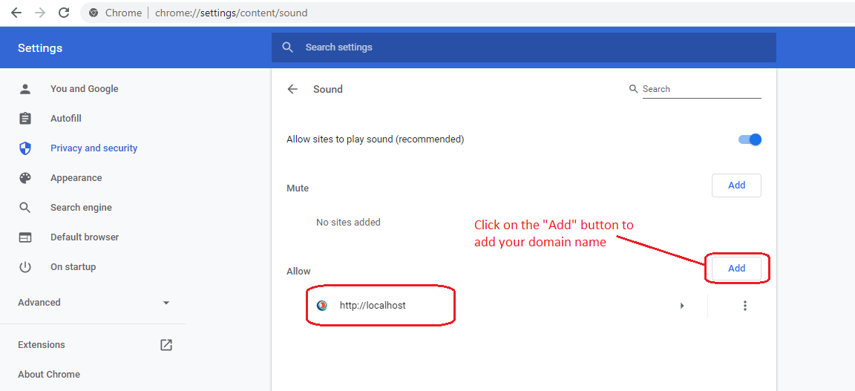

**HOW TO ADD A LANGUAGE?**

-------------------------------------------------------------------------------------------------------------

You can not add any language directly, can do it programmatically.

All language files are located in the **resources/lang** directory.

You can see the available **phrases(default English)** in **resources/lang/en/app.php** file.

Copy the **app.php** file and paste in your local language directory then open the file and modify the array value to your local language.